n

The fun things to do at a beach in Northern Ireland

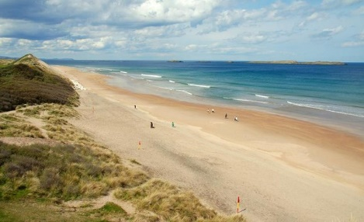

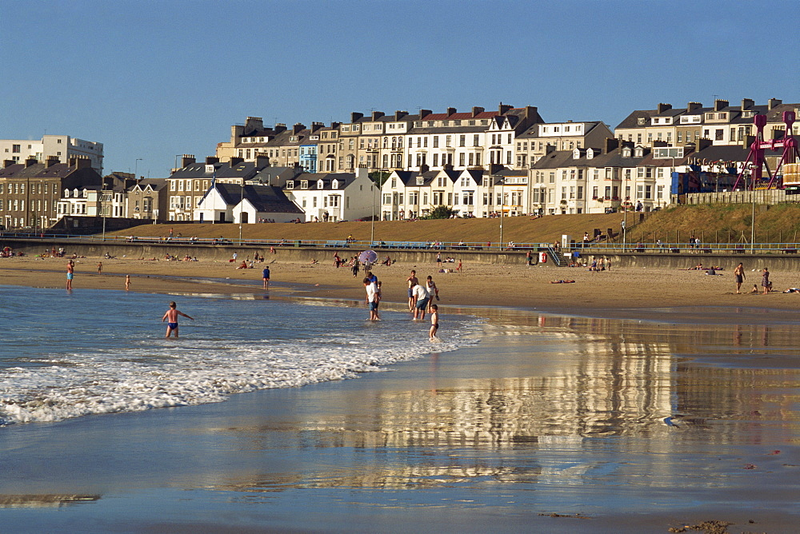

**Portrush- Northern Irelands best seaside resort**

**My favourite things to do at a beach**

1. Bury my parents in sand.
2. Build sandcastles.
3. Swim in the sea and splash my sister in the sea.
4. Sunbathe on the soft sand.
5. Eat delicious ice-cream
6. Donkey rides

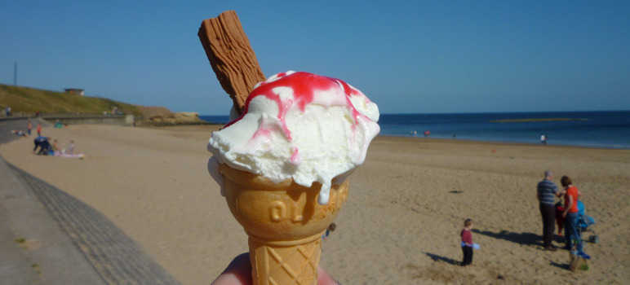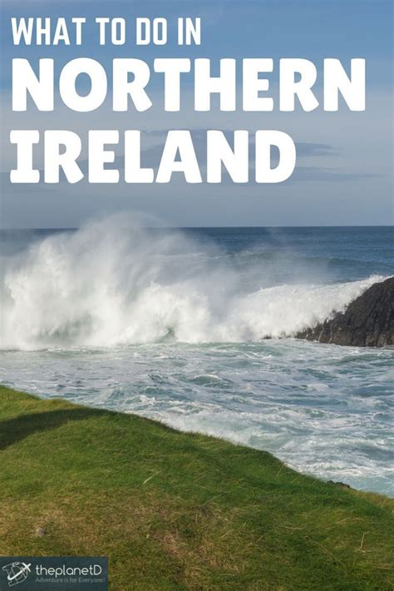[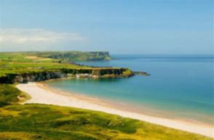](https://www.bing.com/images/search?view=detailV2&ccid=Jx6gqQWh&id=4765D4B7AF9F541497B3663DCEF828FEEA678FC8&thid=OIP.Jx6gqQWhTwSK63Ts4hS5sQHaE7&mediaurl=https://discovernorthernireland.com/globalassets/things-to-do/attractions/beaches/landing-page/17652_white_park_bay.jpg&exph=798&expw=1200&q=pictures+of+beaches+in+northen+island&simid=608053112806706054&selectedIndex=4&adlt=strict)

This beach is located in Belfast

[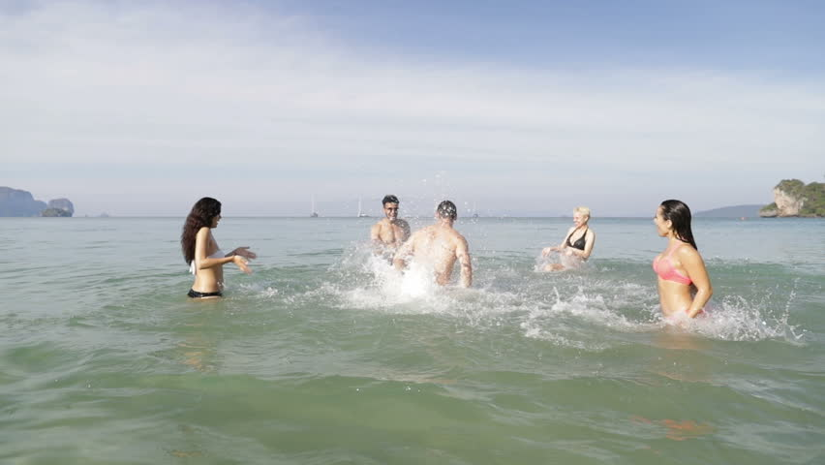](https://www.google.co.uk/url?sa=i&rct=j&q=&esrc=s&source=images&cd=&cad=rja&uact=8&ved=2ahUKEwjKj7P8n_zeAhVoLMAKHVRbCMUQjRx6BAgBEAU&url=https://www.shutterstock.com/video/clip-28235944-people-splashing-water-on-man-cheerful-young&psig=AOvVaw2fe1GCA0KVcQWmnBFkkV6G&ust=1543671608789483)

