**ONE DAY AT THE BEACH**

What’s summer without a day at the beach (or two, or three...) ?

Not many things beat a day by the seaside. There's nothing quite like the feel of the sun on your back and waves breaking over your feet. There are a lot of activities that can take place at the beach… You can...

**Go swimming in the sea**

Is there anything more refreshing than the big blue sea?

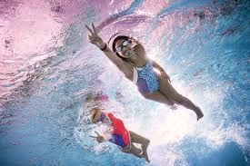

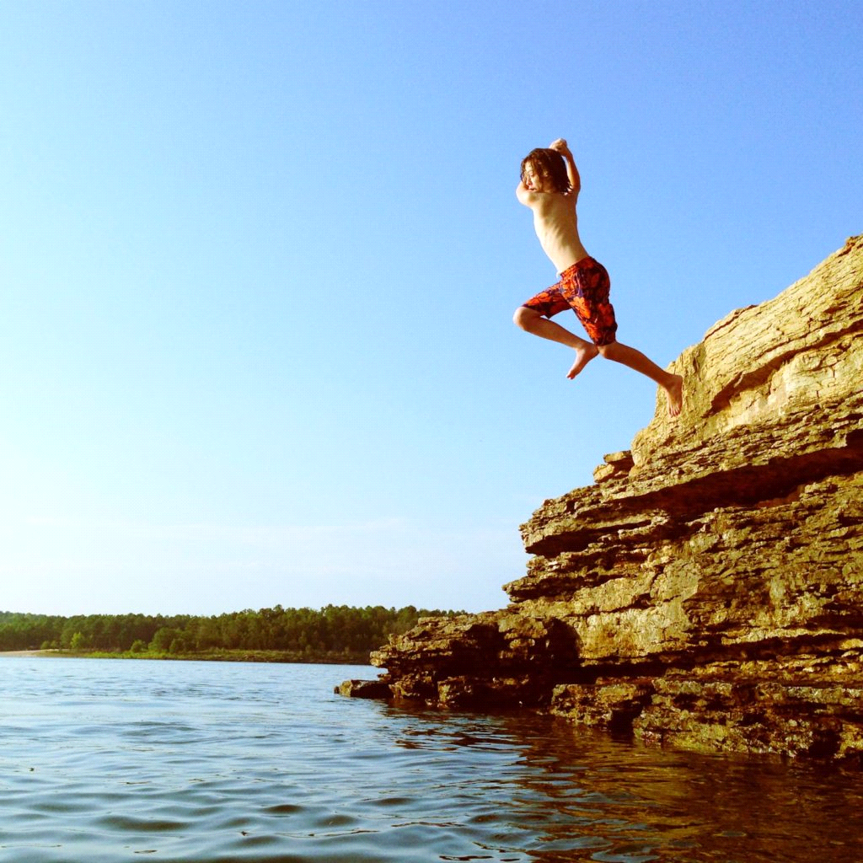

**Sunbathe**

Enjoy the sun.

We all need some sun exposure…but we have to be careful, too much unprotected exposure to the sun can cause skin damage.That's why you must wear a hat and some sunscreen... 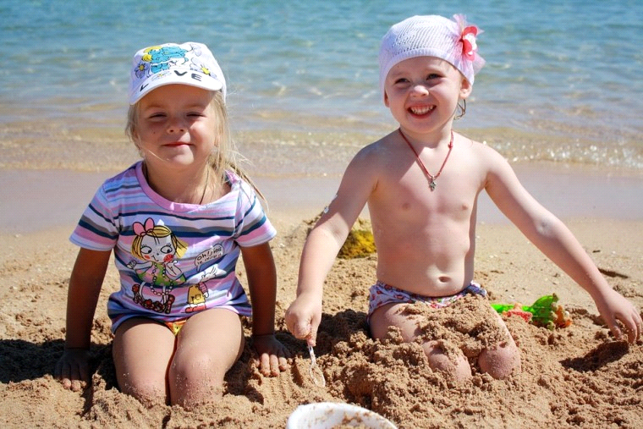

**Splash and Play in the Surf**

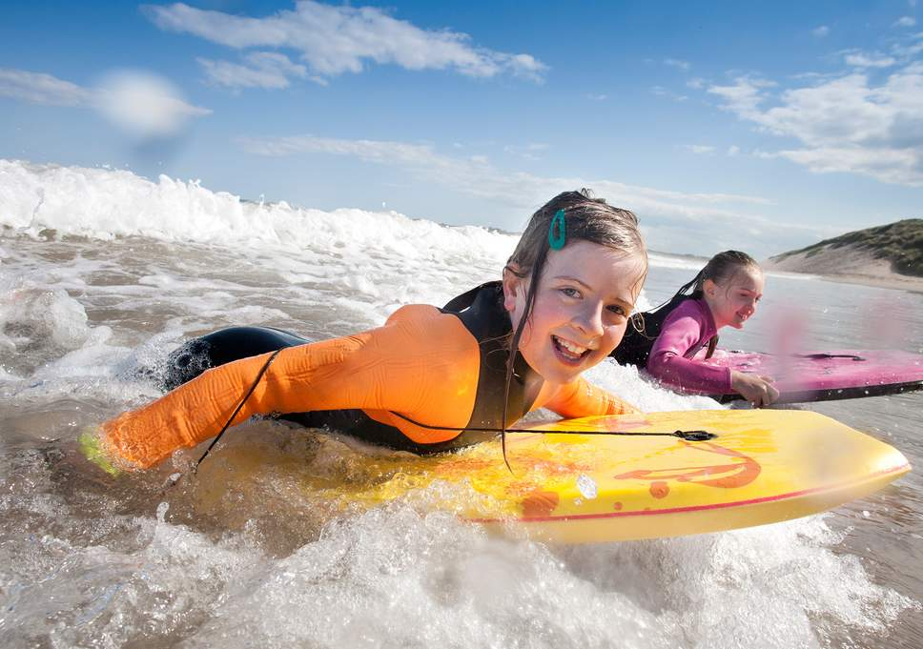

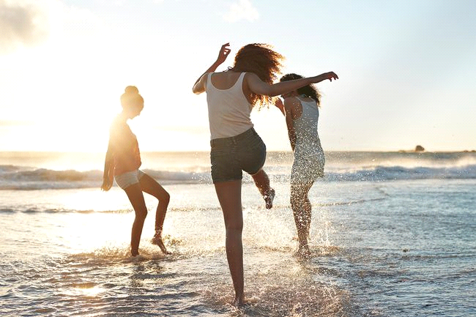

How do you cool off? Get in the water! Splash each other, run and play. Let the waves wash over you, but do be careful.

**Collect seashells and sea pebbles**

You can find shells on just about any beach. You will need a container to collect your shells. Only collect "dead" shells—shells that have no animal inside. It is a fun activity to look for shells on the beach. As a result when you will get home you and you will not go to the beach you could paint them and decorate your room or whatever you want...

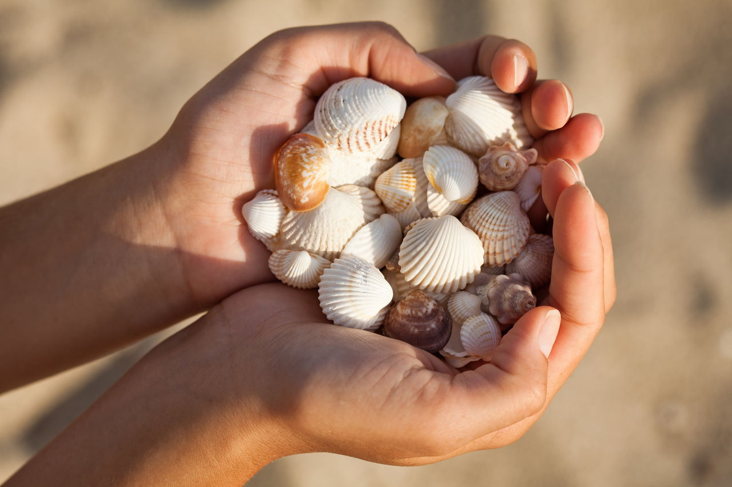

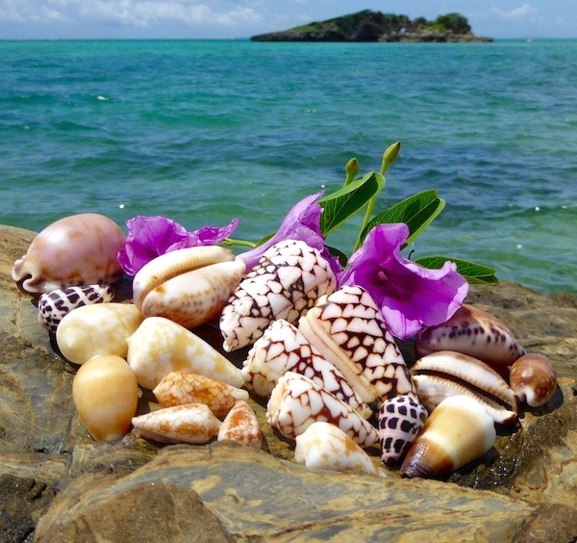

**Skim a stone**

How many bounces can you do? Flat, smooth stones are the best for skimming, and there are plenty to be found on our beaches. Why not challenge your family and friends to a competition?

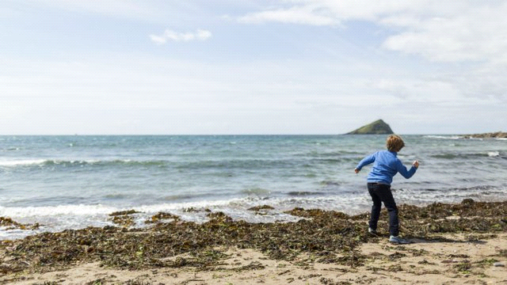

**Explore a sea cave**

Wonderful wildlife - who knows what you’ll discover? Lots of our places near the coast have caves to explore, but you'll need to watch out for the tides!

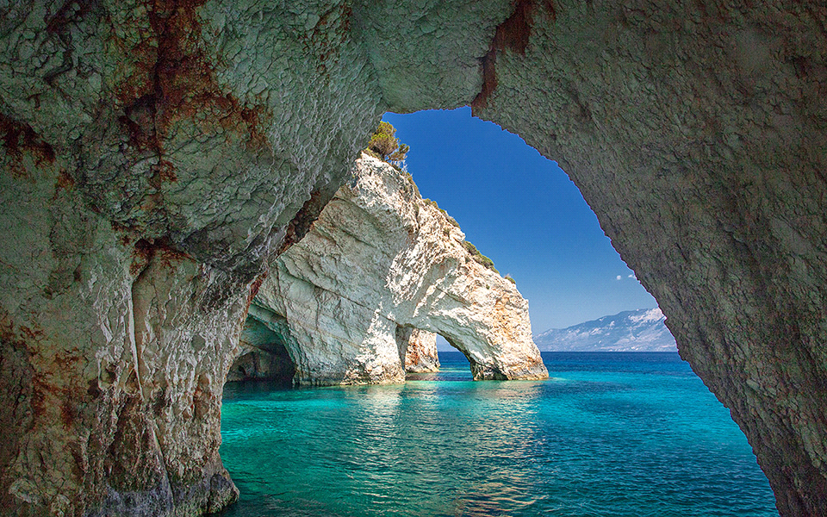

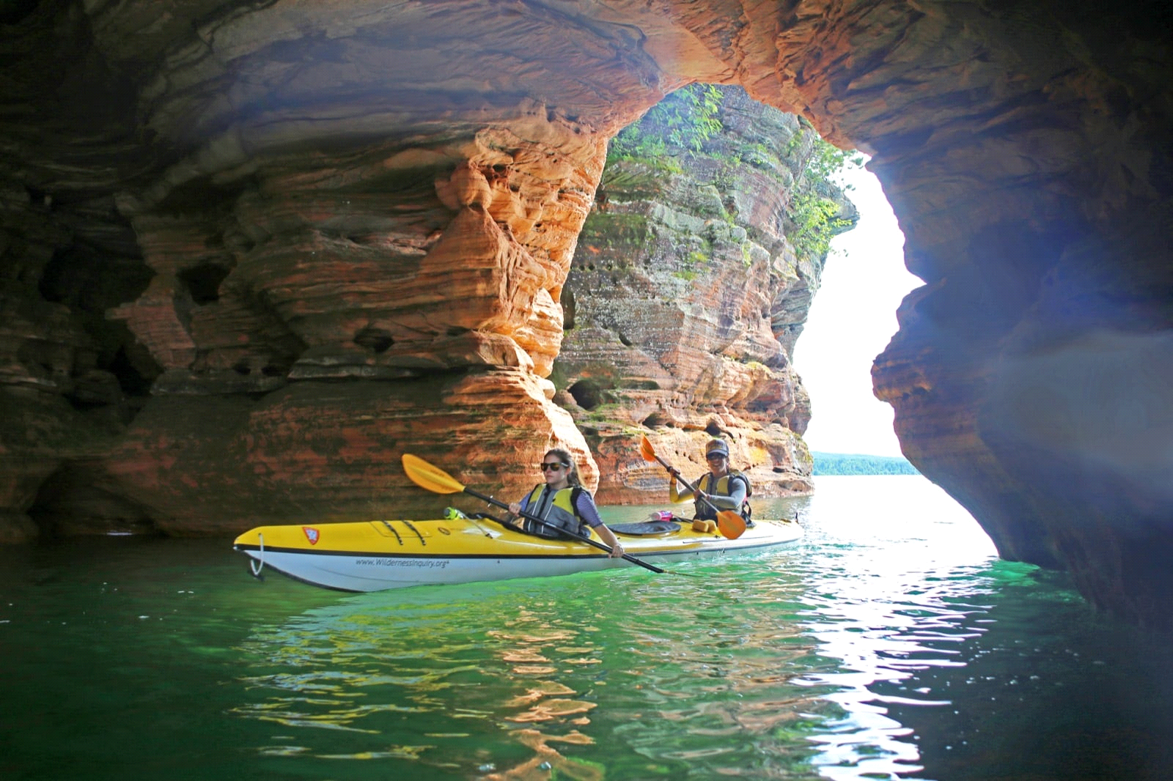

**Build a Sandcastle**

Sandcastles and sand sculptures are so much fun to build! No special tools are needed—just sand, water, and your hands will do..

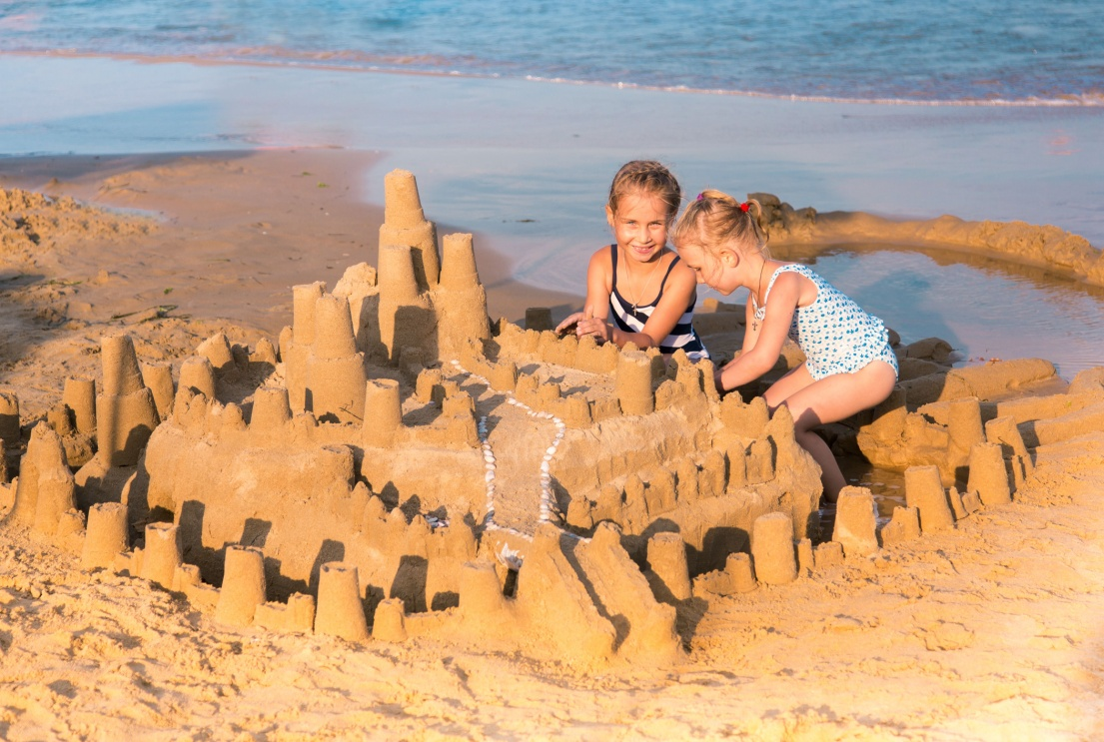

**Spot a fish**

Go on an adventure to the sea and find an underwater world that’s teeming with wildlife. You might find fish hiding amongst the rocks or swimming in shallow waters. Remember to put any fish back quickly once you’ve had a look, and don't ever leave them in a bucket in the sun.

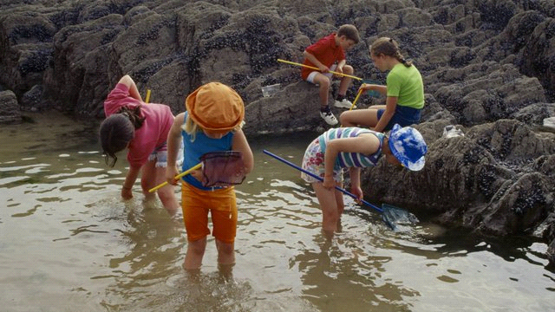

**Catch a crab**

To become a champion crabber you’ll need a net, some bait and a bucket of water. Just remember to put anything you catch back where you found it afterwards. Crabs have busy lives too, you know…

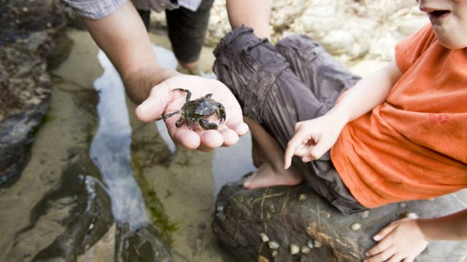

**Take Pictures**

If you're on vacation, of course, you'll want photos of those memory-making moments. After all, you'll have to prove to your friends back home that you really did look like a lobster with that sunburn. Instead of just taking your typical family shots, whip out the artsy Instagram filters and take your picture-snapping skills to the next level. Capture the beautiful scenery. And then you could probably post some of the pictures to social media so you can share those beautiful moments with your friends and relatives.

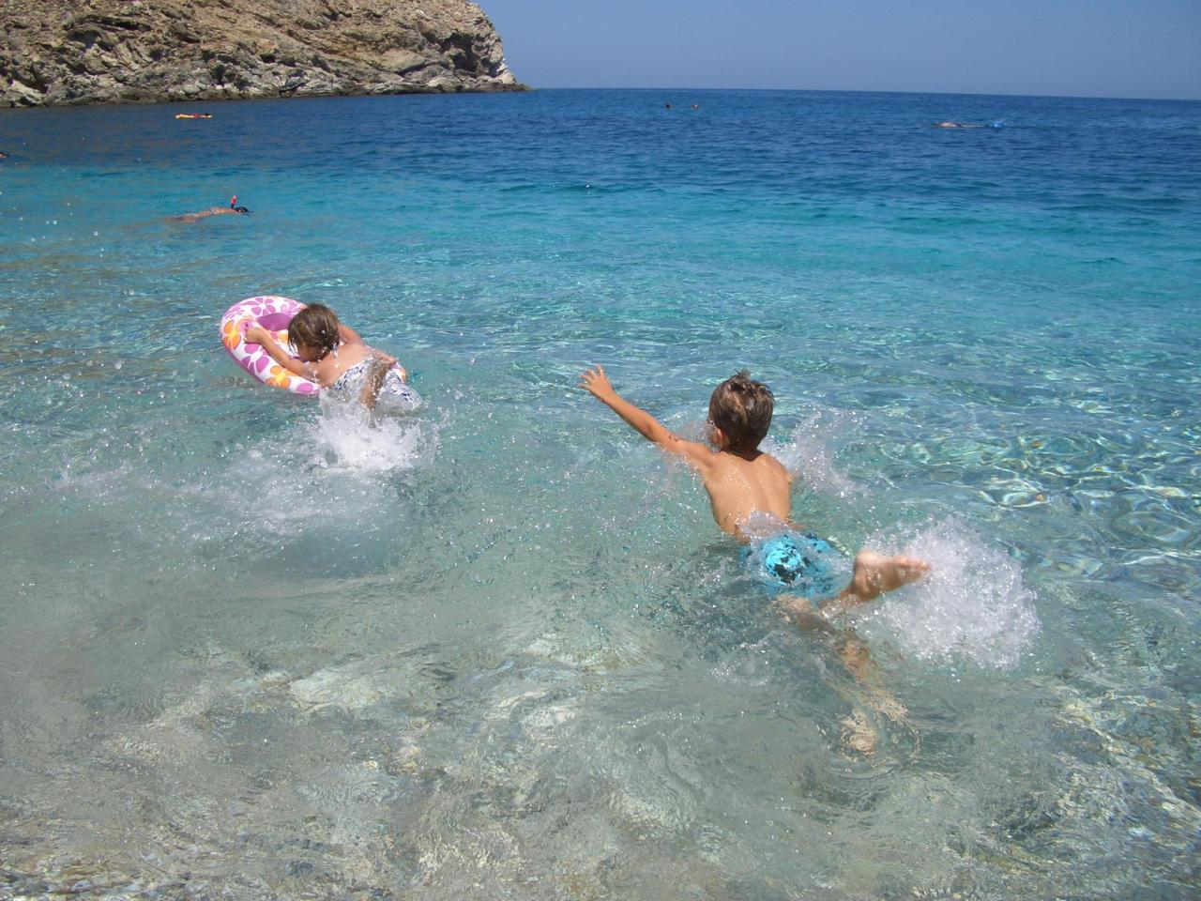

**Watch the Sunset**

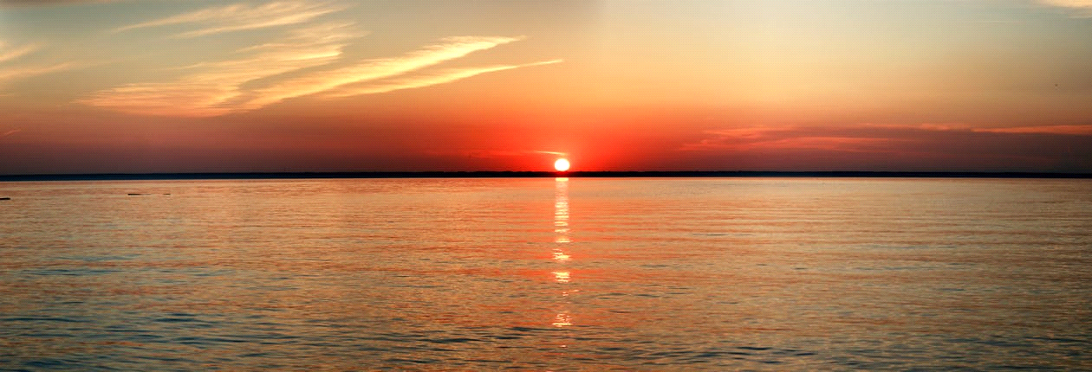

What a wonderful way to end your day at the beach!

**Mouroutsou Melina & Apostolou Sophia**

**3dim, Greece**

**ERASMUS+ THE SEA**

**Athens 2019**