Diving in Greece
And while the wind guides you through the pure beauty, underwater a seabed full of secrets invites you to explore its mystical world. Scuba diving into impressive shipwrecks, underwater caves, reefs teeming with dozens of species of fish – from Skiathos to Lefkas and Zakynthos and from Santorini to Corfu. If you’re a beginner diver, specialised training schools with certified instructors are available, providing you with equipment and guidance, so that you can enjoy the underwater world of Greece in all its glory.
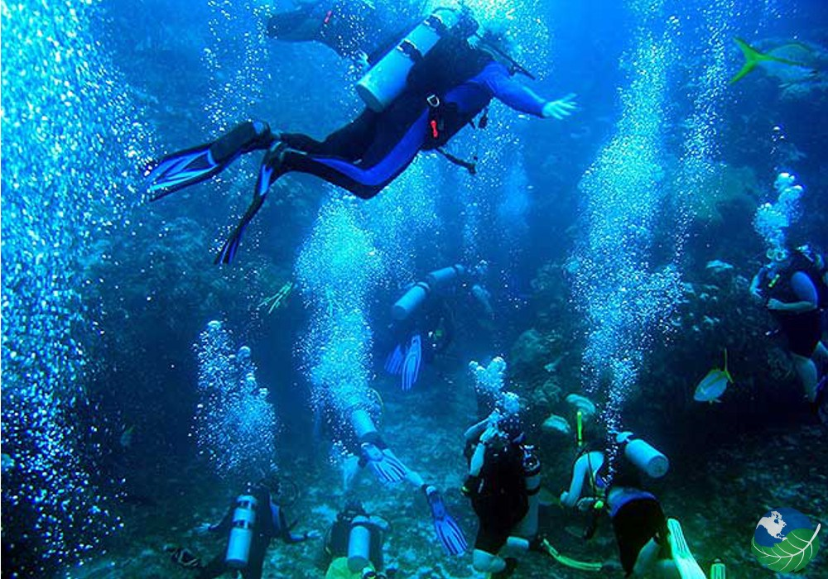
Sailing in Greece
With the meltemia (the prevailing north winds that blow every summer from about 5 to 7 Beaufort) in your sails, you’ll start your own Odyssey. The Cyclades, the Dodecanese, the Sporades, the islands of the North Aegean, Crete – wherever you may go in the Aegean – a sense of relaxation, vitality and wellbeing will flood over you. If you competition’s your thing, there’s the Aegean Regatta, the Cyclades Regatta, the International Aegean Sailing Rally, the Cretan Cup and the Rhodes Cup. Each event lasts from five to nine days and is an adventure, filled with fun and action. At the end you’ll celebrate with parties on the Greek islands.
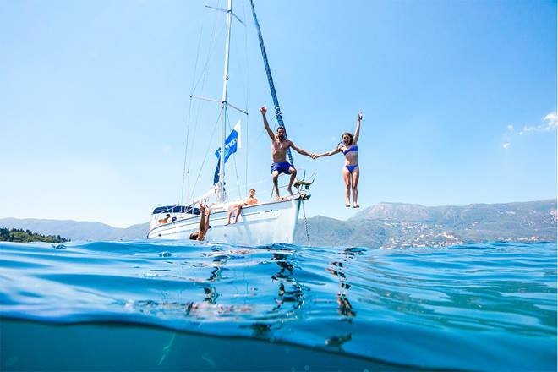
Surfing can be done with a plank, but this is not necessary. In modern surfing, however, it usually involves surfing up on a special surfboard. However, there are many variations, such as the surfer being lying on the board or knees, or even without using a board, using only his body.
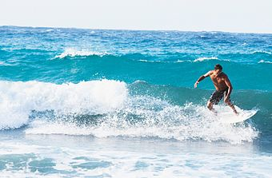
by Irene Gouvatsou, Evi Manioti and Athena Triantafyllou
We are 3 girls in grade 6 and we love sea sports!

