The history of the sea

The sea is very important for us. A large part from the Netherlands borders the sea. It’s important to protect ourselves against the sea through dikes.

The children made lighthouses with paint and markers.

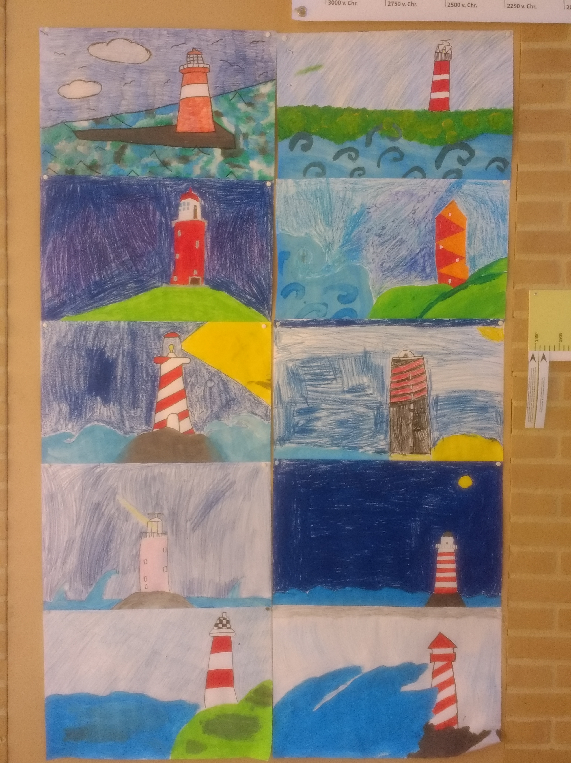

We visited the water treatment place. A father of one of our students works there. He has given us a guided tour of the company. He showed us what happens with the sewage.
It was a very interesting tour.

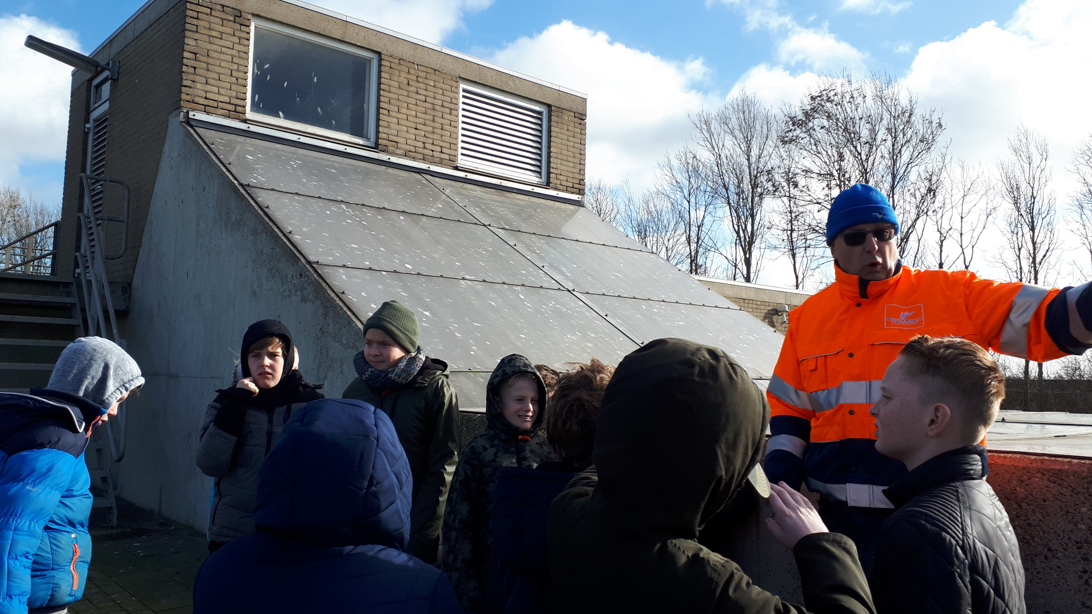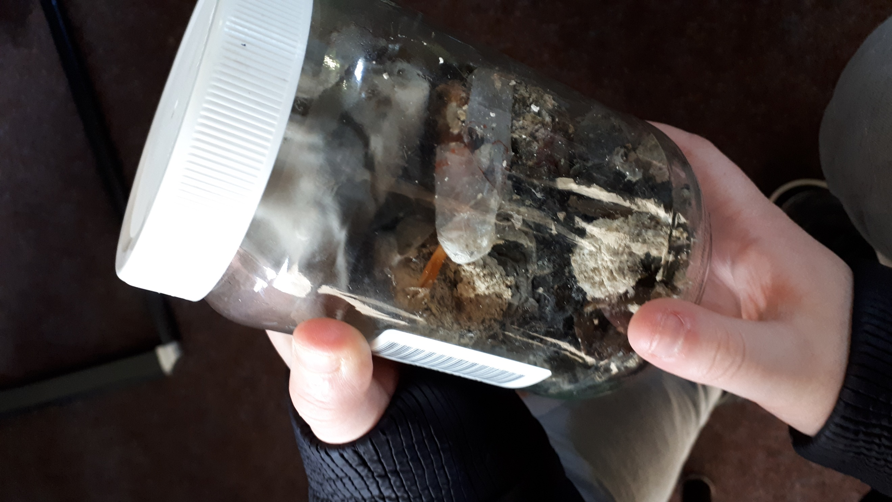

This is waste that people flush through the toilet. The people who are working there, find the most crazy things, like mobile phones, goldfishes, creditcards etc.

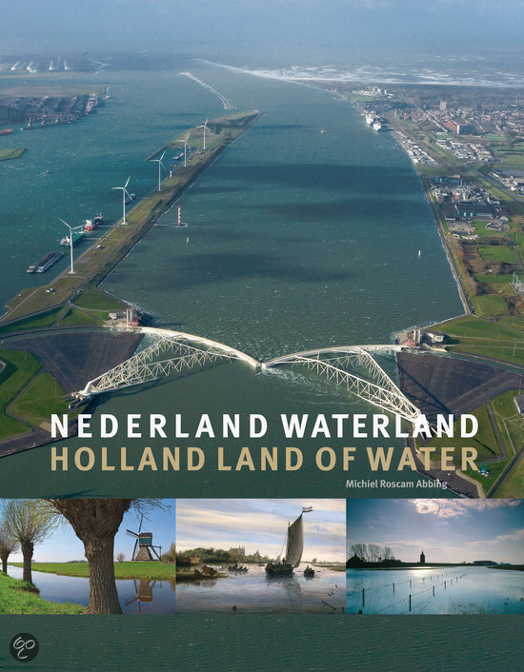

Many villages were build on mounds. This is a higher place. If there’s a lot of water, people could hide there.

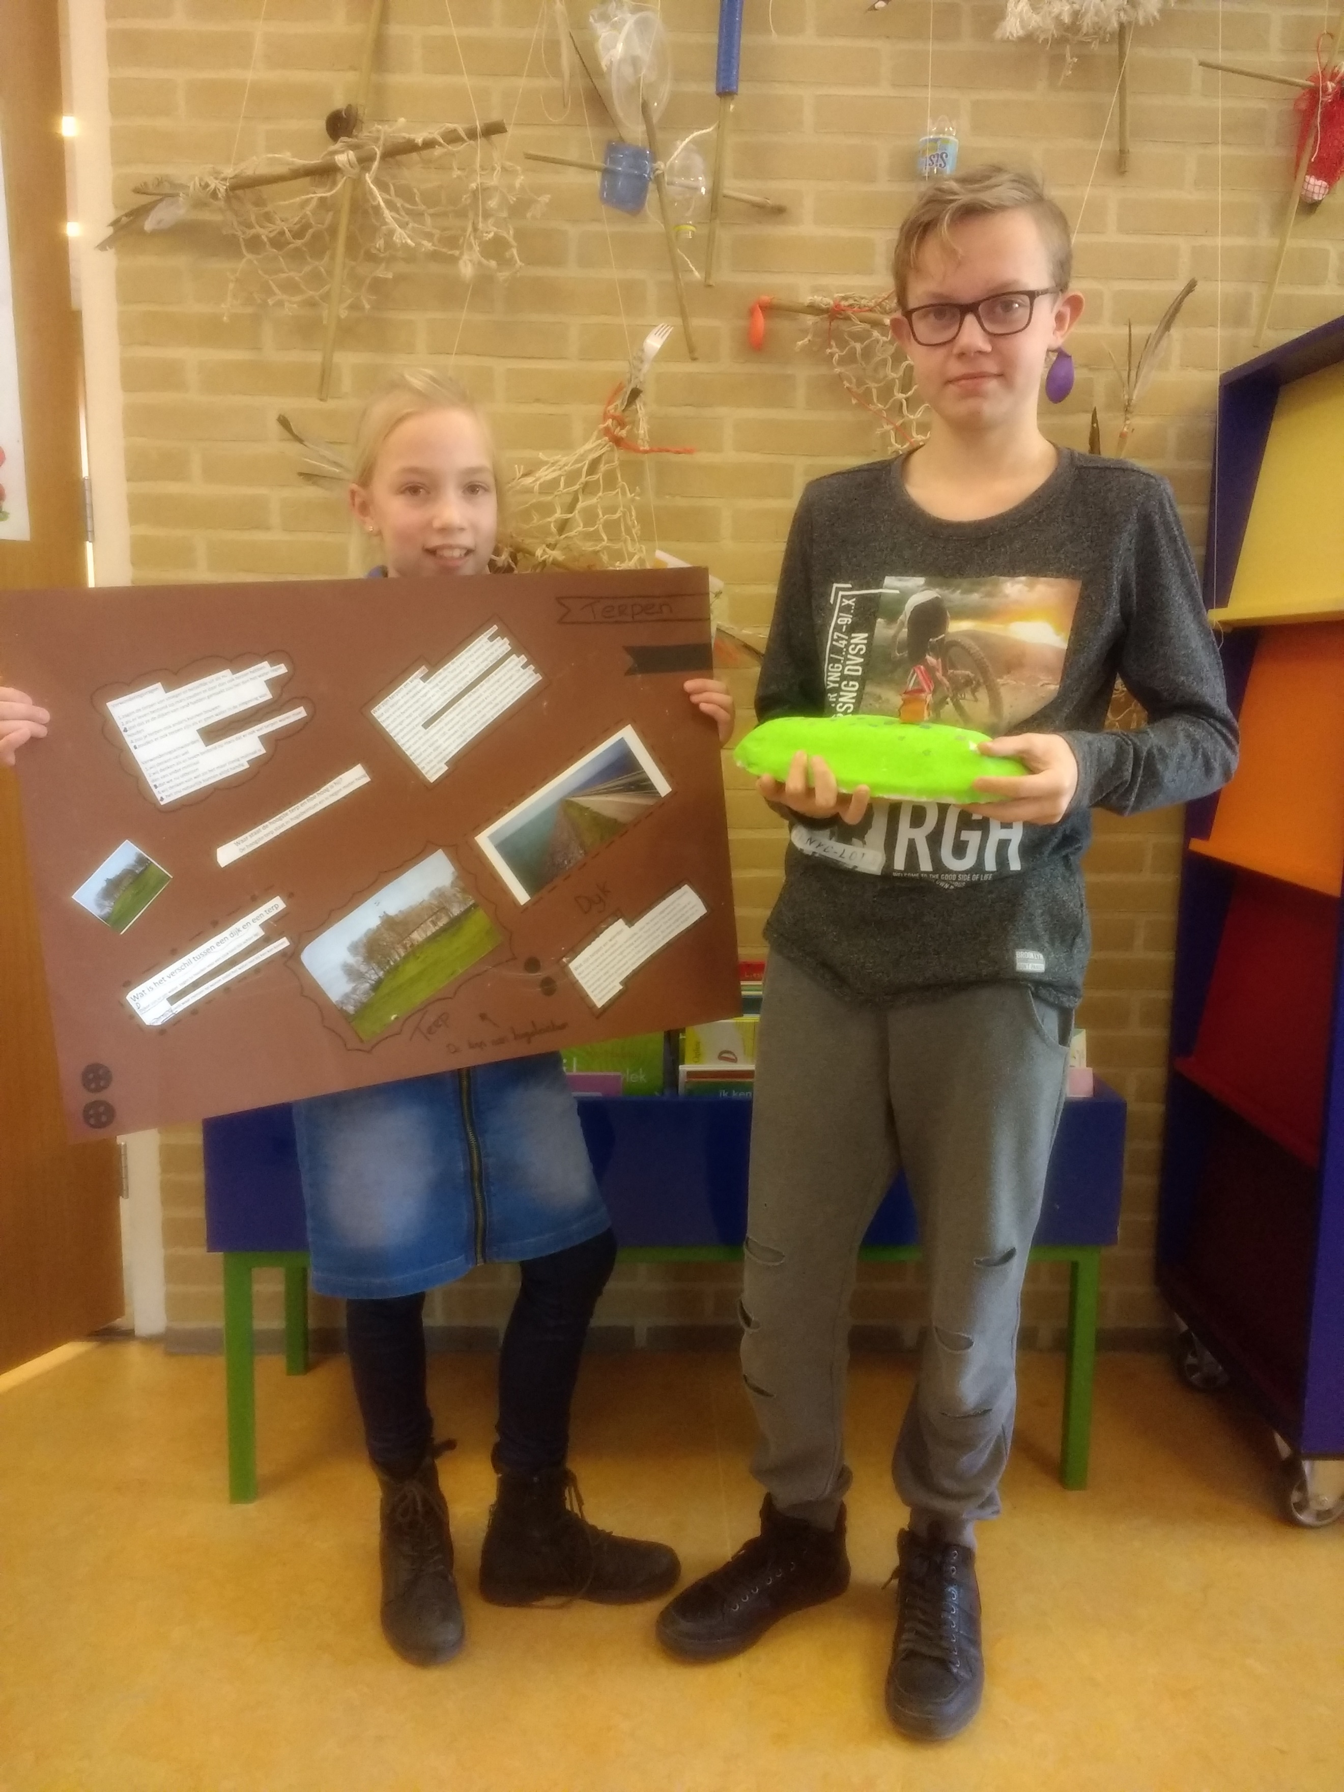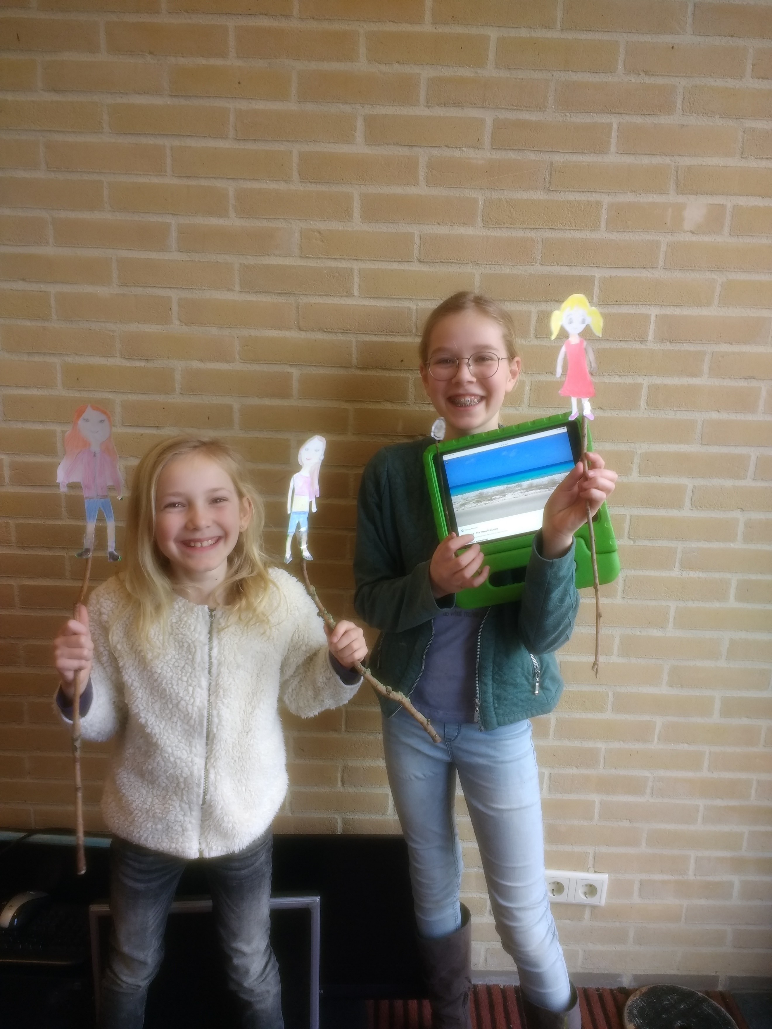

This girls made a puppet show about ebb and flow. They have processed all information in their presentation.

In 1953 in the Netherlands we had the biggest natural disaster of the 20th century, a flood. During this disaster dikes broke through and there died 1836 people and there are over 10.000 animals.
After this disaster we build many dikes to protect our country against the sea.

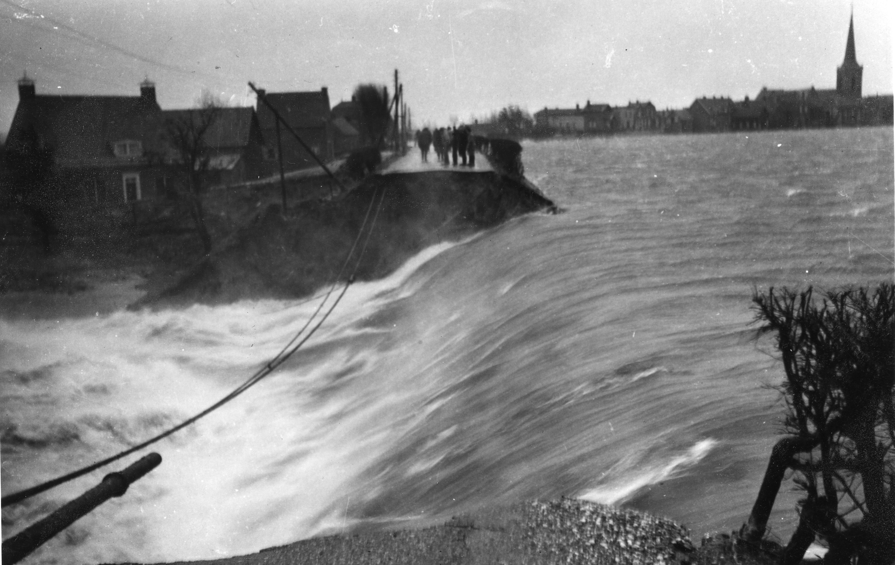
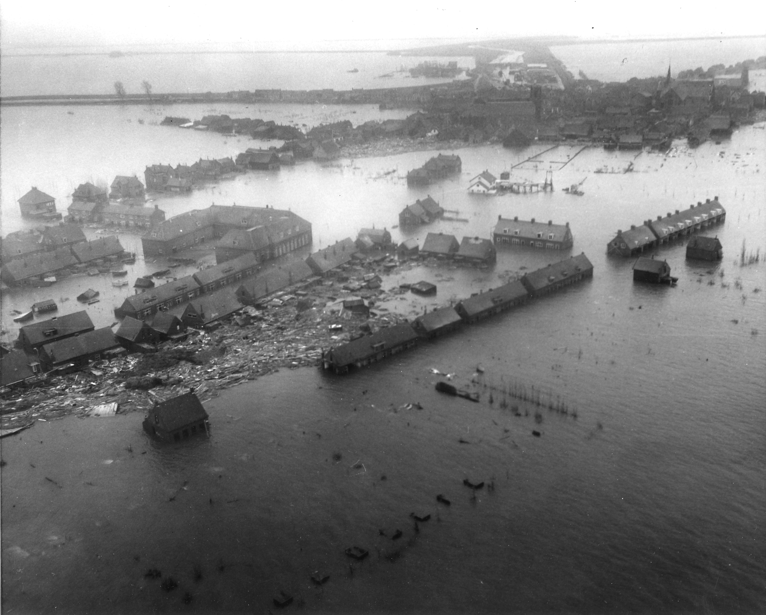
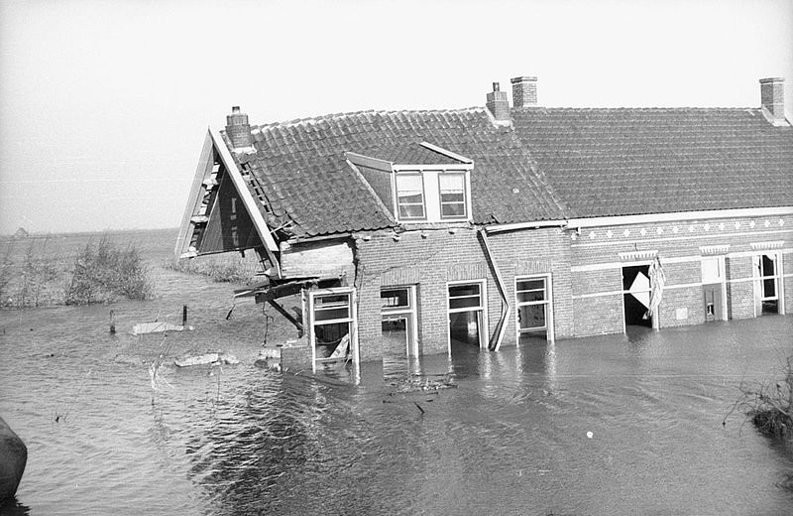

We build the ‘Deltawerken’.
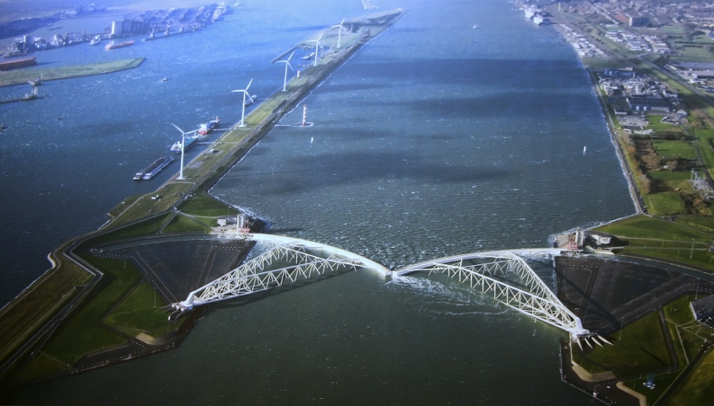
And good dikes to protect ourselves.
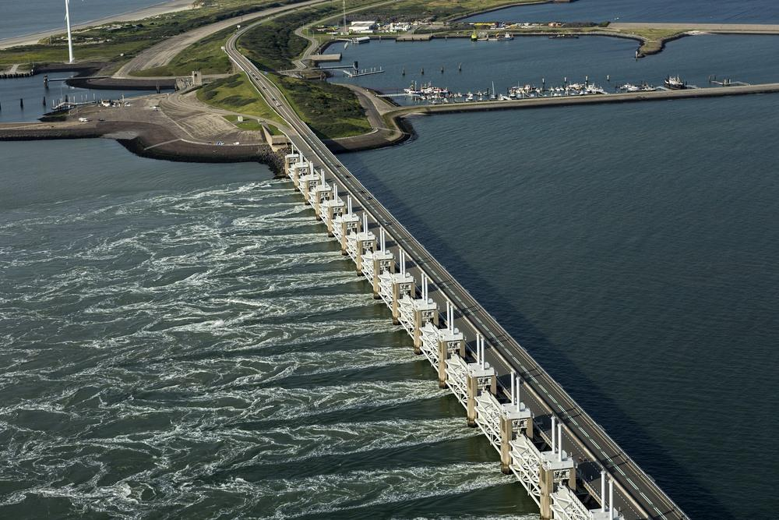

Children did their investigation about this subject. They’ve investigate what will happen with our country if there are no dikes. Then our country will look like this
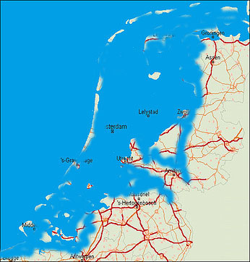

We want this never to happen!

