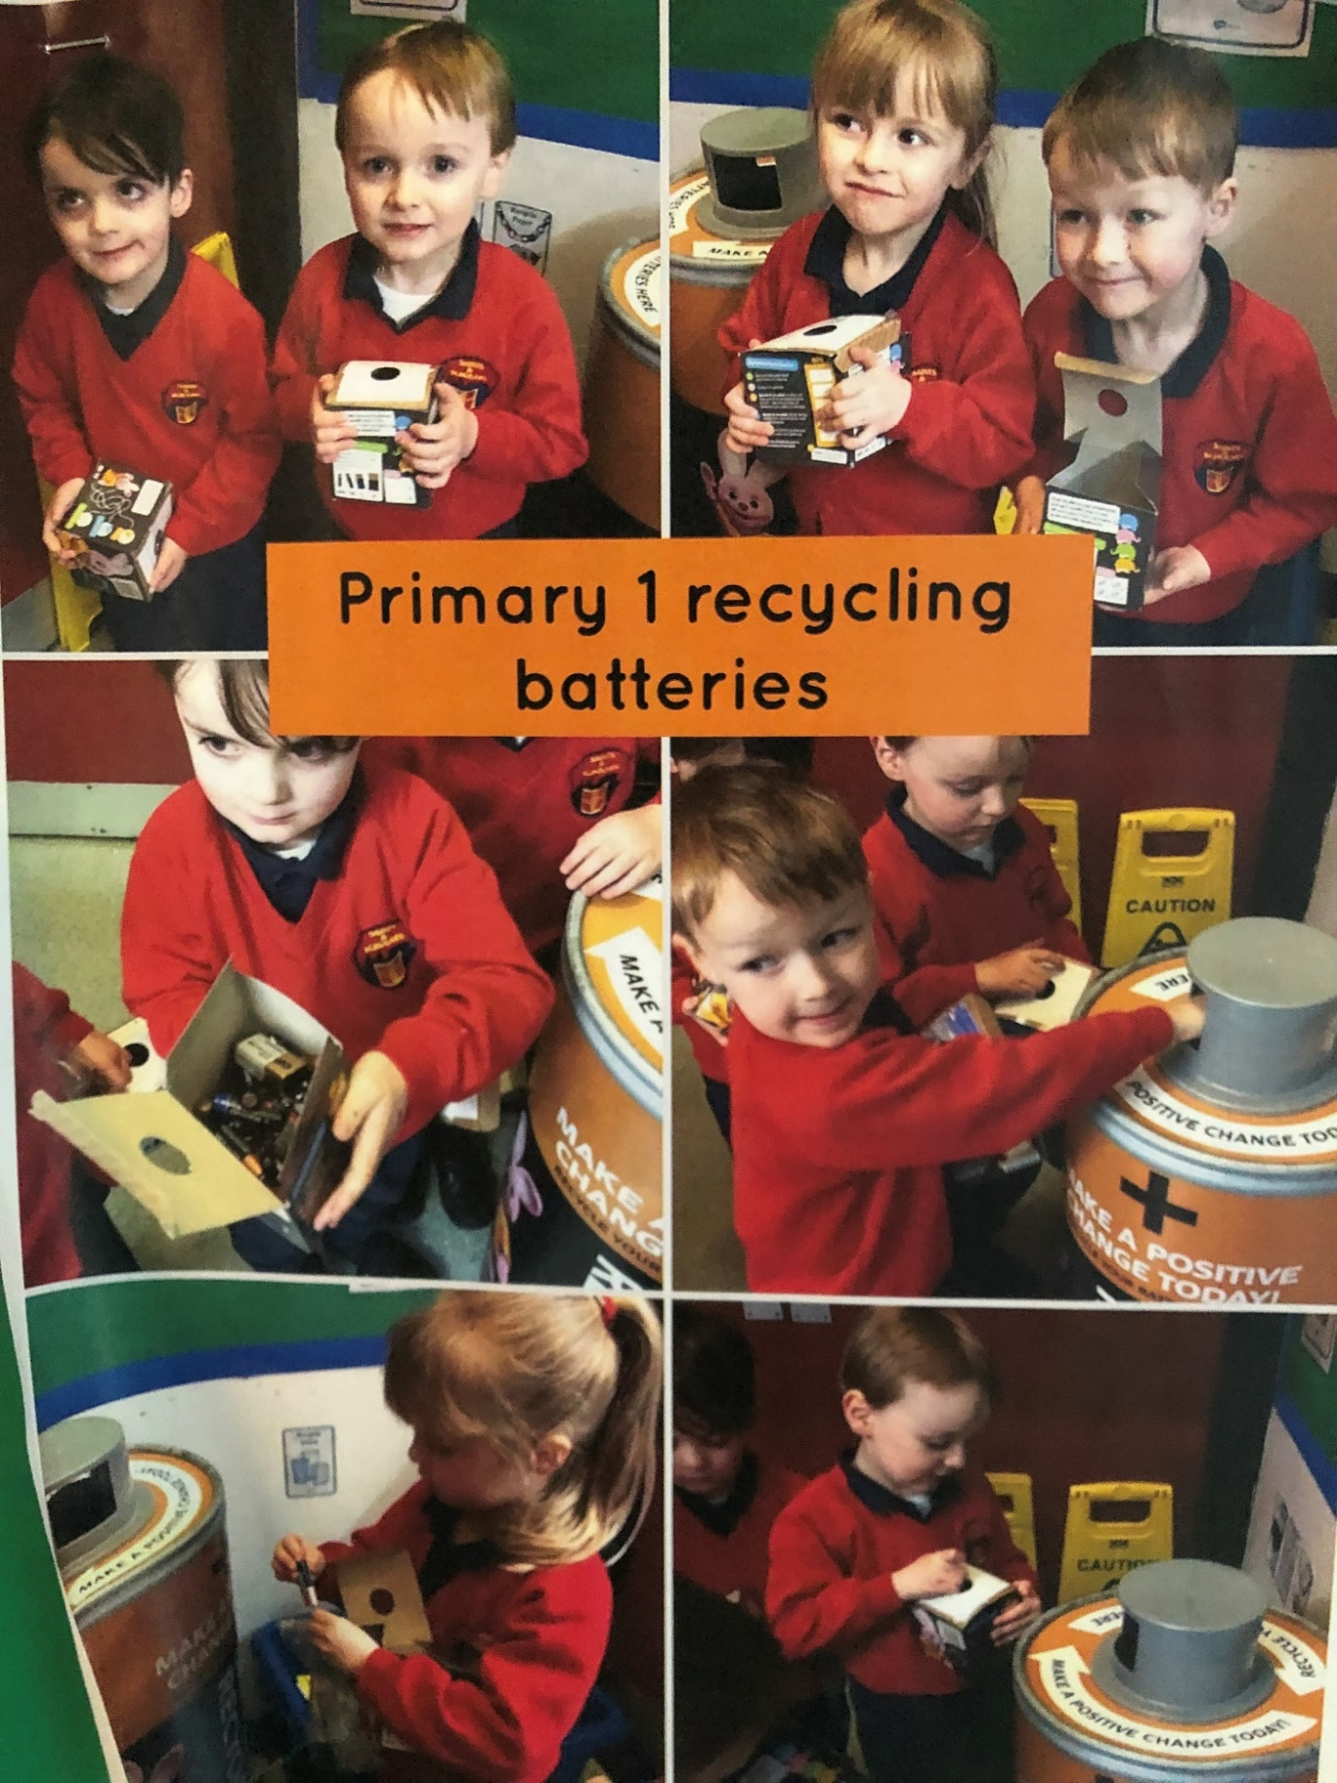Our youngest children set up a station to recycle batteries.