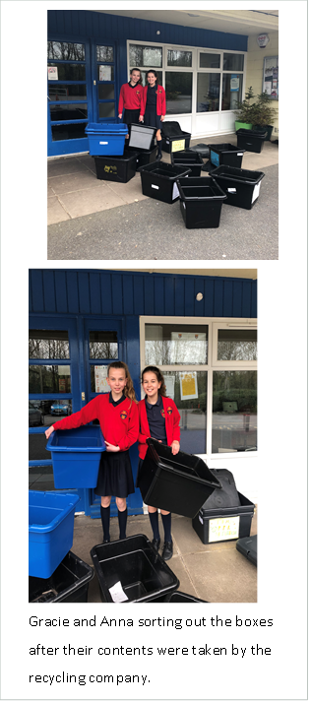

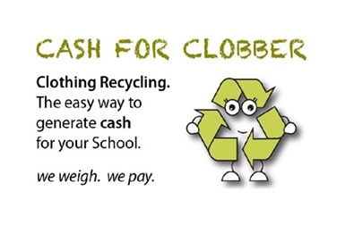**Cash For Clobber**

Cash for Clobber is from Cookstown Textile Recyclers is the easy way to generate funds for your school, club or organisation. It is also a great way to raise awareness of global recycling and demonstrate the benefits of a greener, cleaner future for us all, both here and in the developing world.   
When our parents participated in the Cash for Clobber programme, it encouraged children, parents and guardians to contribute their used or unwanted clothes, shoes (pairs only), handbags, hats, scarves, bed linen and curtains. Our school reevied a cheque after the collection.   
  
The scheme is free - there are no collection fees or any hidden fees. We also run separate competitions, with cash prizes in the thousands of pounds, for the schools and clubs which recycle the most clothes and textiles throughout the year. House now collect our kerbside boxes recycling every Tuesday morning. Over 170,000 households in Northern Ireland have a kerbside collection service every week.

# **EACH CLASS WAS GIVEN TWWO RECYCLING BOXES A BLACK AND A BLUE ON**

# **The chidlren in P7 made a recycing noticeboard**

# 

