# 

**Keeping Healthy Out of doors**

**We made healthy break as part of our Erasmus+ project**.

In Saints and Scholars, we encourage all of the children to improve their fitness levels. We have lots of initiatives to support this. The pupils love cross country- we have a running club and compete in lots of cross country event. We have pupils who get thought to the Northern Ireland finals .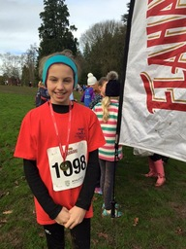

During our health and fitness week we had a competition for our pupils whereby pupils with the support of their parents had to design a healthy breakfast. Each class voted on their best design and then we made these in school. It was a great way to involve our whole school community in the Erasmus + project. 