# **Chidlren at saints and scholars are encoURaged to keep fit and heatlhy**

Special Olympics Visitor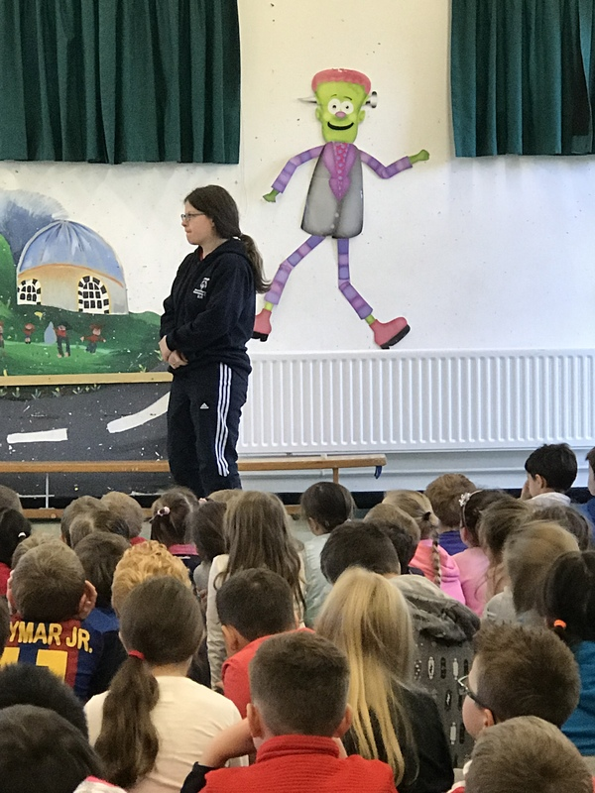

Our Health and Fitness day started with a Special Olympics Athlete. She explained what Special Olympics are and what as an athlete how she needs to train to ensure she can compete at this level. She told the children that she needs hard work and dedication to succeed.

saints and scholars integrated primary school and nursery unit

Keeping Healthy at Saints and scholars ips

Scholars IPS Armagh

In our school we try to do lots of things to keep our children healthy.

As part of our Erasmus+ project we spent some sharing how we keep healthy.

All the school had a healthy day. We had our Health and Fitness day on 27th October 2017, just before our Hallowe’en holidays. We were all allowed to wear sports clothes that day.



