# **Children at saints and scholars are encouraged to keep safe**

saints and scholars integrated primary school and nursery unit

Keeping Safe at Saints and scholars ips

Scholars IPS Armagh

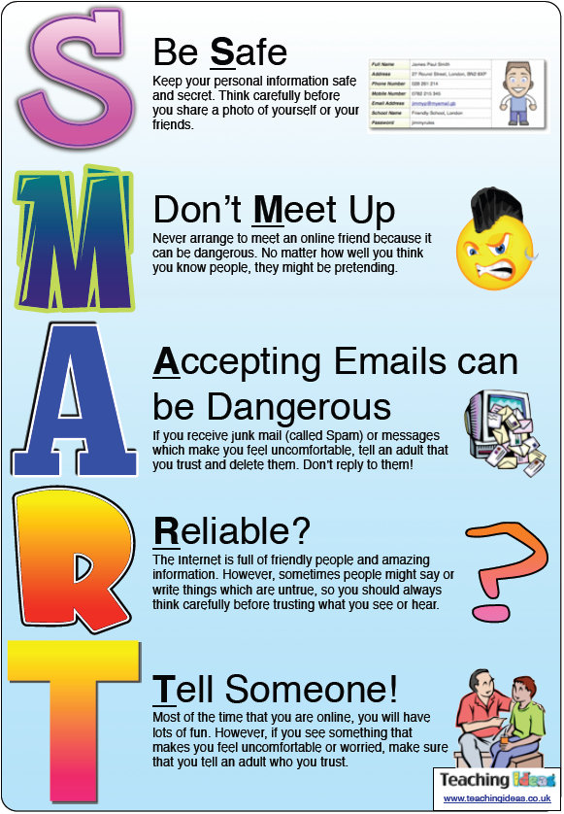

Amazing Fact

When 400 scientists engineers and academics were asked what was the greatest invention ever there were three popular answers – the wheel, the printer and the World Wide Web(Internet) . The overall winner was the World Wide Web.

We have to make sure we are safe and sensible when we are online

**We looked at our digital footprint**

**We made internet safety posters**

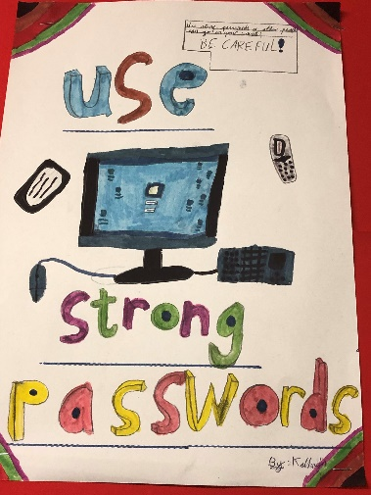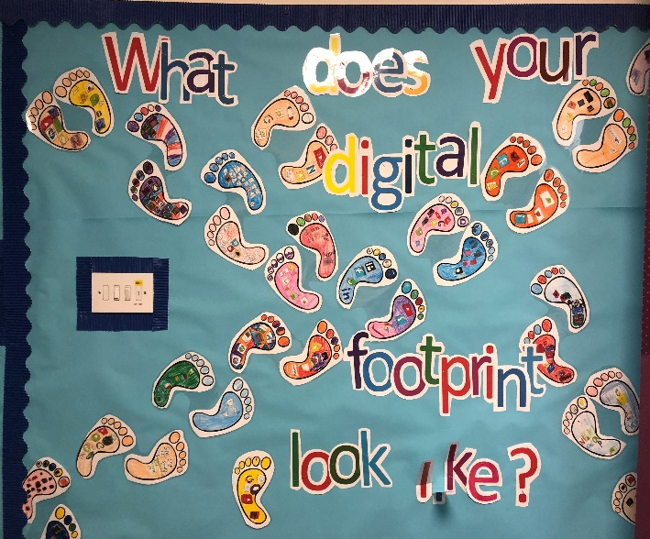

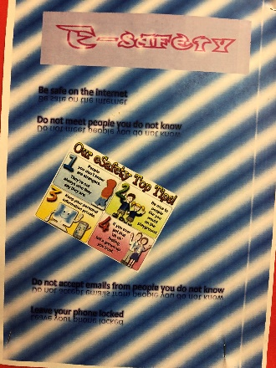

**SAFER INTERNET DAY**

This year's Safer Internet Day celebration took place on **Tuesday, 5 February 2019**. The campaign's slogan, "**Together for a better internet.**” We participated in this event and hoped to play our part in creating a better internet for everyone, and especially for younger users.

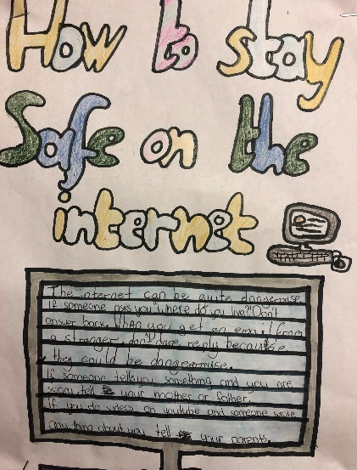

Staying Safe Online

7)      Remember that not everyone online is who they say they are

8)      Think carefully about what you say before you post something online

9) Respect other people’s views, even if you don’t agree with someone say before you post something online say before you post something online

9)      Respect other people’s views, even if you don’t agree with someone else’s views doesn’t mean you need to be rude

10)   If you see something online that makes you feel uncomfortable, unsafe worried: leave the website, turn off your computer if you want to and tell a trusted adult immediately.

1)      Don’t post any personal information online – like your address, email address or mobile number.

2)      Think carefully before posting pictures or videos of yourself.  Once you’ve put a picture of yourself online most people can see it and may be able to download it, it’s not just yours anymore

3)      Keep your privacy settings as high as possible

4)      Never give rut your passwords

5)      Don’t befriend people you don’t know

6)      Don’t meet up with people you’ve met online.  Speak to your parent or cared about people suggesting you do