Μείνε υγιής
3^{ο} Δημοτικό Σχολείο Αγίων Αναργύρων

Healthy habits for healthy kids and healthy adults
Having healthy habits at a young age is a wonderful way to help children learn the benefits of these habits and continue wanting to practice a healthier lifestyle as they grow and mature. It is very important that both family and school cooperate to build a healthy way of living for the children.

6.Don’t forget cleanliness and safety
Keep the rules of good hygiene
Brush your teeth twice a day
Wash your hands properly
Take a bath regularly
Use a tissue when sneeze
Keep the road safety rules
Always wear a seat belt or a helmet
Be safe!
t
Love yourself!

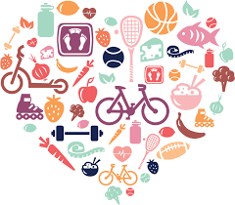

Mathilde & Emily, 6th graders

Healthy …….Riddles
by Dimitris & Yiannis,10 yrs 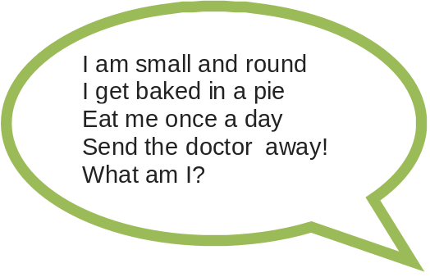
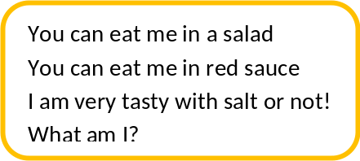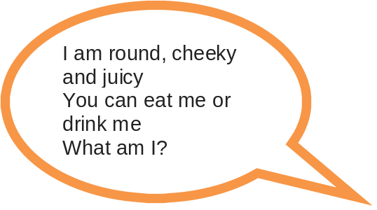

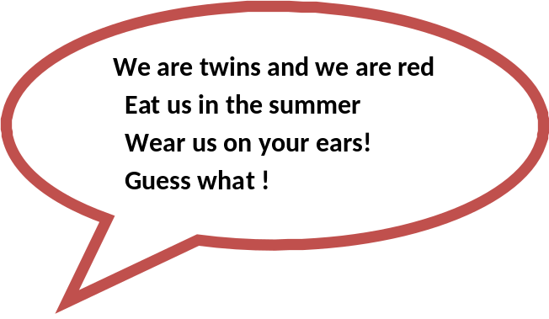

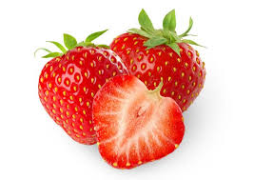
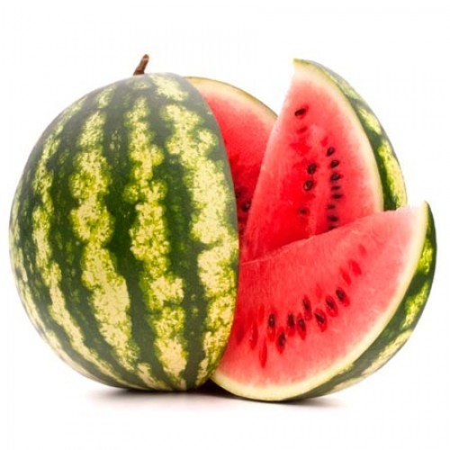
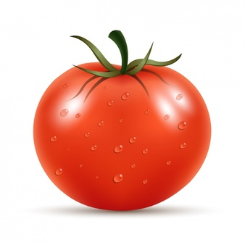
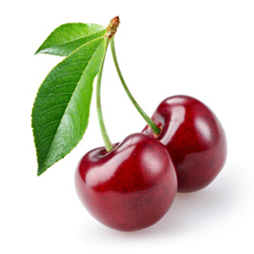
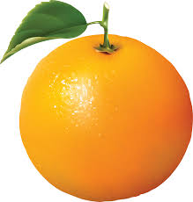
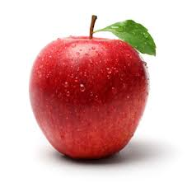

Healthy tips
by Mathilde & Emily

Dear fellow students
Have you ever wondered how you can be healthy and safe? We thought about it a lot, we made a research and we came up with the following tips.

1.Eat the rainbow every day:
Colourful fruit and veggies, dairy, protein
and grains will make your day!
Snack on healthy foods and eat less junk food
and sweets.
Drink water and fresh juice, not soft drinks

2.Don’t skip breakfast
Going to school without breakfast can make you
hungry and grumpy later on

3.Put physical activity in your life
Get out, play games, do sports
But… don’t overdo it with extra curricular
activities
Keep time for yourself! Relax!
Get a 10’ “brain break” before starting your
homework
Sleep enough

4. Put the electronics away!
Limit screen time, watching T.V. surfing the
net, playing computer games
Read books instead! Or Write your own book!

5.“Dad, Mum show me your love!”
Spend more useful time with your family
Play board games, ride your bikes or go for a walk
together. Make a nice healthy meal or go shopping
together with your family.
“Hmm.. shopping! Lovely idea!”

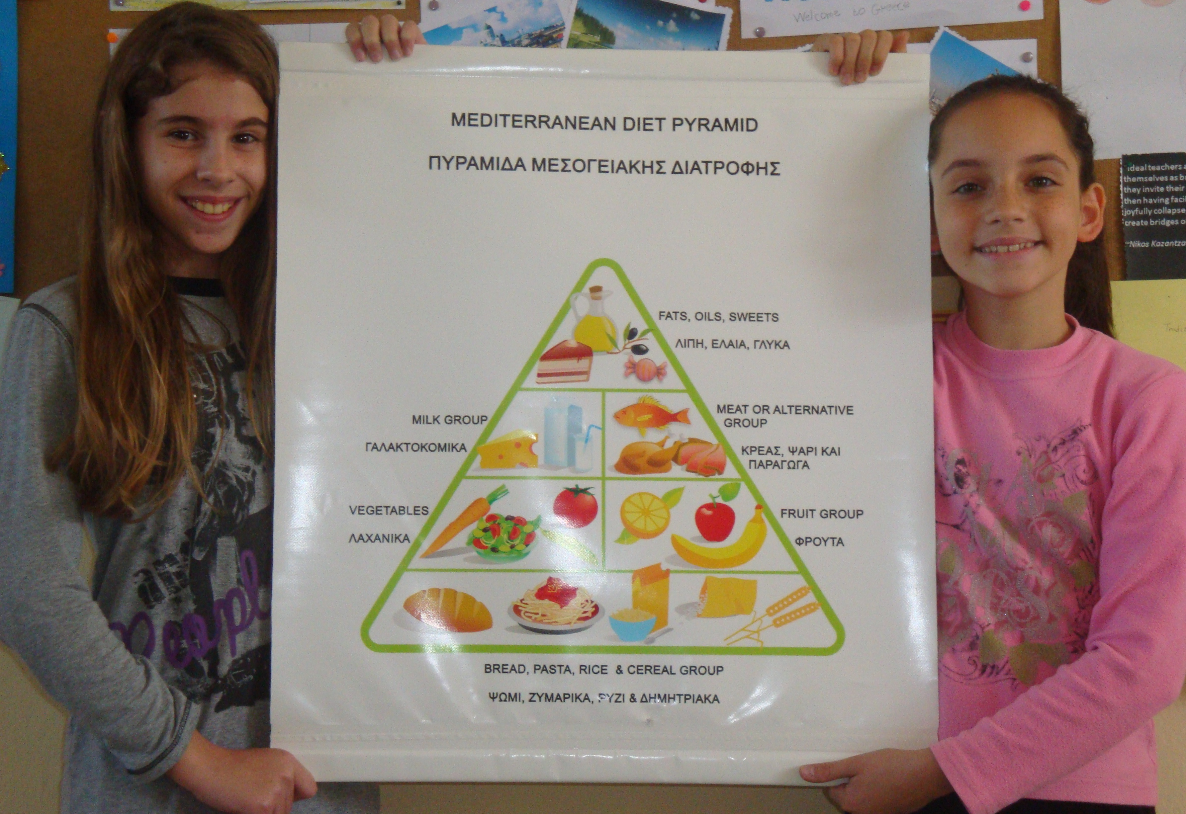

Our Greek salad was unique!

One day my friends and I had the idea to make
the famous Greek salad for you.
Have you watched our video?
We used fresh, organic tomatoes and
cucumbers, onions and green peppers, olive oil
and capers, feta cheese and crispies on top. We
sprinkled it with olive oil and here it is!

Example of image text

https://www.youtube.com/watch?v=xWvUlWN24SA&list=PLLGGxBEi1F7iy6wjVmr8WdaIB4e2aCnUl&index=4

But today we have prepared another salad for you with pomegranate which is very healthy as well.
Read the recipe and just make it. Please!
It is going to be your favourite!

by Melina, Joanna, Helen, Bleona (10yrs)

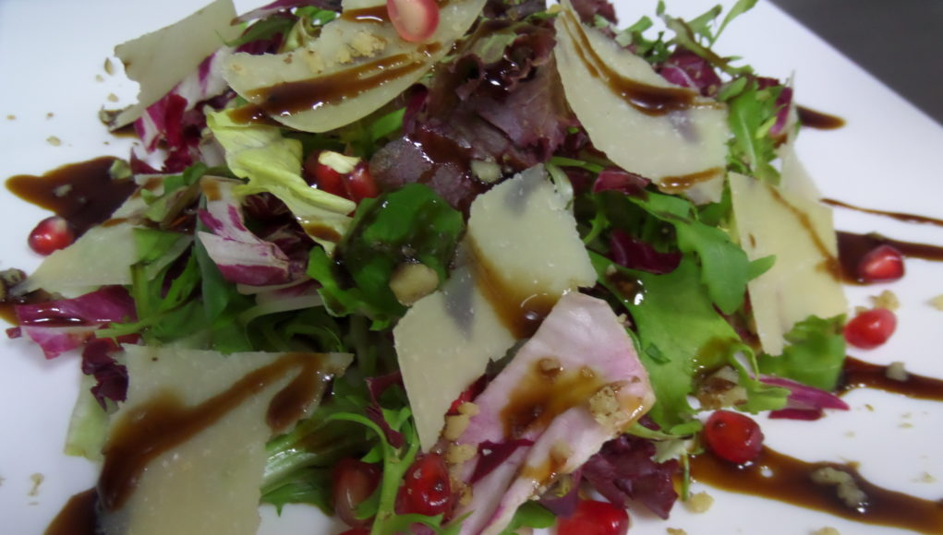

By Melina, Bleona, Eleni & Joanna
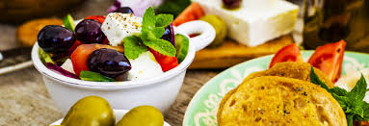
Greek cuisine & traditions

Traditional Greek food combines fresh ingredients from land and sea to create a highly appetizing and healthy cuisine. It follows the principles of the Mediterranean diet with olive oil being the main ingredient of this diet.

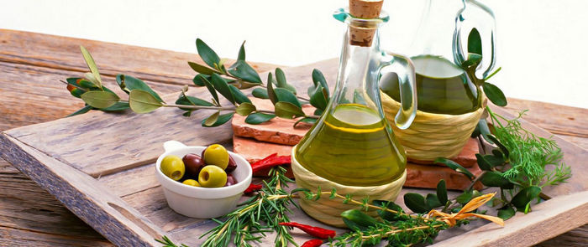

We feel very lucky because we had the joy to live the experience of olive harvesting in our schoolyard.
We picked up the olives, we took them to the oil press and finally we took the valuable olive oil, our own olive oil. It will help us live longer!
We made healthy biscuits and our favourite Greek salad with it. Look!

Despina & Sophia, 4th graders

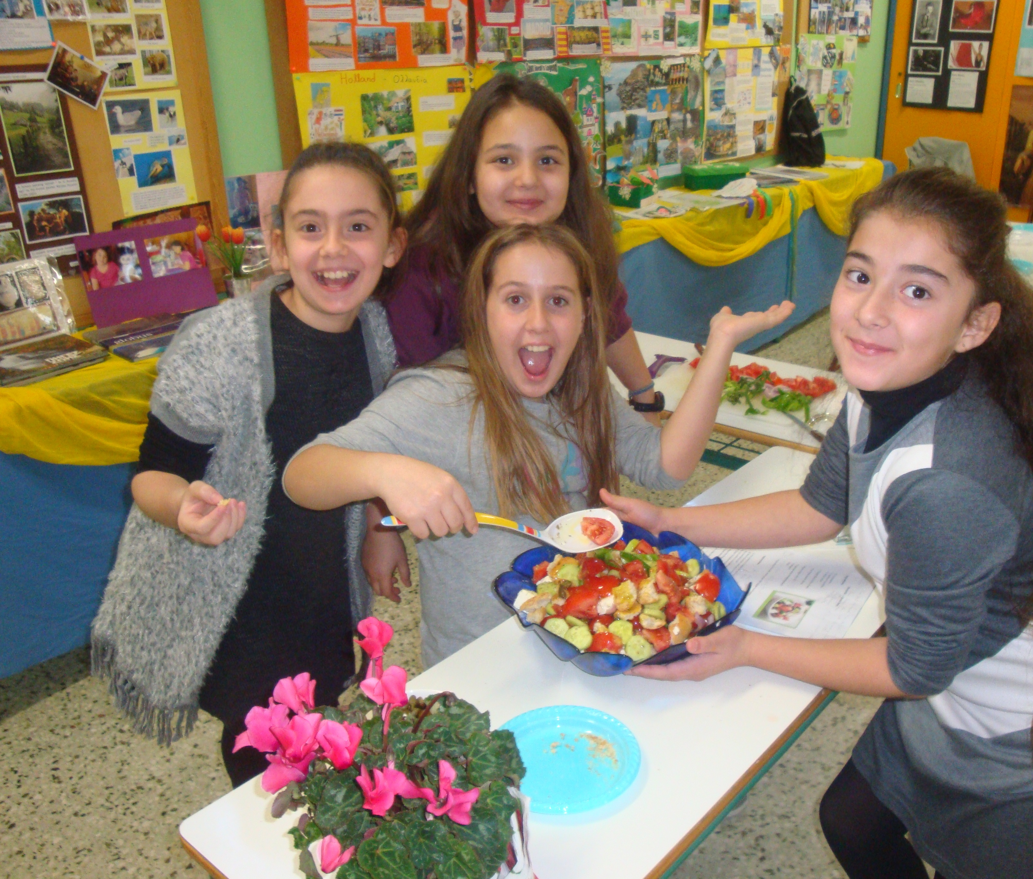

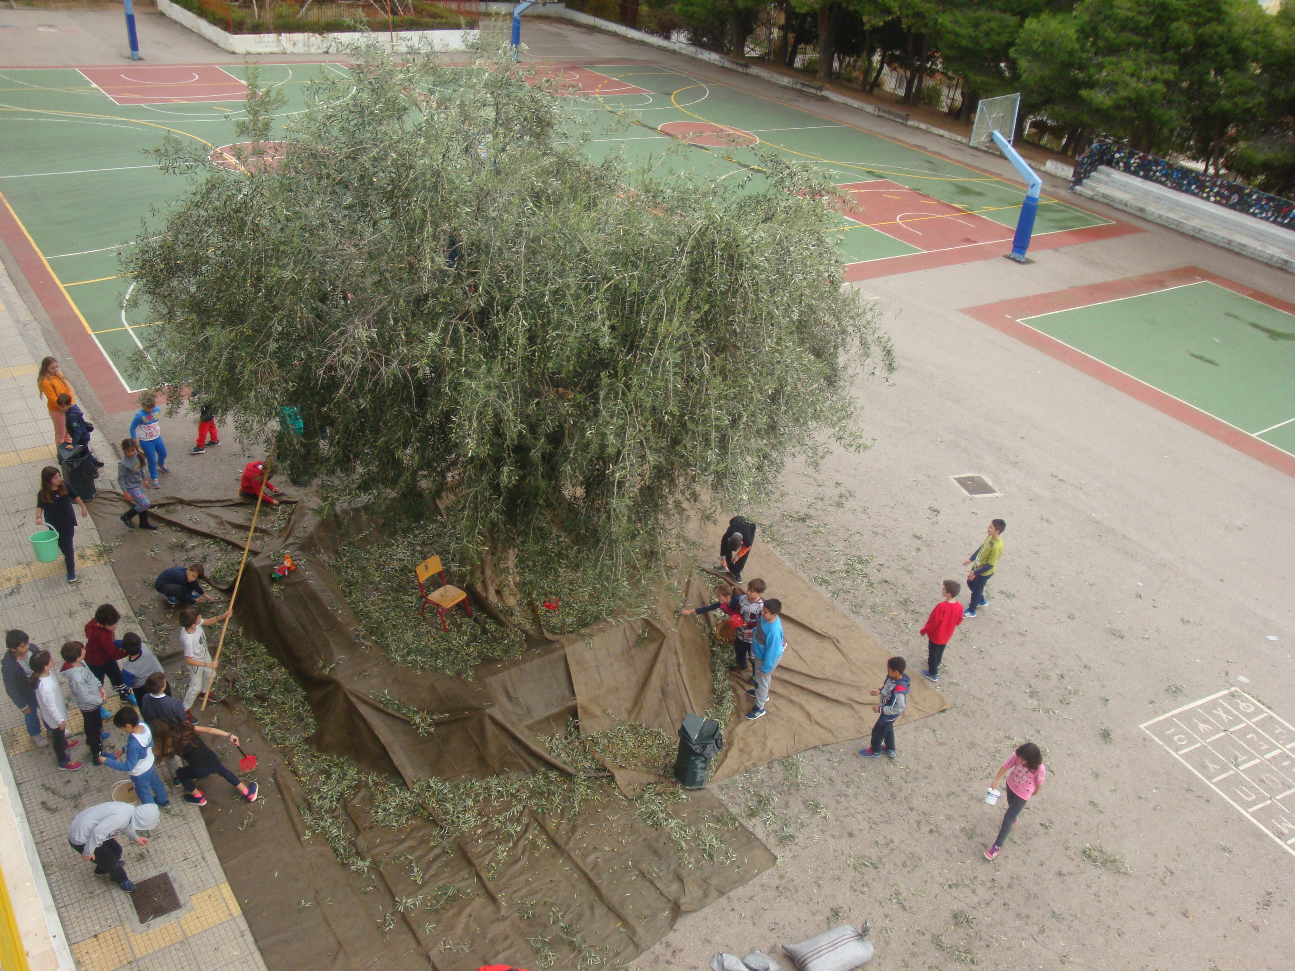
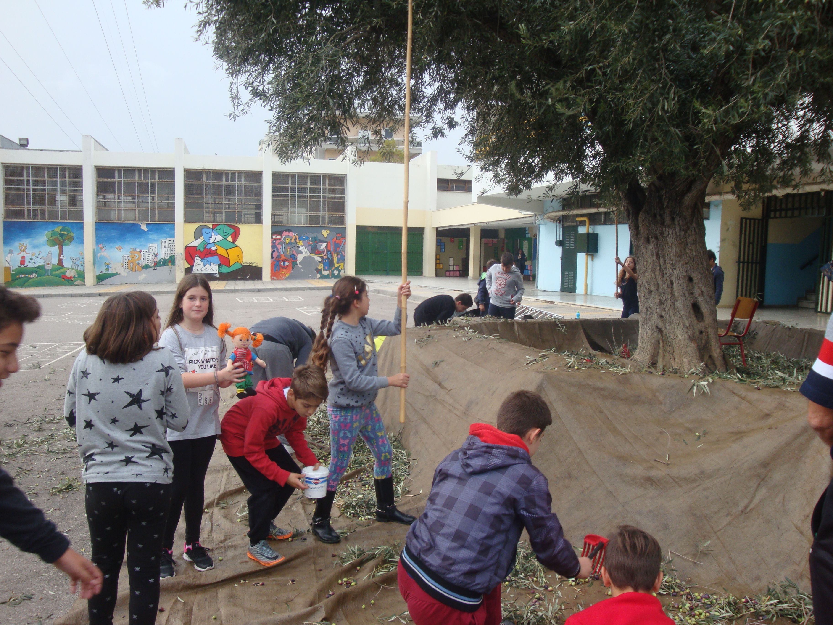

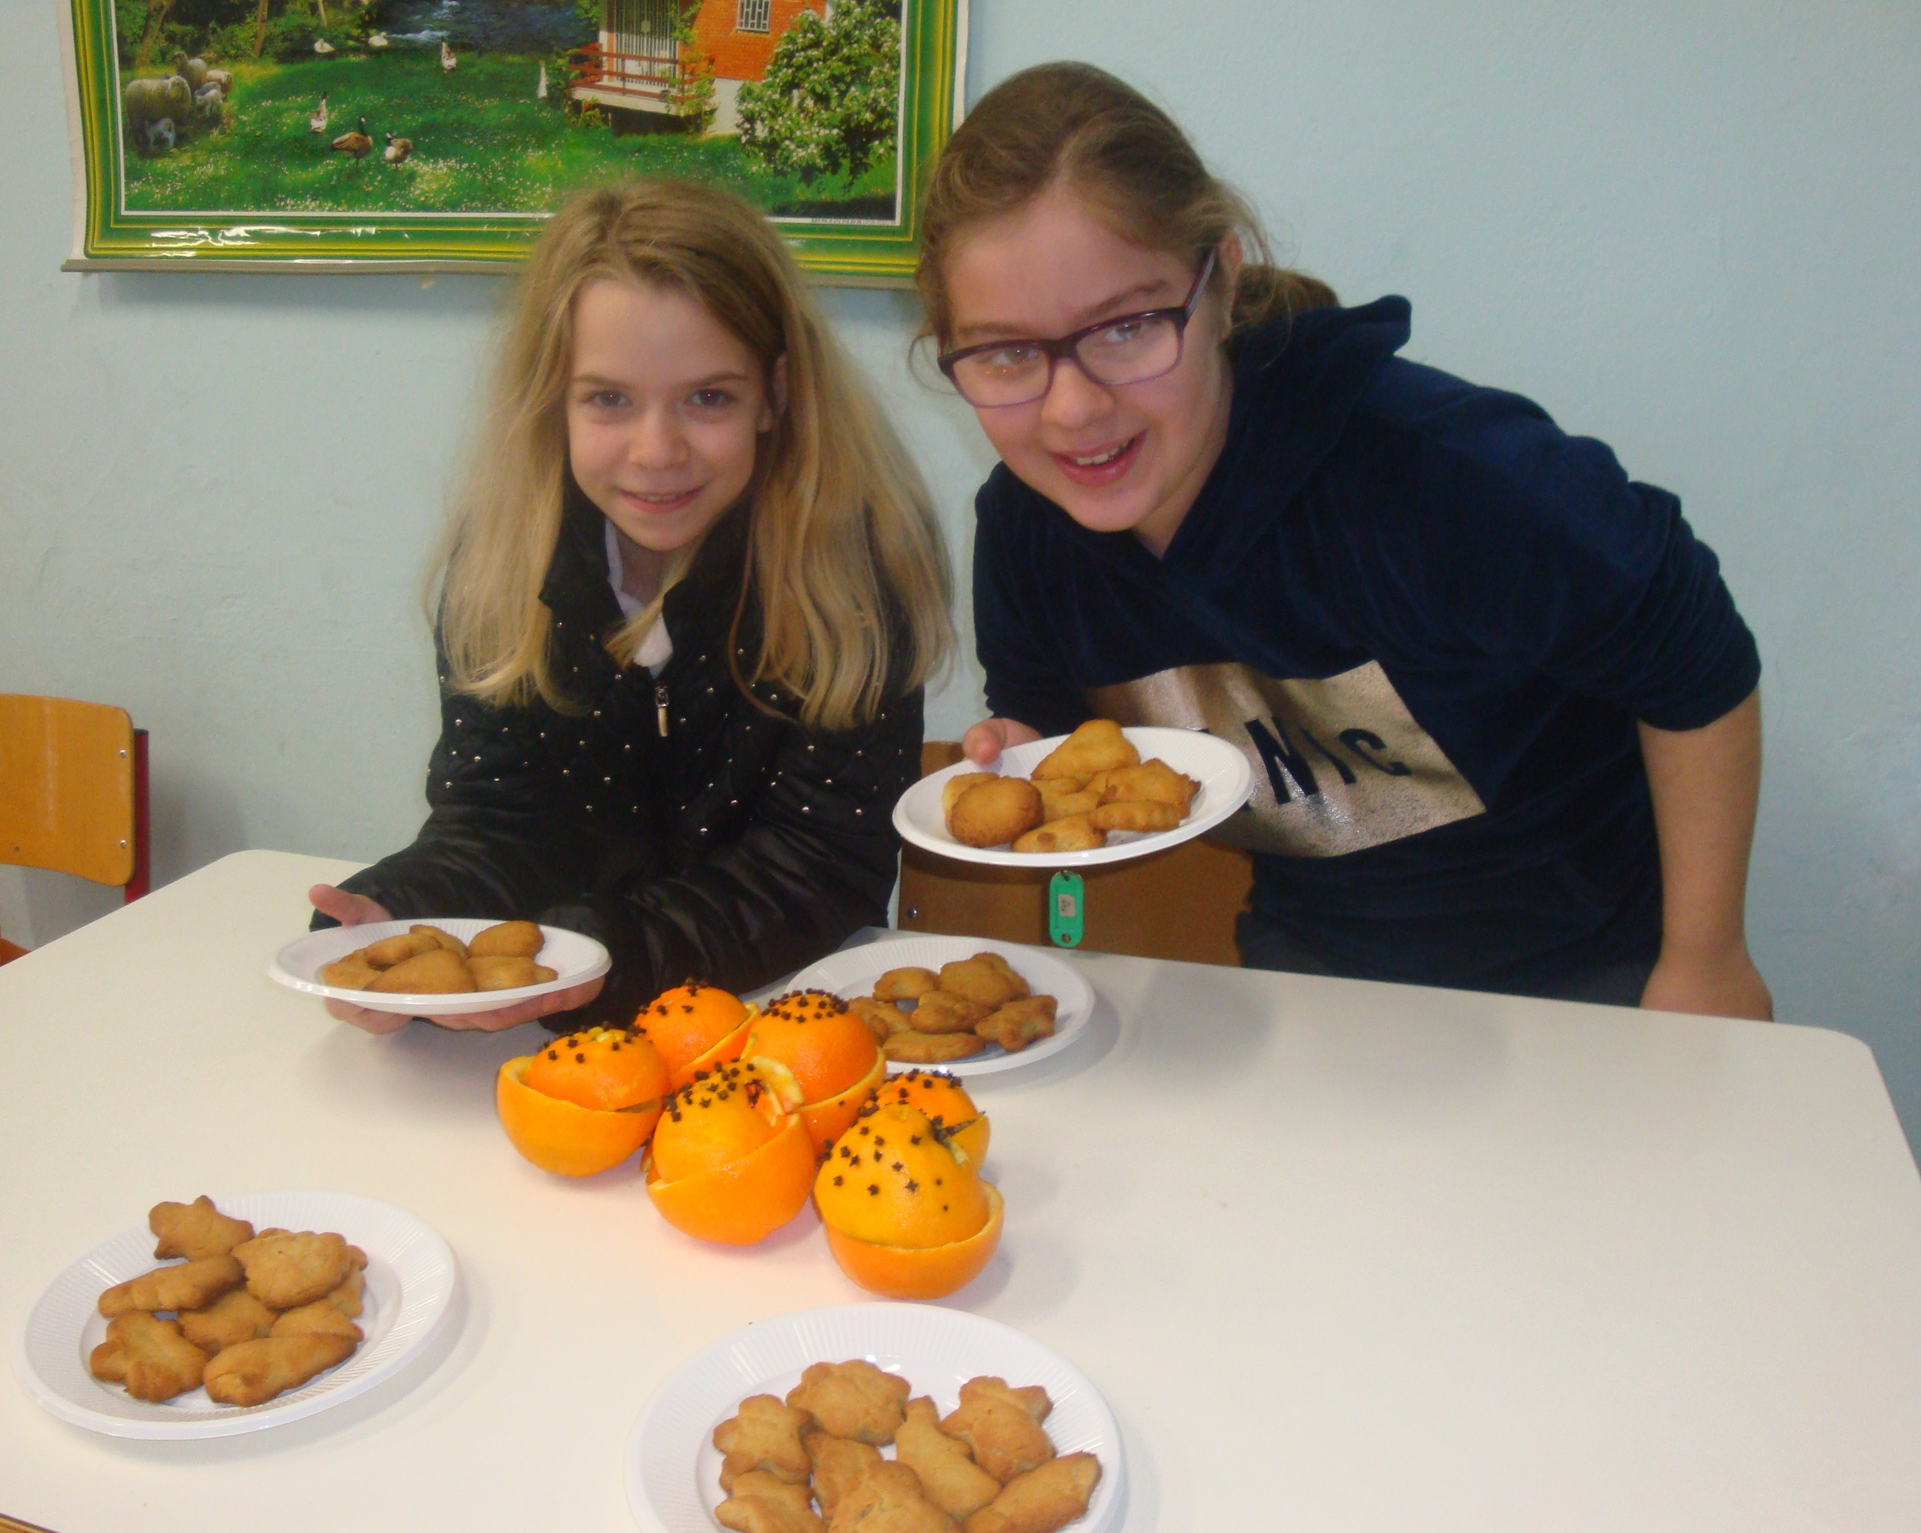

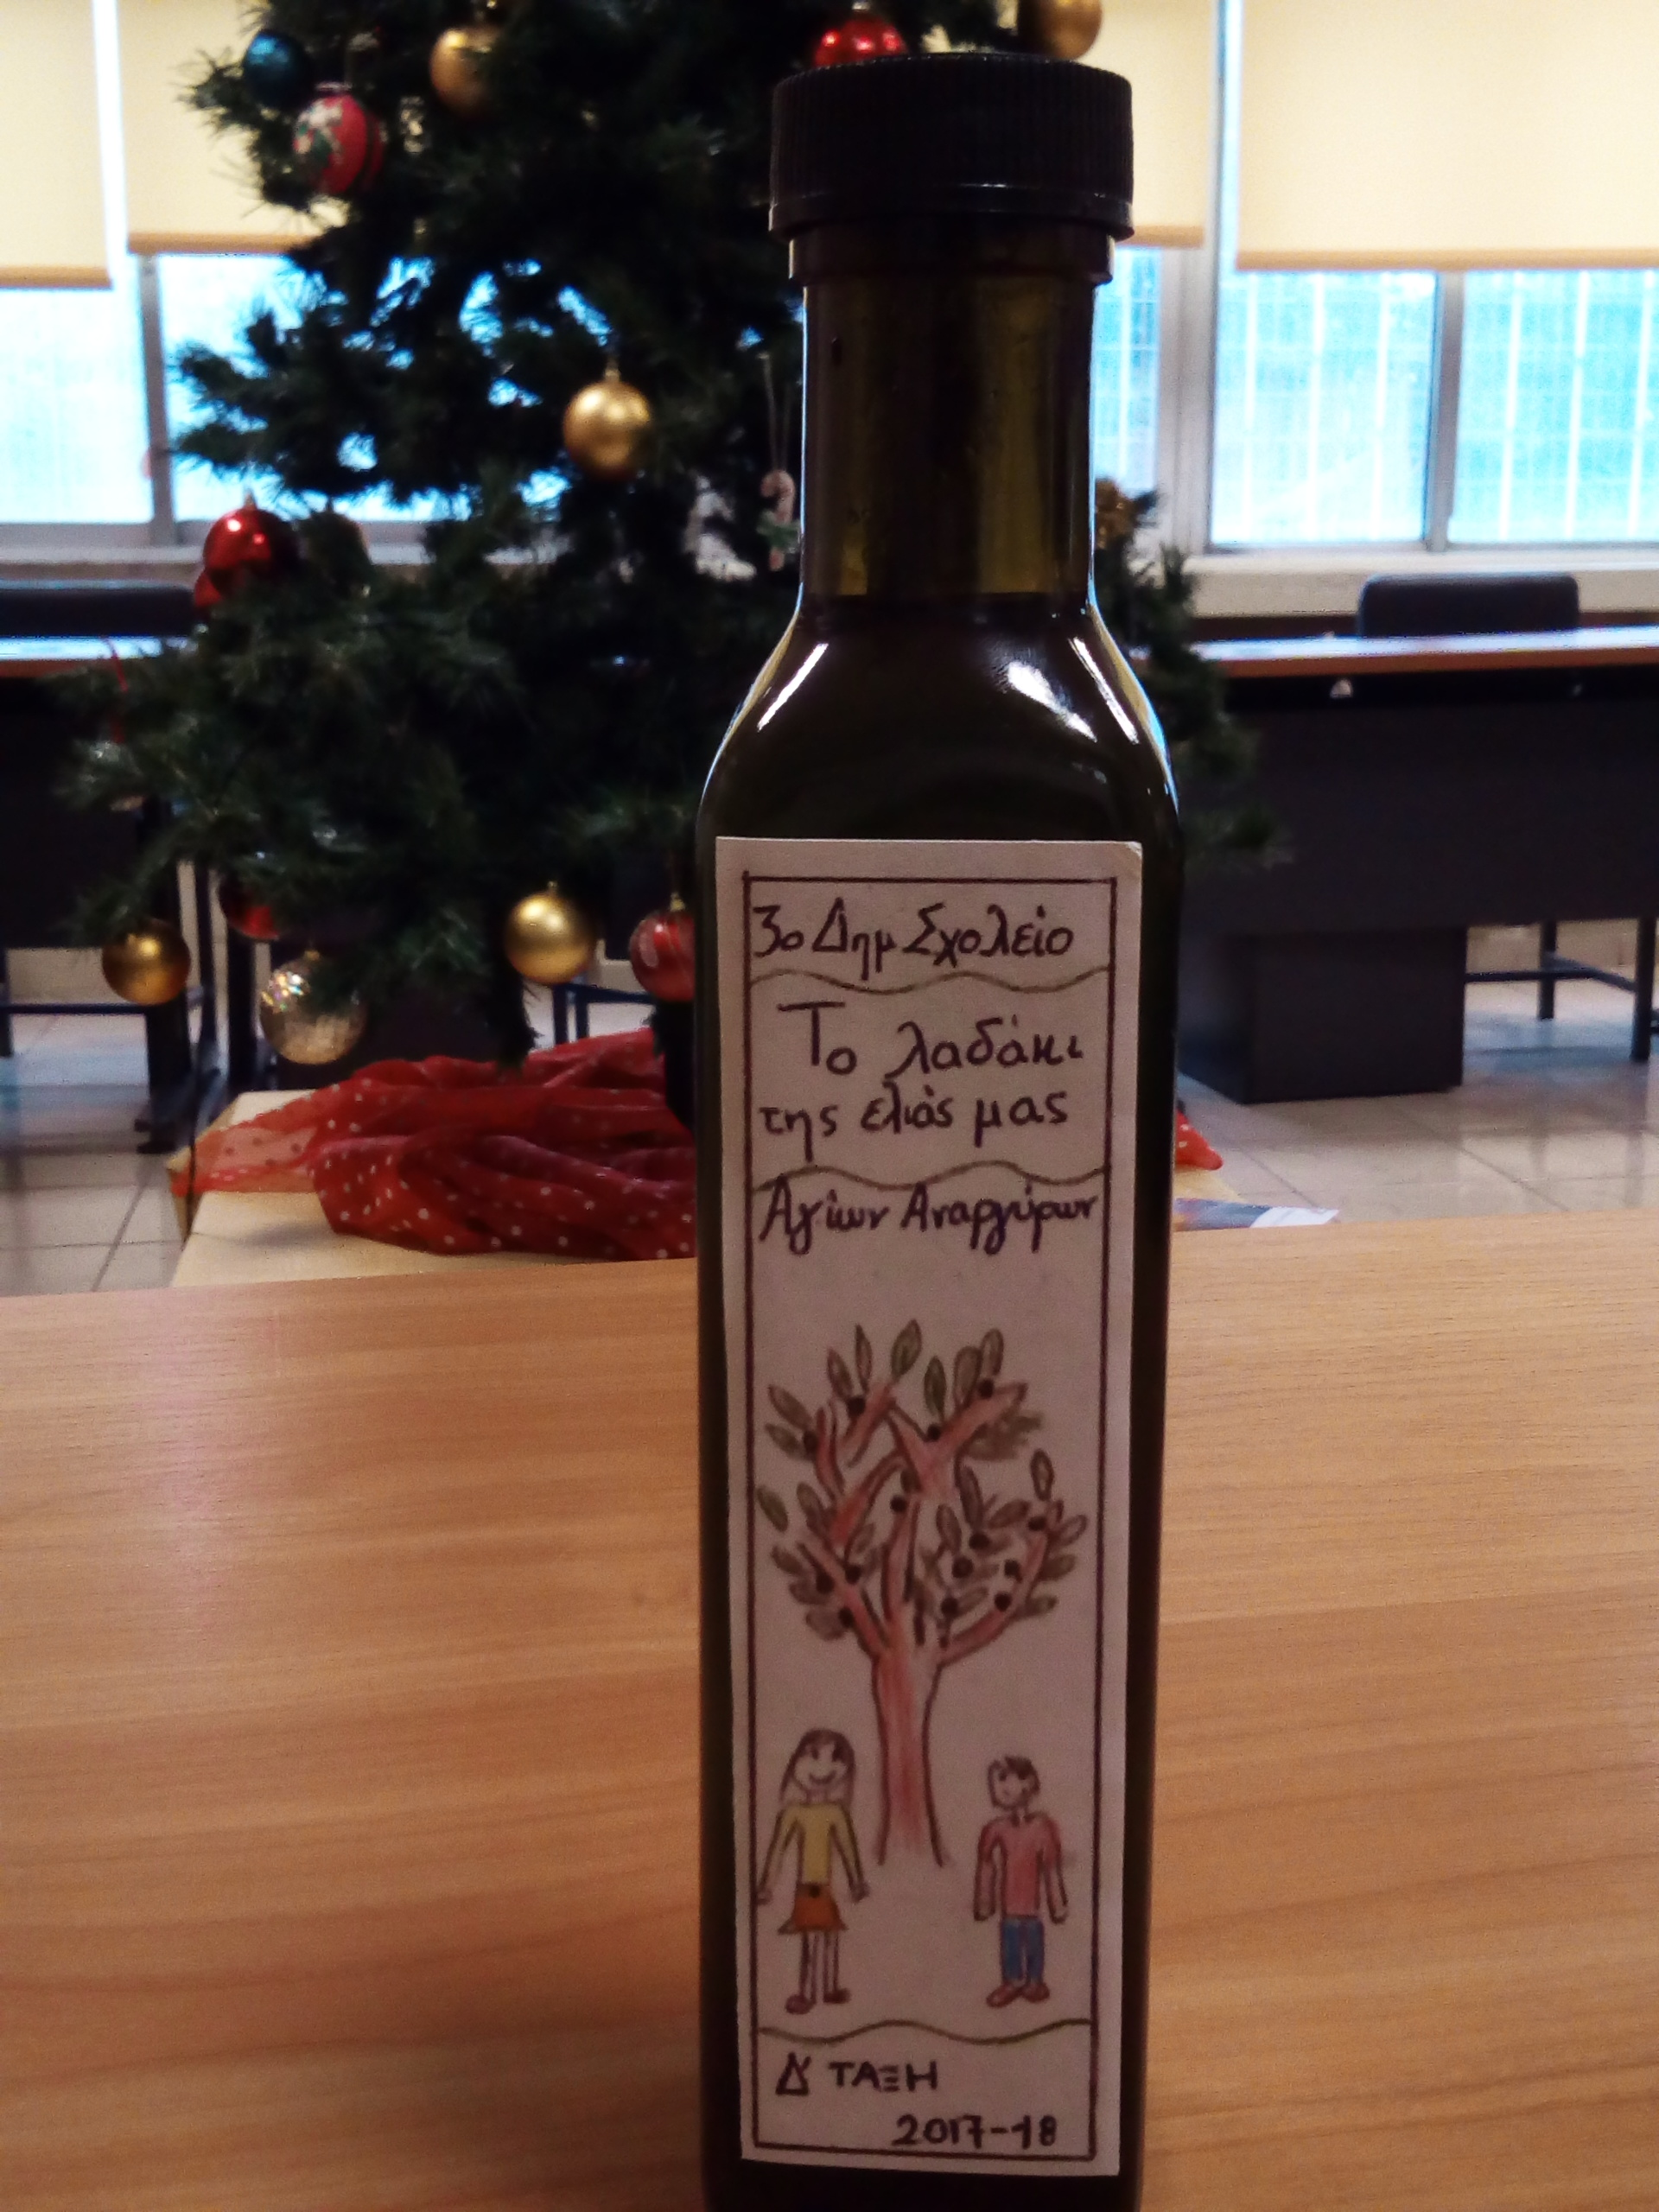

Tasty salad with pomegranate

Mixed green salad leaves(lettuce, spinach etc)
1 pomegranate, seeds and juice
1 pear in slices
100 grams of grated hard cheese
Pepper

Dressing

4 tablespoons of pomegranate juice
1 >> of lemon juice
1 >> of olive oil
1 >> balsamic vinegar
½ a teaspoon of honey

Olive oil biscuits Recipe

1 & ½ a cup of olive oil
½ a cup f sugar
6 cups of flour
1 glass of orange juice
1 teaspoon of orange zest
1 tsp of cinnamon
½ a tsp cloves in powder
1 tsp of baking powder
Mix all the ingredients together
Give your biscuits your favourite shape
Bake them in the oven for 20 minutes at 180 C.
Enjoy your biscuits!

Despina & Sophia

A Flashback in the past

For ancient Greeks, food and eating was not only necessary to satisfy physical needs but it was also a social event.
Plutarch, a Greek historian had said, “We do not sit at the table to eat… but to eat together”.

Today, eating in modern Greece is indeed a very social event. It is the norm for people to relax and have great discussions and arguments ranging from politics to relationships while eating dinner or lunch.

The cornerstones of the ancient Greek Diet: bread, wine, olive oil, fruit, vegetables, nuts, fish.

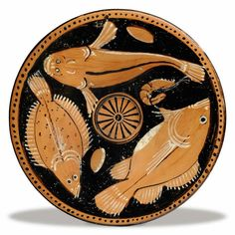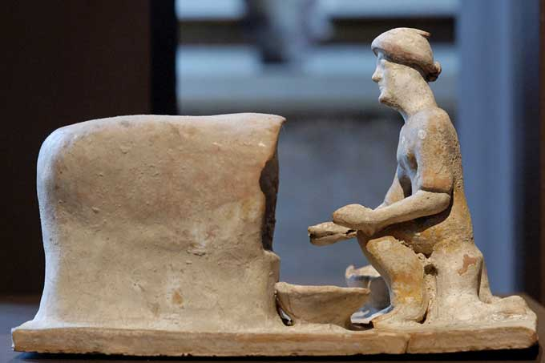
Ancient Greek fish plate Woman baking bread 5thcent.B.C

Ancient Greeks believed that a healthy body was very important. They loved sports and most cities had gymnasiums where only men and boys practiced sports every day to keep fit and relax. Sport was a good preparation for war too.
It is worldwide known that the most important of the sports contests was the Olympic Games
(776 B.C) known as the Modern Olympics today.

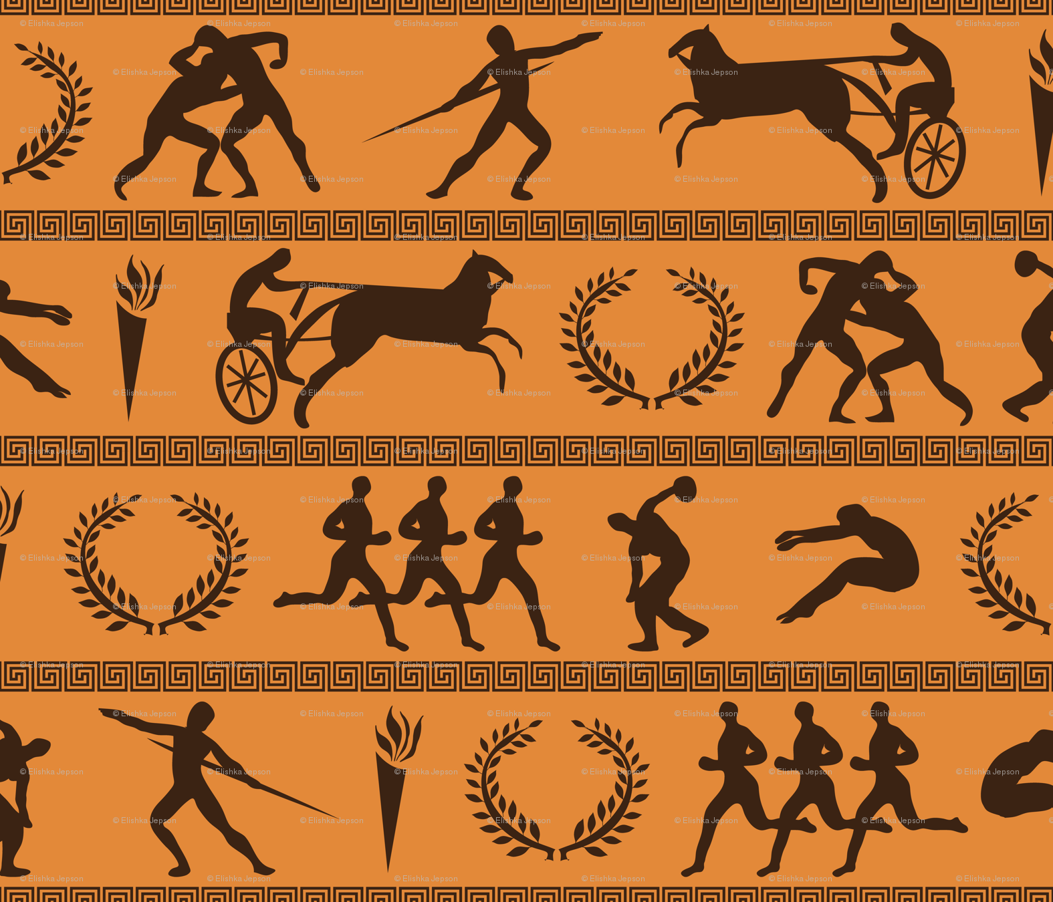



Olympic champion in gymnastics Lefteris Petrounias was the winner of the rings final at the Gymnastics World Cup AGF Trophy 2017 adding another gold medal to his collection.
by Nicky & Sissy, 6th graders

Greek Breakfast habits

Some of the most popular choices of breakfast in Greece are the following:

- Choice of whole wheat or leavened bread, thyme honey, fruit jam and butter
- Cheese with breadsticks
- Pies, sweet or salty
- Fresh orange juice
- Yoghurt with honey and walnuts
- Greek coffee or Mountain tea

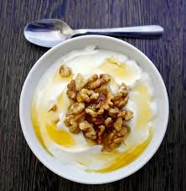

Mid morning snack

Since most Greeks don’t really eat a huge breakfast
they usually get hungry at around 10-11 a.m
Their preferred snack is a savory pie such as a cheese pie
“τυρόπιτα-tiropita” or a spinach pie ~ spanakopita.
But our most favourite snack is “ Koulouri” a sesame bun which we can also buy from the school canteen!

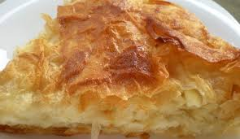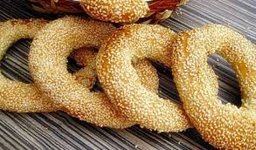

By Valia, 12 yrs

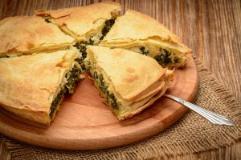
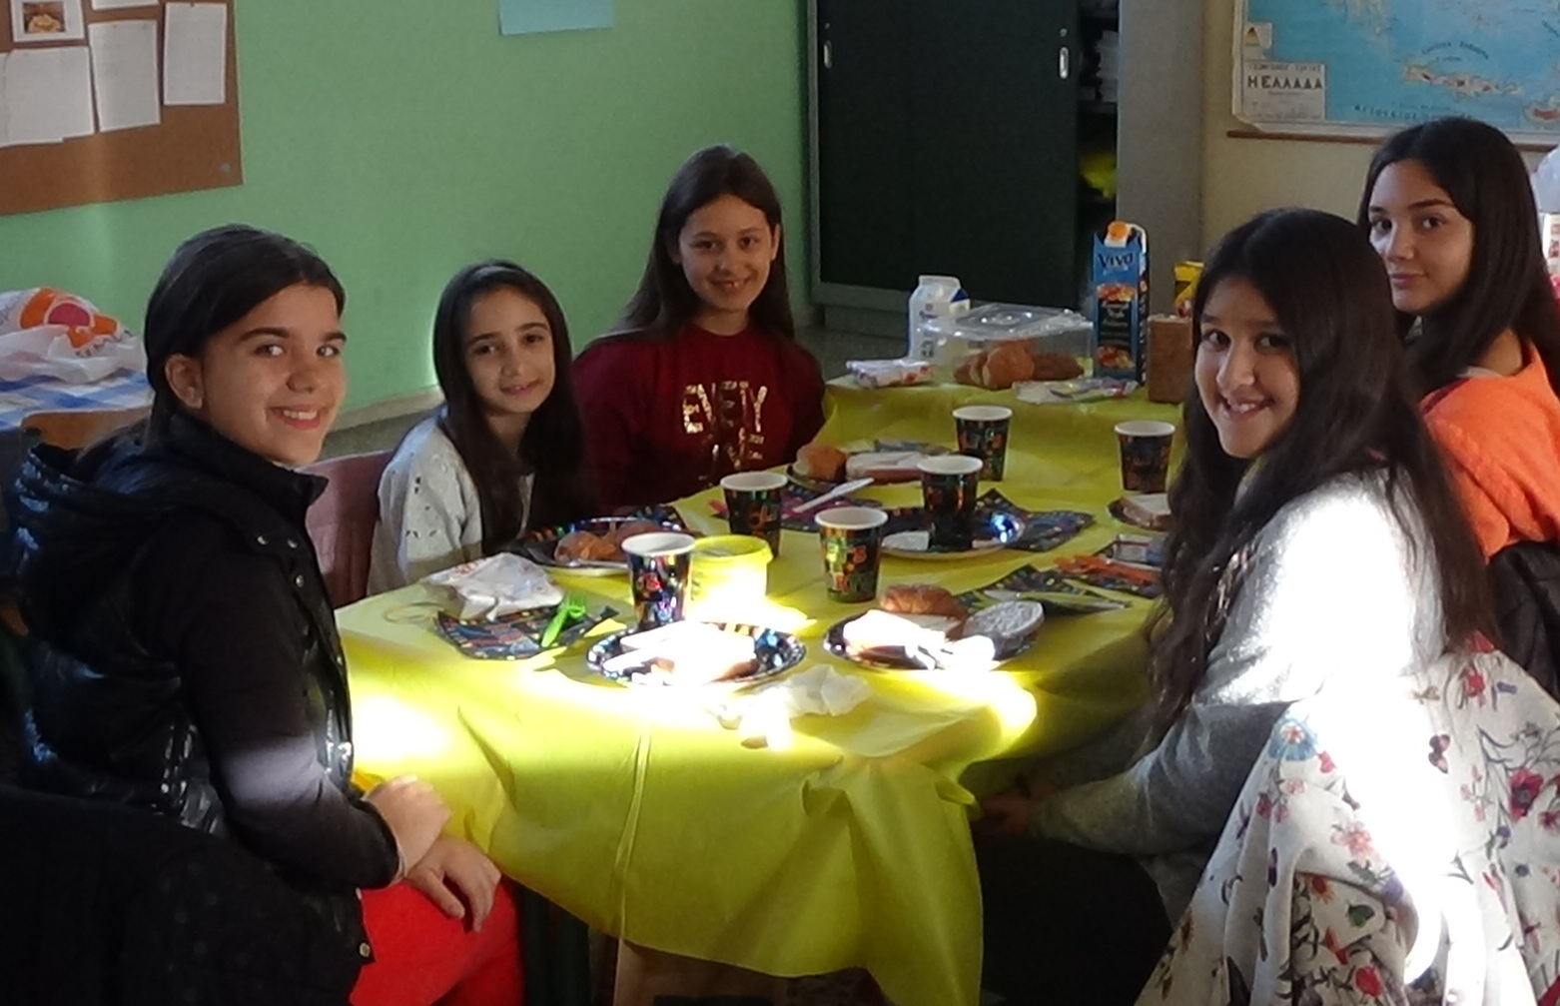

Breakfast at school with Irene, Nicky, Sissy, Angela & Vassiliki from the left.

by Vassliki, 11 yrs
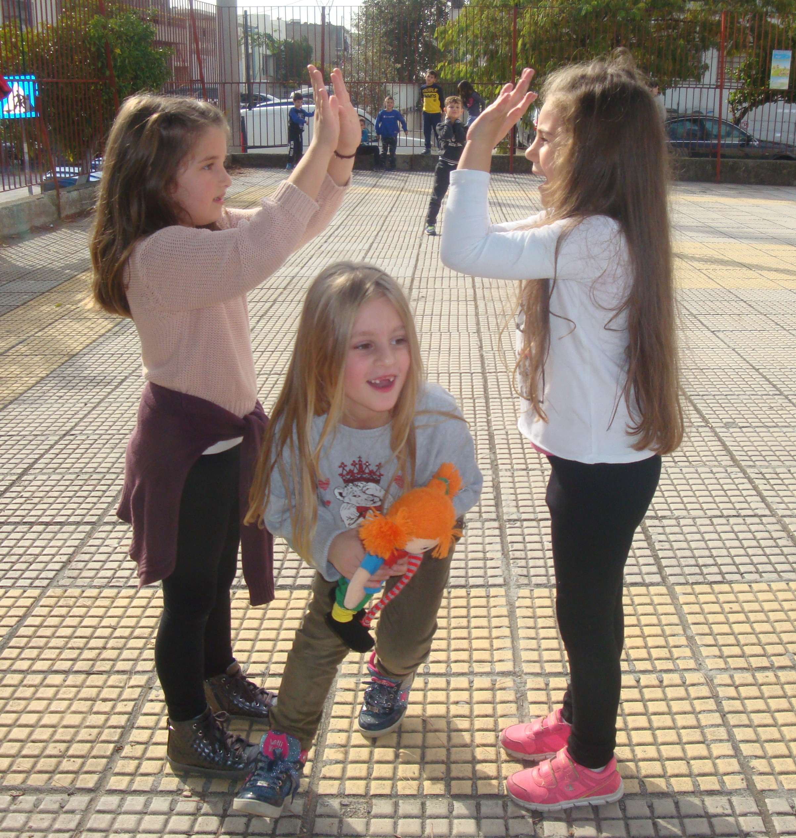
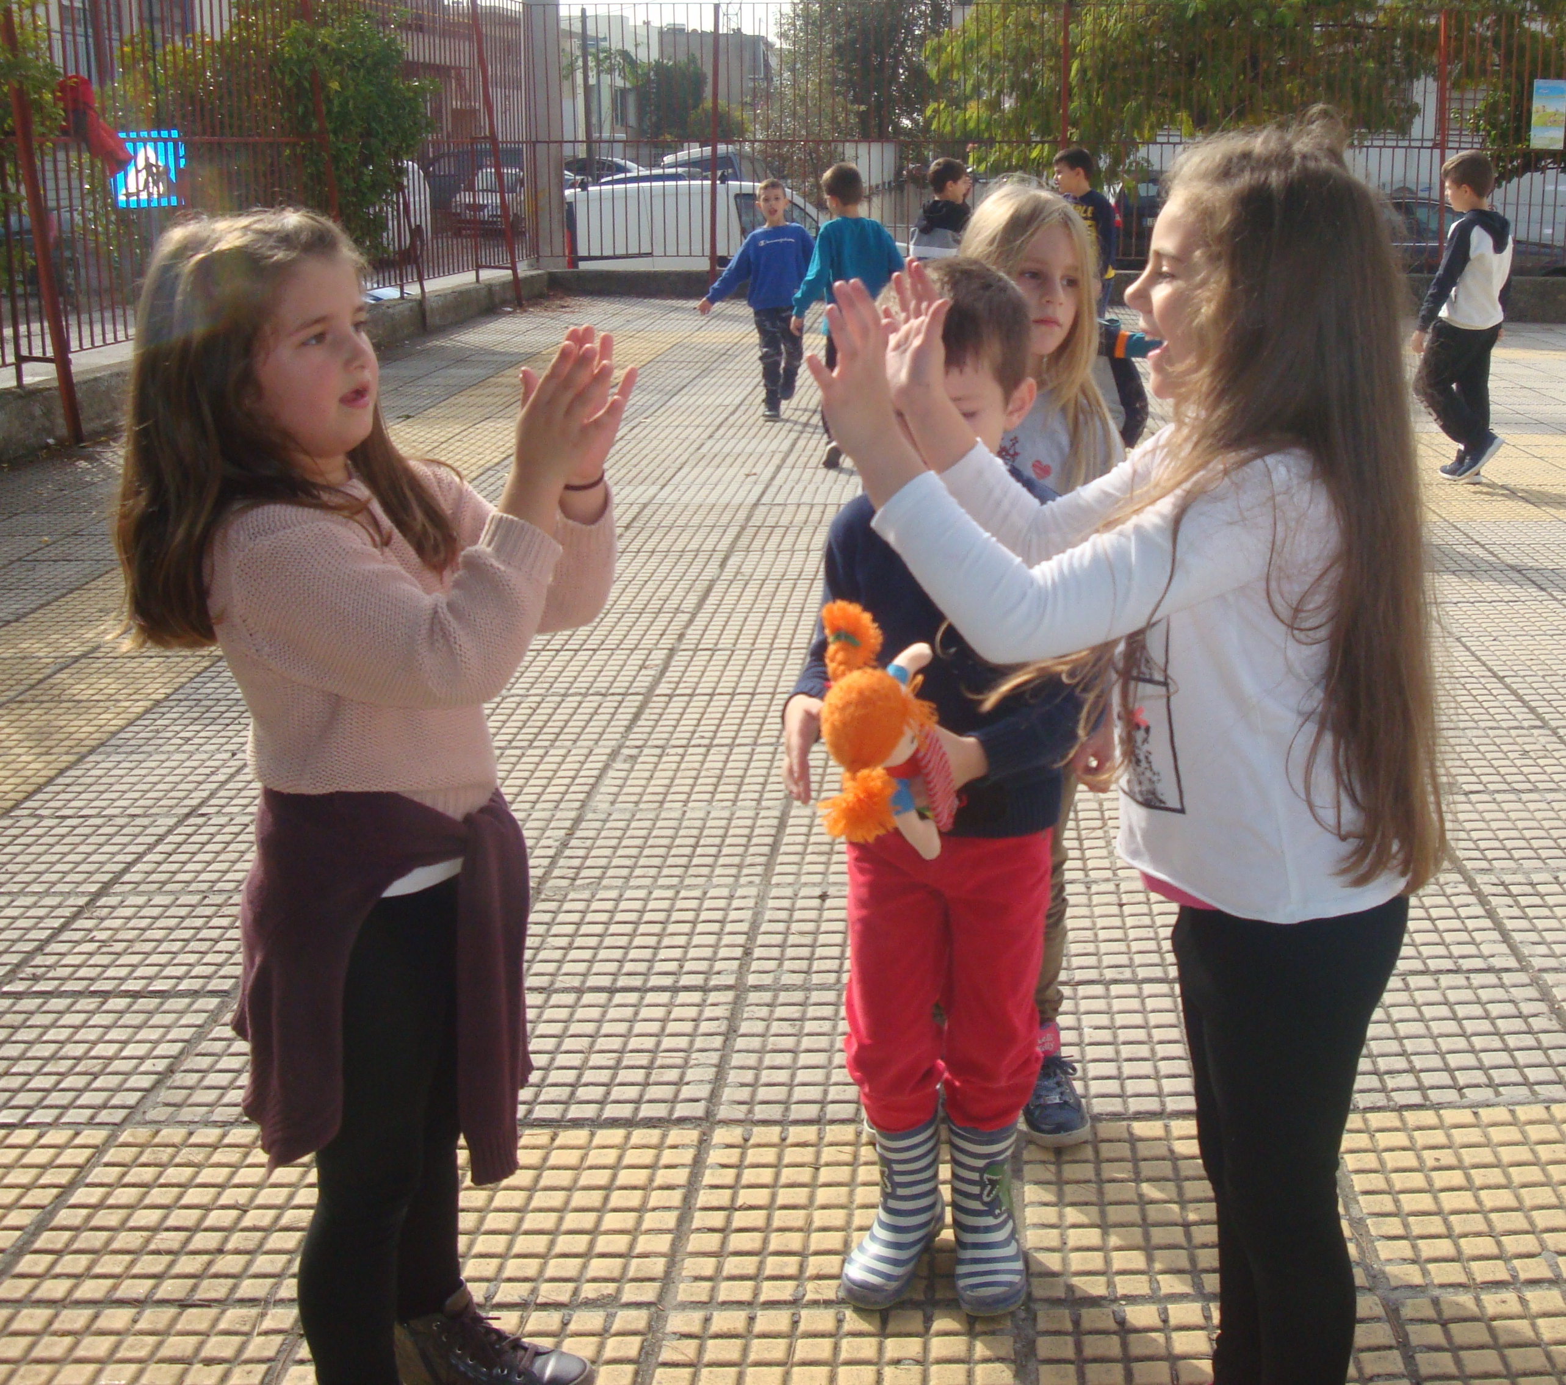
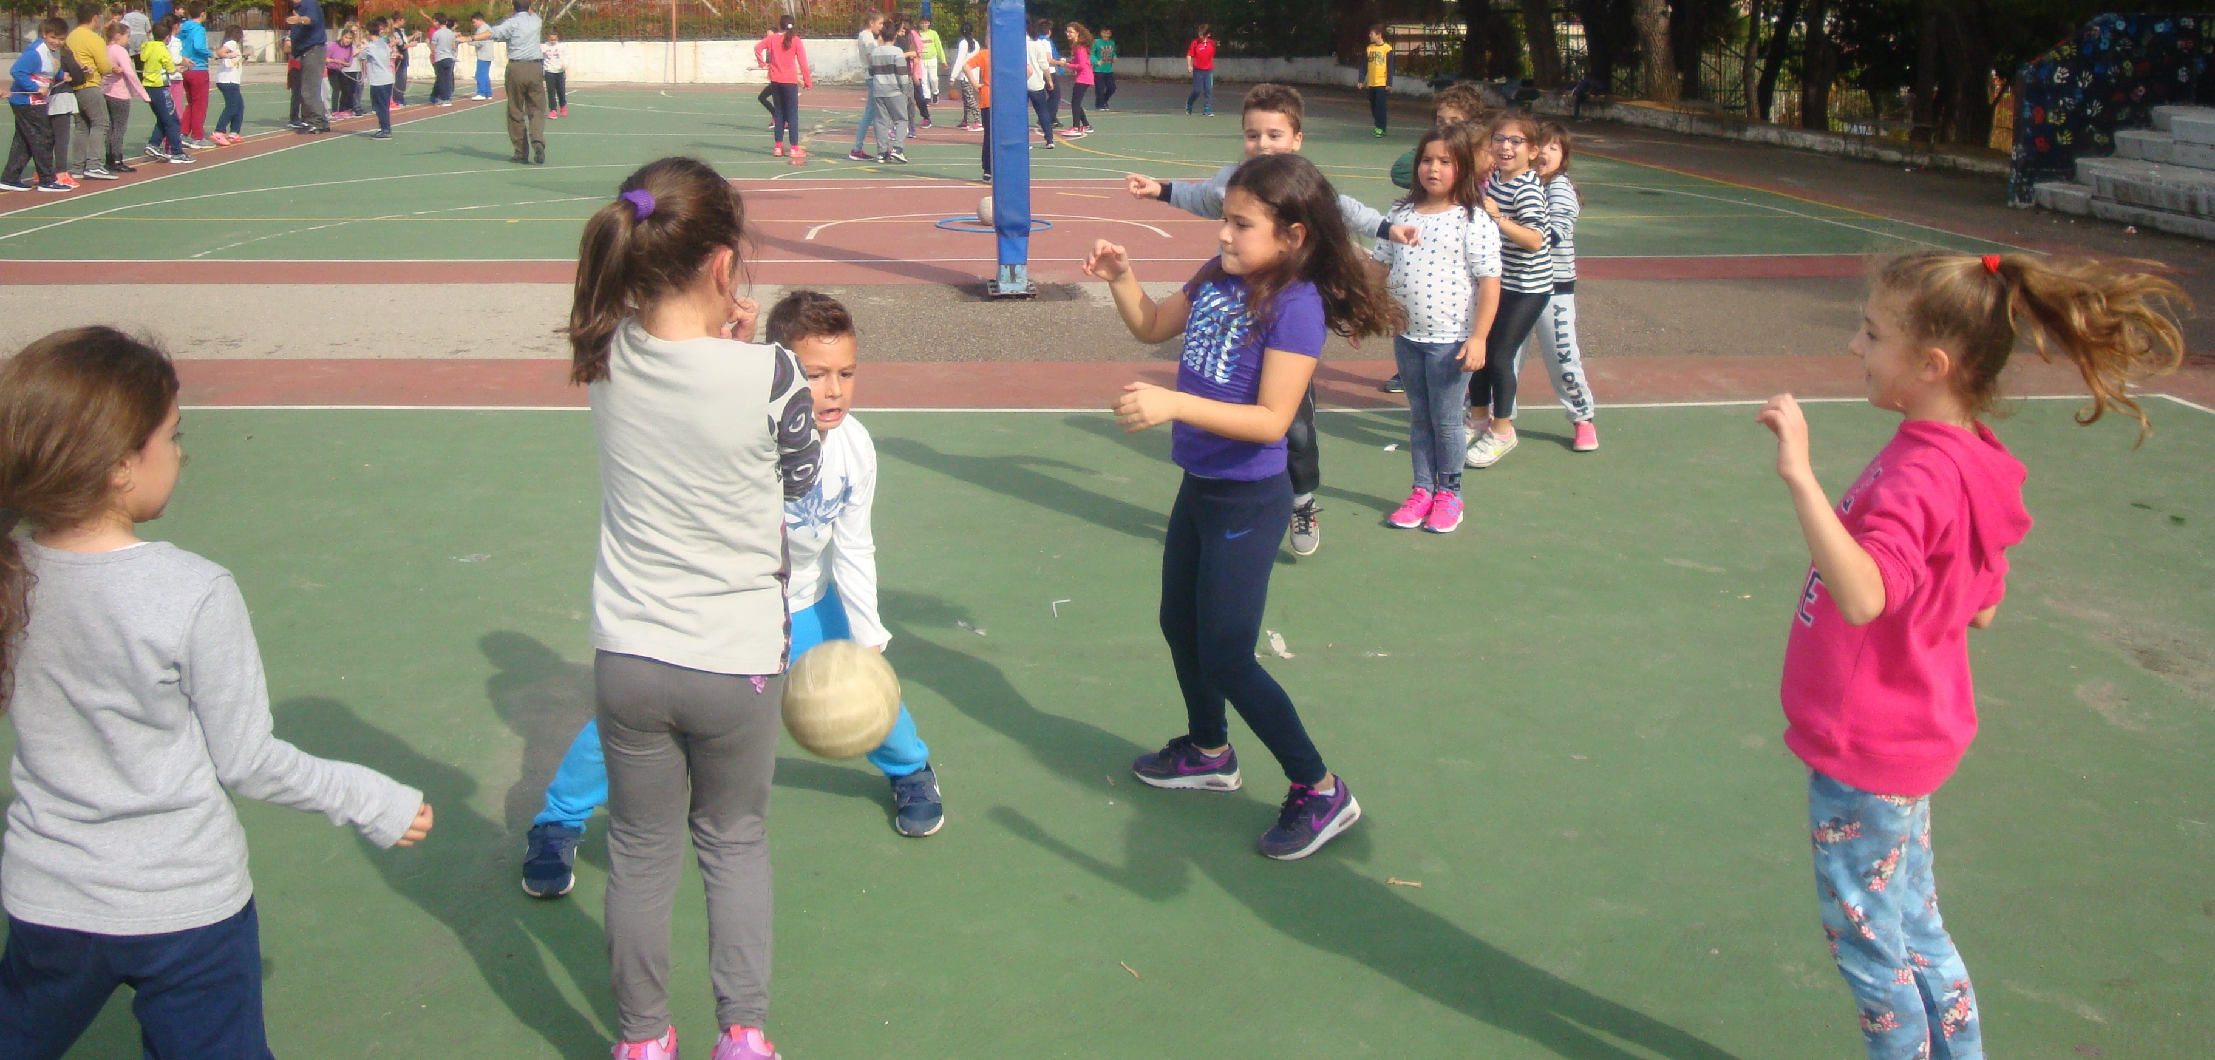

A bee goes by
This is an old, traditional game. At least six children (5-7yrs) are needed. Two children clap and sing.
The rest pass under the clapping hands. Whoever is caught must decide which of the two clapping children he/she will join.
Finally, when all the children have taken sides forming two teams, they play tug of war and those who do not fall down are the winners.
“The bee goes by
with the little bees
and the little kids
[whispering]
What do you want?
The red rose
or the white jasmine?
Go that way!”

Abariza
The game is played by two groups. Each group draws on the ground an “abariza“, a 3-4 diameter circle and a square used as a “prison.” Between the two “abarizas“ there is a distance of 20-40 meters. A random player of the first team starts running between the two “abarizas“ and a player of the other team tries to catch him and put him in “prison.” The winner is the team that manages to imprison all the opponents.
Let’s enjoy our school life with more games and more fun! We are just kids!
by Sotiris & Stavros , 11 yrs

games!

Have fun and keep fit
with games and sports!

Sotiris & Stavros

A few decades ago children in Greece used to gather out in the streets or in parks and play games. Games that involved physical play and imagination. Nowadays, TV and computer games have taken up most of children’s lives, however, a trend for traditional Greek games seems to attract more and more children who wish to learn how to play their parents’ and grandparents’ games.
In our school we play a lot of traditional games during the breaks and on “The Sports and Games Day” once a month.
We have chosen three of them for you.

Apples

In this game children are divided into two groups. Two players of one group stand opposite one another at a distance of 20 meters and the players of the other group gather in the middle, between them. The two players throw a ball at each other trying to hit one of the children of the rival group. If the ball hits a player then they get “burned” and get out of the game. However, if a player catches the ball, he wins an “apple.” The goal of this game is to get as many “apples” as possible. Each “apple” gives the player an extra “life” he can use in case he gets “burned.”

