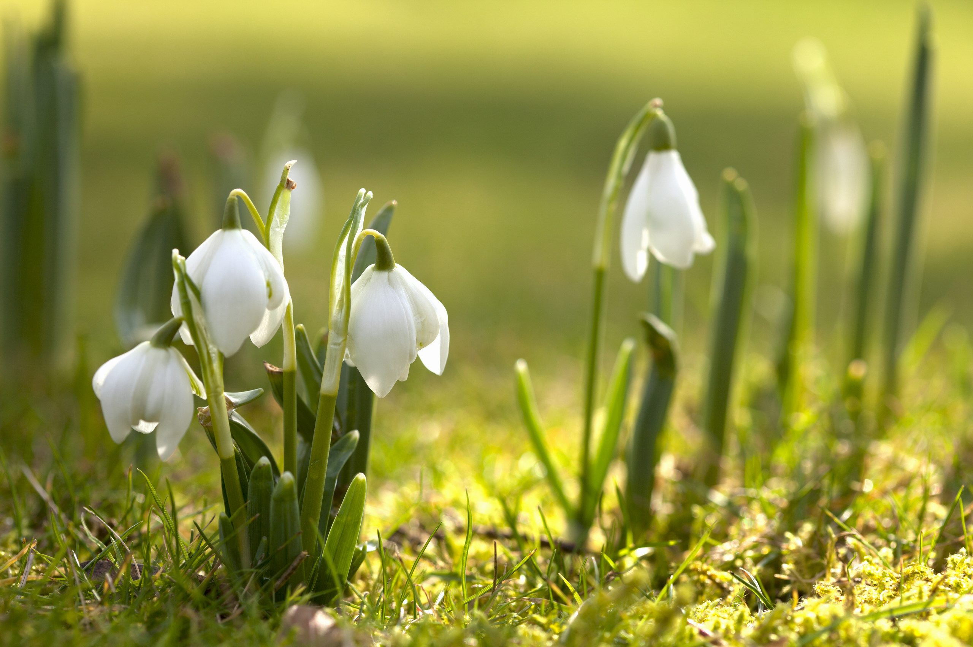

Culture – connectedness in diversity

Part two: Spring traditions

1st theme: Culture

2016-2017

Το Ελληνικό Πάσχα

Easter Time in Greece

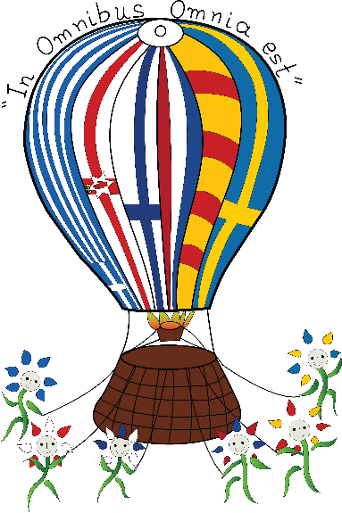





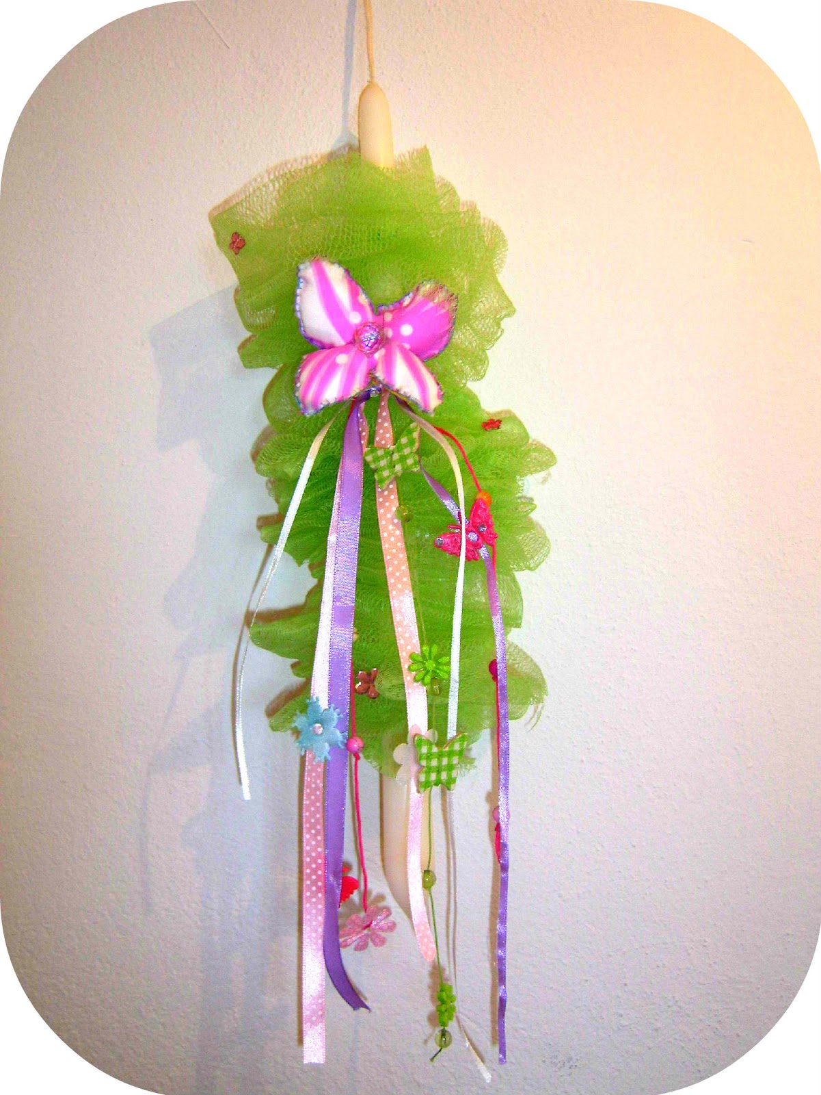

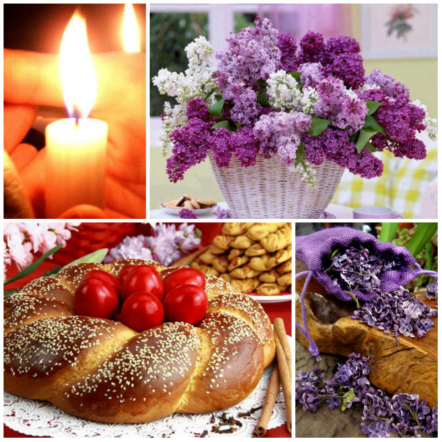

“My godmother brought me a fabulous Easter candle yesterday. When my friends saw it, they admired its beautiful ribbons and Katerina said that it was the most beautiful Easter candle she had ever seen. It was made by my godmother herself.

Most people in Greece buy their Easter candles for their godchildren but my godmother enjoys making my Easter candle on her own. I can’t wait to light my beautiful candle with the Holy

Light in the church of my village at the midnight of Holy Saturday!”

*Eleni , 7 years old*

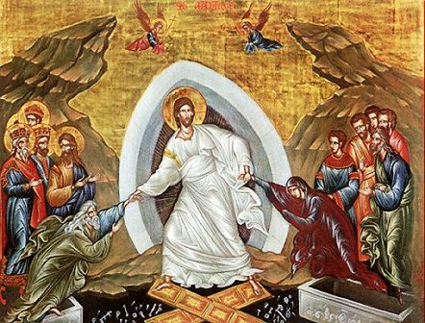

Easter in Greece is the most spiritual and the most religious period commemorating the Holy Passion, the Crucifixion, the Burial and the Resurrection of our Lord, Jesus Christ giving hope of rebirth for mankind.

Unlike other Christian faiths, which emphasize on the Holy Passion, the Orthodox give emphasis on the joyful and hopeful message of the Resurrection of Christ.

It’s a period when the feelings of deep **sorrow and joy** are becoming one: the so-called “**Xαρμολύπη”.**

The Greek Easter is a very important, family religious holiday. It starts 7 weeks before Easter Sunday with the 40-day-period of Lent and comes to its peak the **Holy Week,** right after the Palm Sunday, when Jesus was accepted with honour and love by the people of Jerusalem.

The faithful Christians all over Greece follow the Holy Week ritual with reverence and piety.

**“***Holy Week, for a Greek Orthodox, means you clear your calendar, you don’t make plans for that week at all because you will be in church every day... It is a powerful, beautiful, mysterious, humbling, healing and moving week. It is filled with tradition and ritual. It is about renewal and faith* *devoutly, giving themselves body and soul into the culmination of the Passion of Christ and finally rejoicing in His Resurrection*”.

**Holy Thursday** is the day of Christ on the Cross and the day when children with grown-ups usually receive the Holy Communion and their Easter candles~Λαμπάδες~ from their godparents.

**Holy Thursday** is the day of Christ on the Cross and the day when children with grown-ups usually receive the Holy Communion.

This is when Holy Services are held every evening in the churches.

1

Easter Season is the most significant and sacred time in the Orthodox Calendar and in the Greek Orthodox Faith in particular. It holds the most exceptional place in the hearts of the Greek people, and it is also known as ~Το Ελληνικό Πάσχα~To Elliniko Pascha ~ The Greek Easter. It is even more important than Christmas. It is the ΑΝΑΣΤΑΣΗ ~Anastasi~Resurrection of Jesus Christ that makes it so important.

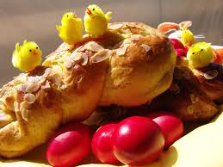

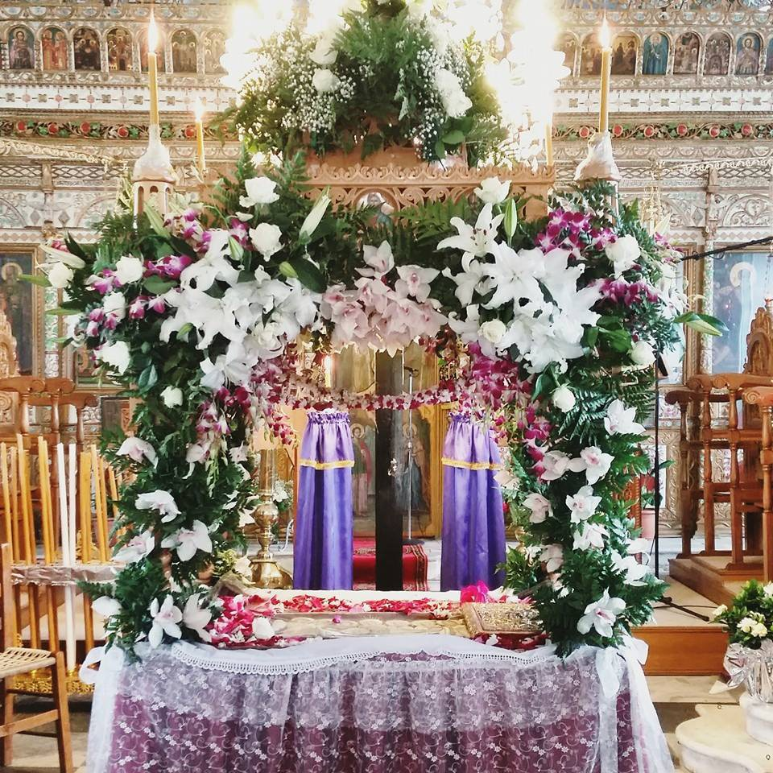

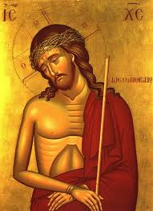

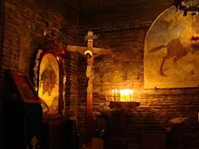

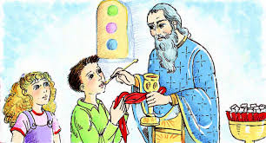

The women dye eggs red, to symbolize the blood of Christ, Life and Victory against death. This tradition is in commemoration of the Last Supper, the final meal which Jesus shared with his Apostles in Jerusalem before his Crucifixion. It is common belief that dyed Easter eggs can stay edible forty days without being refrigerated. If, however, a priest blesses the eggs on Easter Sunday, they are said to last a whole year without turning bad.

. 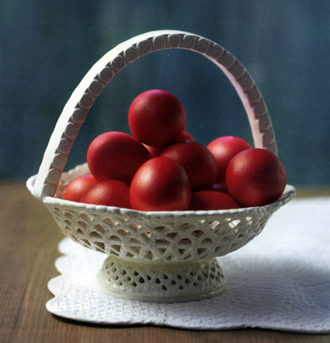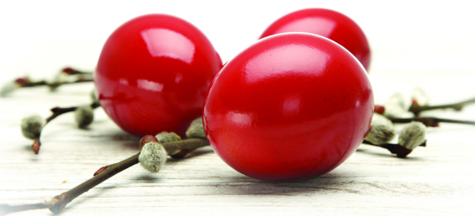

Women also bake Easter cookies “ koulourakia” and “tsoureki” a kind of sweet, croissant-like bread. They will be placed on the Easter table to be eaten after Holy Saturday. Children have to wait …and not eat them secretly!

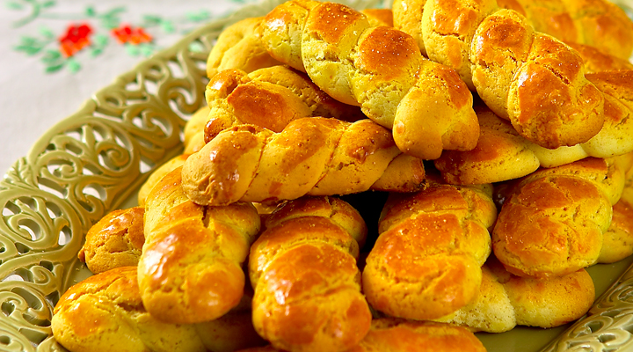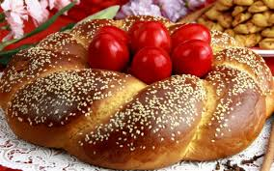

**Holy Friday** is the most sacred day of Holy Week, a day of mourning. The church bells toll mournfully all day while the girls decorate the **Epitaphios**, Christ’s Epitaph with beautiful flowers like violets, lilies and lilacs. Holy Friday is also a day of remembrance for the members of the Greek families who have passed away. We visit the cemeteries placing spring flowers on their graves.

«**Ω, Γλυκύ μου Έαρ ~Oh, my Sweet Spring!” people chant in church, mourning with Virgin Mary, Christ’s Mother.** 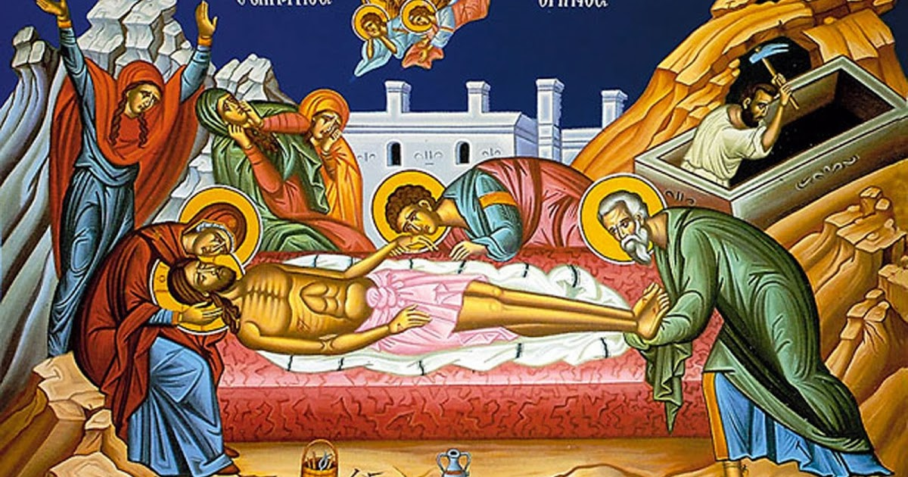

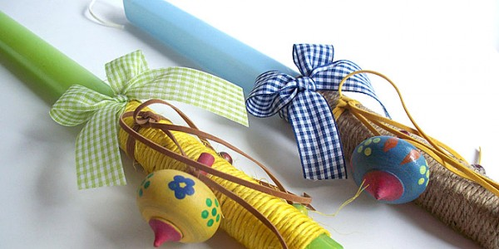

**Easter Sunday**

On Easter Sunday there are outdoor banquets. Families and friends meet up for the Easter Day roasting of lamb outside on a spit and a big celebration party with food, wine, music and dancing all day long.

We eat a round, flat loaf, marked with a cross that is decorated with red Easter eggs called ***Christopsomon.***

Children love breaking each other’s eggs while saying "Christ is Risen" to get the reply ”He is truly Risen”!!!

Many families prefer spending the **Λαμπρή –the Brightest Day of the year** in their home towns in the villages or in the islands.

The **Supper of Love** is also offered for the people in need on Easter Sunday by church parishes or local communities.

**Nature in spring** celebrates the Resurrection of Jesus Christ, too. White lilies, violets, poppies and lilacs blossom in spring in Greece. They are the flowers of Easter.

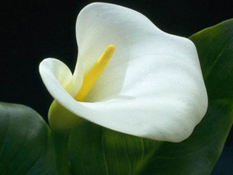 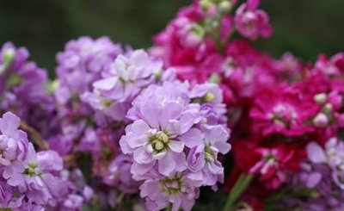

2. At dusk the Epitaphios, a candle-lit procession with priests and then the congregation file to the town square. All the people, children, grown-ups, old men and women follow the procession of the Epitaph all around the city, village or island while chanting Byzantine hymns with music bands.

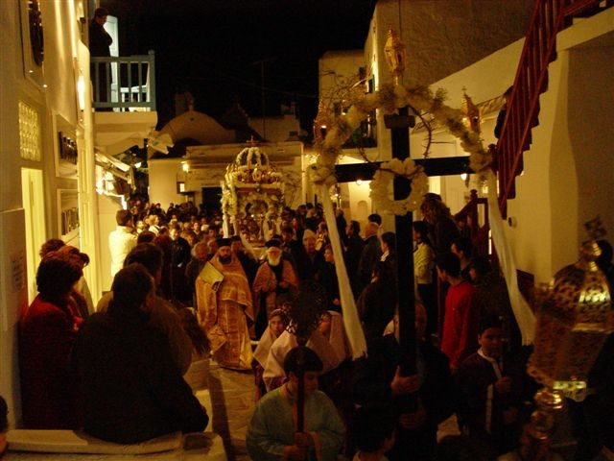

Holy Saturday is a day of happy preparation. Churches are decorated with white and red ribbons and everyone prepares a feast with the family.

**The Midnight Easter Service & The Resurrection**

The Anastasi, the Resurrection, takes place at midnight and it is the culmination of Holy Week. The whole of Greece attends church for the midnight service and the lighting of the **Holy Flame**(**see below)**.** We go to church with unlit candles and when the lights go out, the Priest announces the Resurrection of Lord Jesus Christ and shares the Holy Flame with all of us. We light our candles with it saying: -**Christos Anesti!~ Christ has Risen!**

**-Alithos Anesti! ~He has truly Risen!**

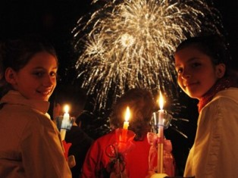

Families and friends give the kiss of love to each other while fireworks are let off in the sky in celebration. Then they take their lit candles home, making the sign of the cross with the smoke of the candle flame in the doorway of their homes and then they light the oil candle on the icon stand ; it’s a sign of blessing.  
The breaking of the Fast takes place now: at midnight, after the church service people go home to eat Mageiritsa – a meat soup with rice, dill and lemon and do the **tsougrisma** –cracking of the eggs.  We try to break each other’s eggs and the owner of the last uncracked egg is considered the lucky one. **The breaking of the eggs symbolizes Christ breaking the Tomb and defeating Death.** Church Bells toll, fireworks brighten the night while the next day is a feasting and merry-making day.

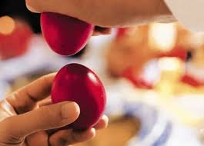



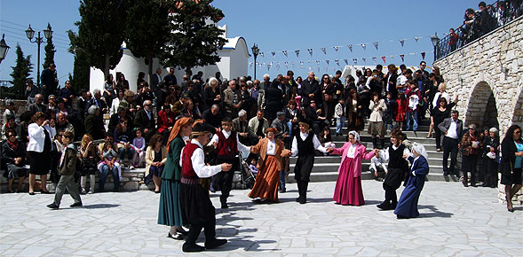

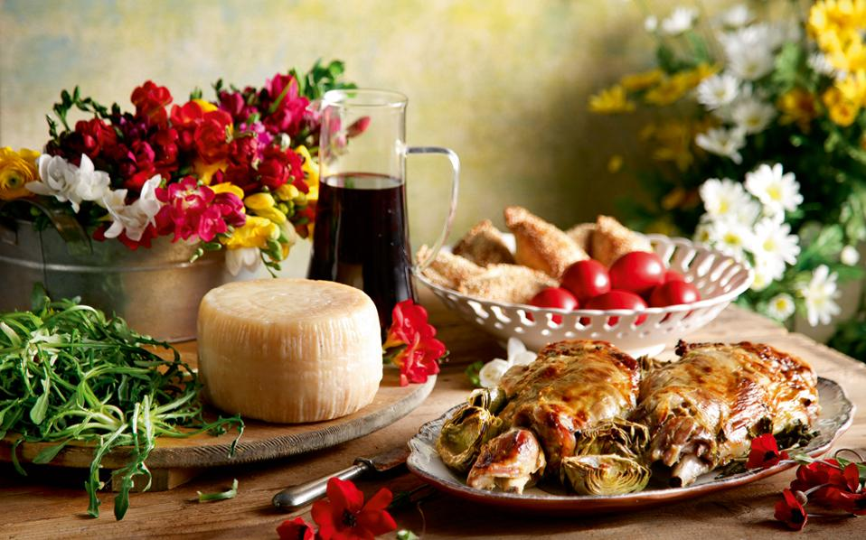

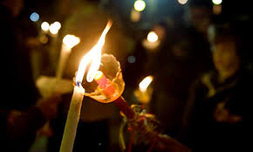

*Semmelwrap*

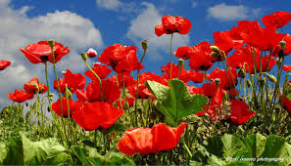

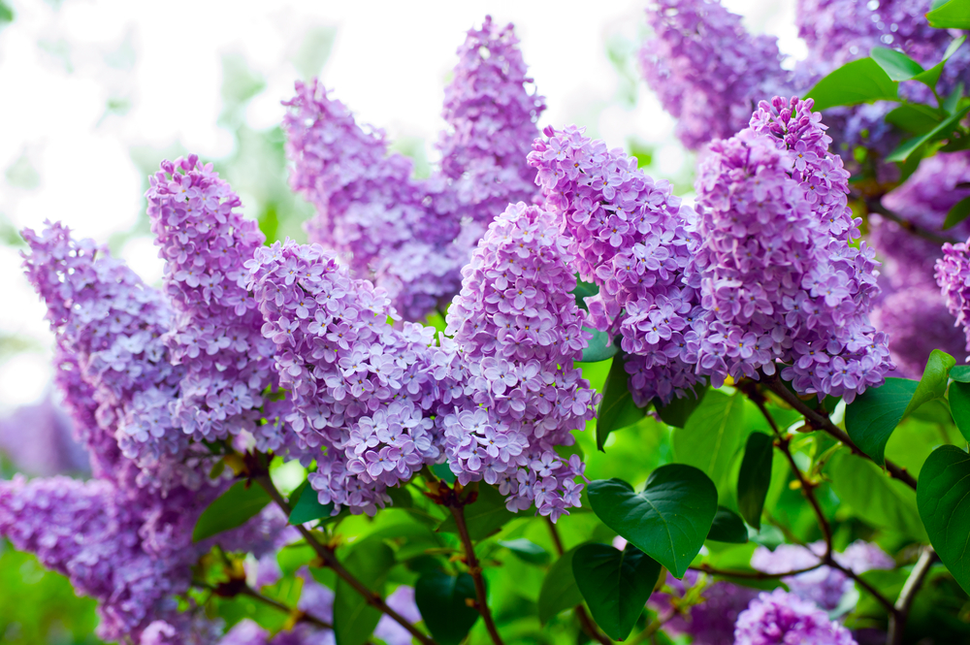

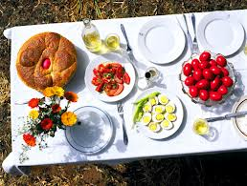

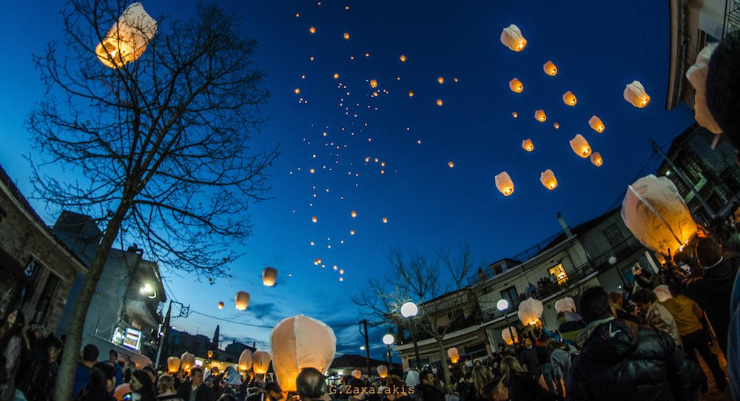

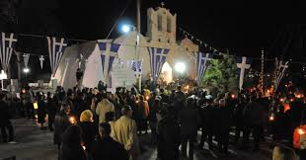

**Patmos, the island of Apostle Ioanni’s Apocalypse**

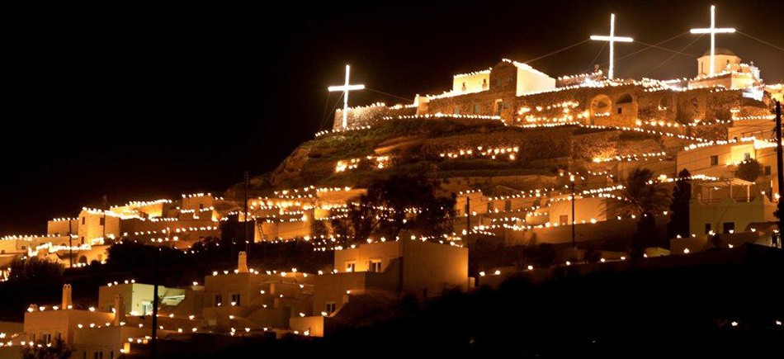

**The Epitaph in the sea, to sanctify the waters**

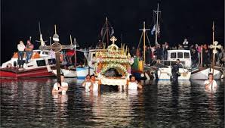

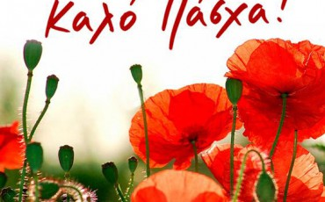

***Καλή Ανάσταση***!

***Happy Easter!***

**Kαλή Ανάσταση και Καλό Πάσχα!**

**Kali anastasi ke Kalo Pascha!**

**The teachers and pupils of the 3rd Primary school of Agii Anargyri, Athens**

**3. Easter traditions and customs**

Easter traditions are deeply rooted in centuries but they are still alive; they are different from place to place, from every small village and island to every big city. It’s worth referring to a couple of them.

**“The Pot Throwing**”

On Holy Saturday at 11am, the First Resurrection and the “Pot Throwing” custom take place on the island of Corfu, with local people throwing pots out of their windows, smashing them onto the streets below to keep away death and the evil spirits.

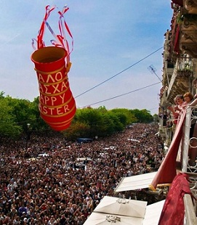 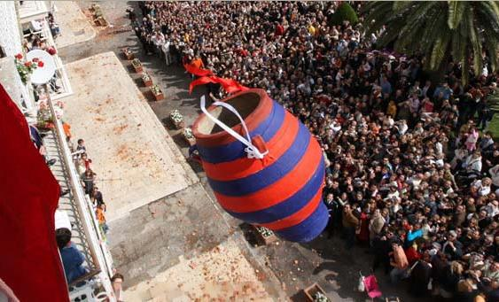

But what is the most touching and spectacular sight is that of

**“ The Flying of the hot air balloons”** in Leonidio, Arkadia : The children frame hundreds of red and yellow hot air balloons all through the holy week and release them in the sky in the night of Holy Saturday. When we say “Christos Anesti” (Jesus has risen) people from the parishes hold them and twist them in a special way which helps them rise up in the sky under the stars.

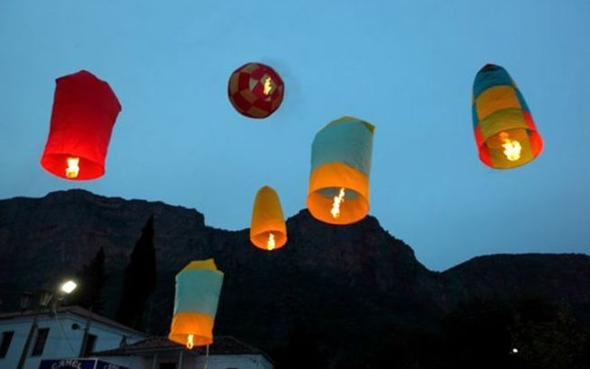 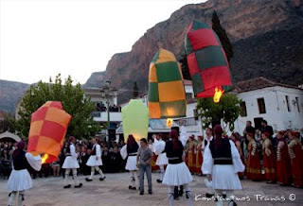

**\*** **\***On Saturday before Easter Sunday, the Orthodox Patriarch of Greece breaks the seal of the door of the Tomb of Christ in the Church of the Holy Sepulcher in Jerusalem and emerges with the Holy Fire. The flame is then flown to Greece, where it is distributed to churches all over Attika and the rest of Greece.

**Every place in Greece keeps its own traditions and passes them to the next generation.**

**It’s worthwhile visiting a Greek island or a village in springtime, at Easter time and enjoy the pure and sincere hospitality of the locals. Nothing has changed for a long, long time now!**

