Keeping safe headline

Computer gadgets

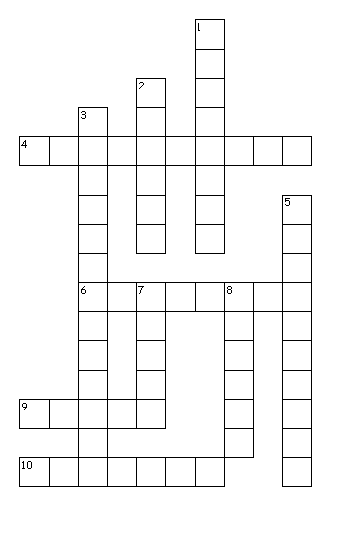
Across
4. You can listen to music without disturbing others.
6. It's stuck on your table.
9. It's always with you.
10. You can play music with it.
Down
1. You write with its buttons.
2. You can open its cover.
3. You play games with it, but you need a controller.
5. Teacher uses it in the classroom to teach.
7. It's a small animal with a wire.
8. It's like a phone but bigger.
Made by Viveka and Kerttu the 8th grade

How do I know if my computer is infected?

- The computer is slowing down.
- Strange adds are displayed.
- There are crashes.
- You get pop-up messages.
- Unusual messages show unexpectedly.
- Your friends say that they receive odd messages from you.
- You have unusual error messages.
- Your security solution is disabled.
- You can’t access on the control panel of your computer.
- Unfamiliar icons are displayed on your desktop.

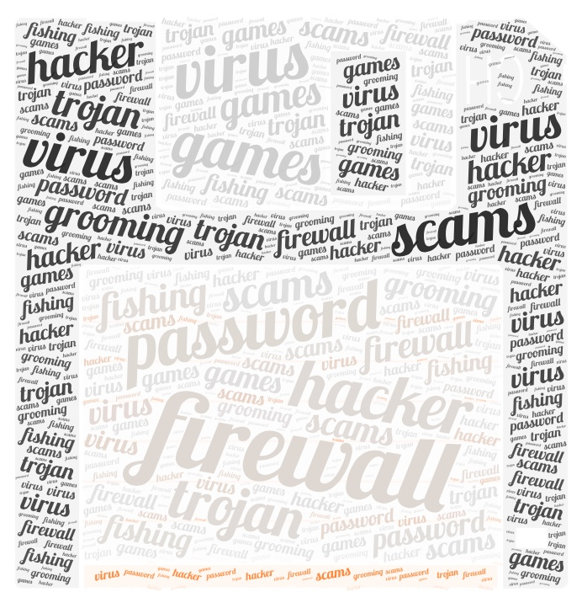
Wordcloud made by the 6th grade.

I nstagram
N etflix
T witter
E xel
R eddit
N exus
E xe
T ablet

S amsung
A pple
F acebook
E bay
T iktok
Y outube

Dangers of different APPS
- Snapchat: if your map is on, anyone can see your location
- don’t add strangers
- Instagram: if your account isn’t private, anyone can see your photos

Opinion

Should parents restrict how much the children use Internet?

Yes, we think so. The parents should restrict children’s Internet usage because the children use their mobile phones too much and they don’t focus on school. They use their phones all the time, at school and on freetime. We think that two hours with a mobile phone is enough.

Joonas and Jesse the 8th grade



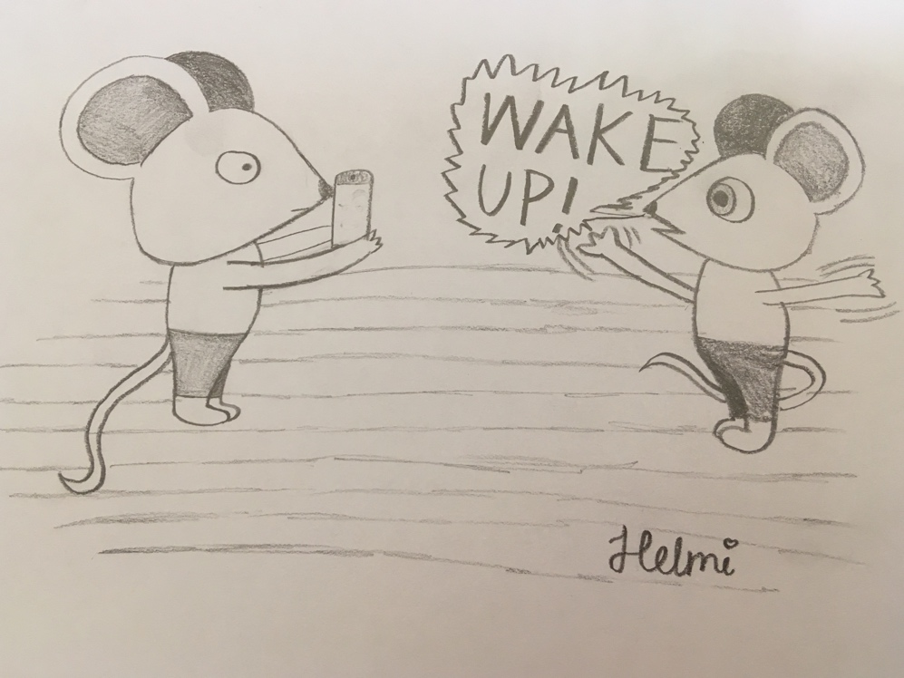

Be aware!!

- Don’t open weird ads
- Don’t share your password in Internet
- Don’t load any files in Internet
- Don’t take part in to unofficial competitions and share too much information about you
- Check the mail address if you get warnings that your account has been hacked.



