Connected by the sea

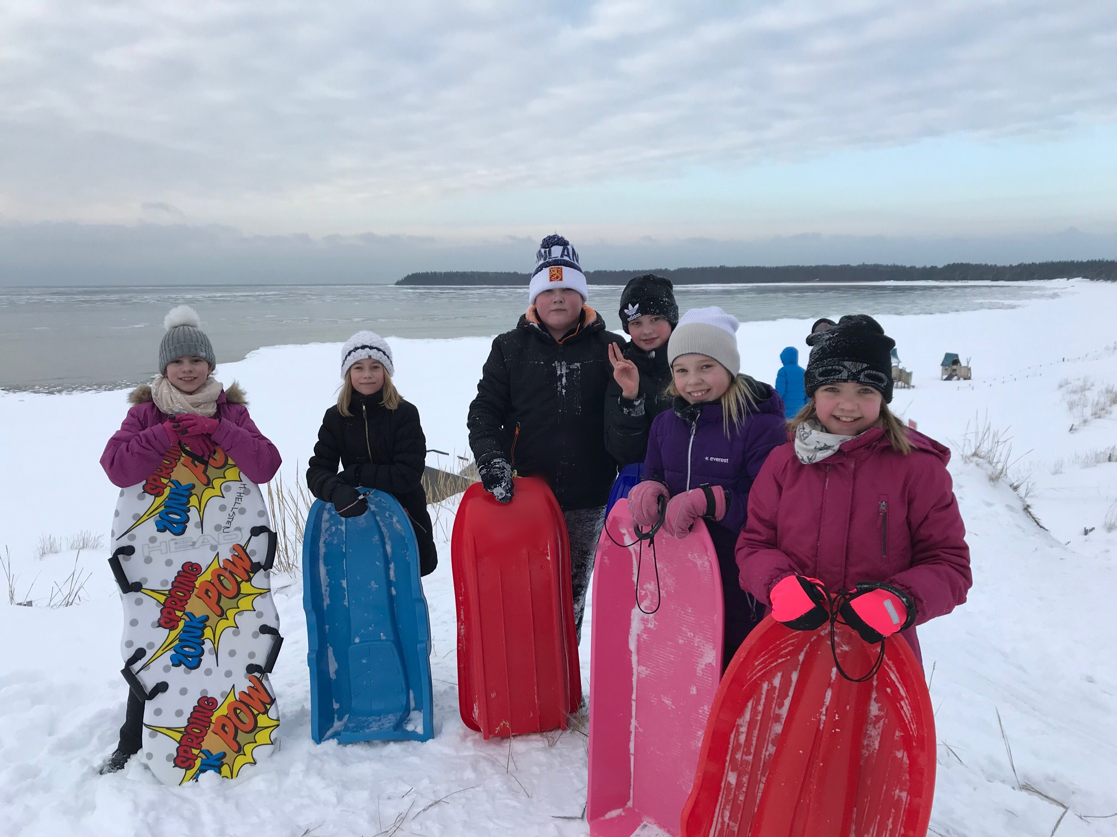
The pupils with sledges.

Students in Porin Kristillinen koulu have studied the sea theme during the last months. The students have learnt why Pori was built where it is situated today because of the sea. The students have sung sea songs, written stories and poems with sea theme. Here are some highlights of our theme.

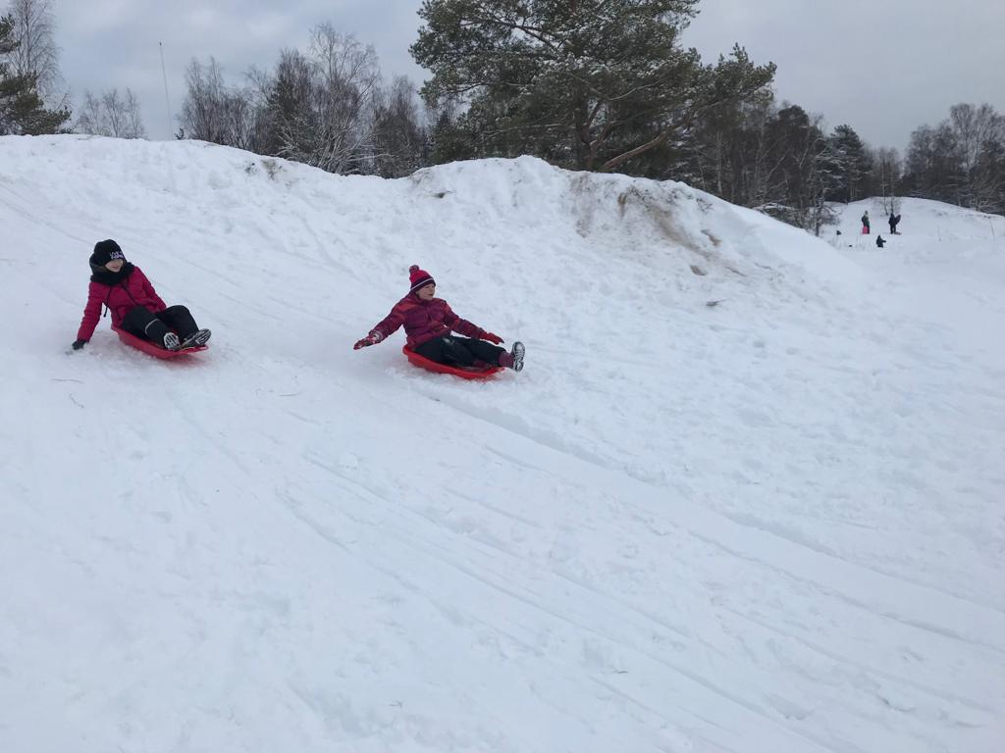
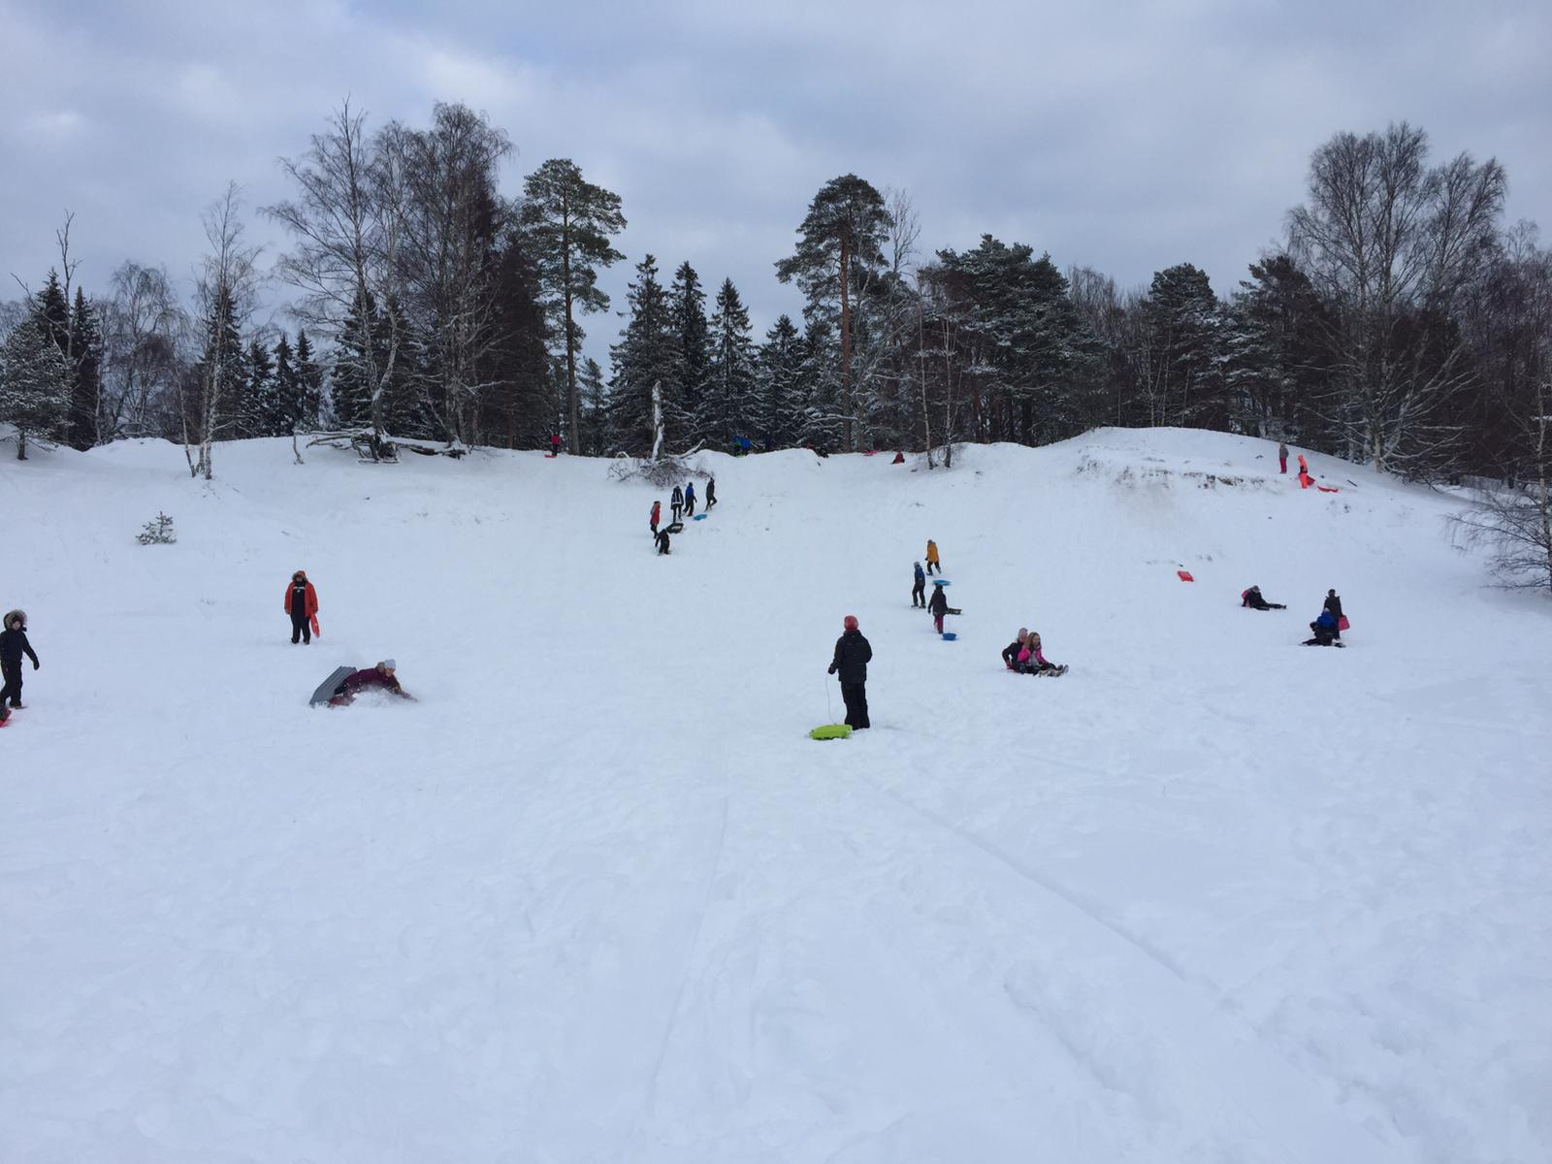

The gym lesson in Yyteri

The pupils of 3rd, 4th, 5th, 6th and 8th grade spent their gym lesson in Yyteri, near the sea. We took a bus from the
school and found “a Winter wonderland” with snowy dunes and
fresh air. Here are some thoughts from our 3rd and 4th grade pupils about the day and the
activities you can do by the sea. The sea
between Finland and Sweden is the Baltic Sea and the part
between the countries is called the Gulf of Bothnia. The sea close to Pori is called the Bothian sea.

“We sledged on the dunes of Yyteri. There were many ski jumps and lot of snow.
We ate the snack there. It was fun!”

“In summertime you can build sand castles,
swim, dive and enjoy the sun on the beach. In the winter you can skate, go ice fishing, sledge and even walk on ice.”

“At sea you can sail, swim, row the boat and fish.”

1

Short stories - Lighthouses

In the old days lighthouses were taken care by the lighthouse keepers. Today this profession doesn’t exist anymore because the technological advances. The pupils of the 3rd and 4th grade have studied The Baltic Sea and during that time they wrote diaries of the lightkeepers.

Diary

I was about to go swimming but then I saw blue-green algae. If I had gone swimming, I would have got sick. But then I noticed that it was me who had trashed.

Jasper the 3rd grade

Example of image text

Aenean rutrum, ligula in bibendum suscipit, magna risus tristique ipsum, vitae porttitor eros lectus sit amet est. Pellentesque et lacinia urna.

Maecenas pretium consectetur sapien ac rhoncus. Cras volutpat consequat leo, eget luctus metus cursus et. Nam a tortor sit amet ante finibus faucibus vel et sem. Aenean sollicitudin lobortis molestie. Aliquam in magna turpis. Duis porttitor elementum felis, ac fermentum ante vehicula non.

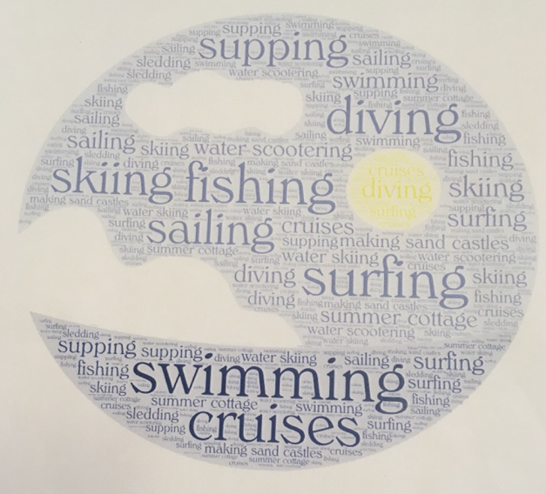

Today was a horrible day. I got a lot of hate, because I trusted that the light house’s light would last all night and I fell asleep. The lamp broke in the middle go the night and that’s not all, it started raining and it stopped at six. One ship sank, but just a couple of people got injured. But now it’s a very beautiful weather, the birds are singing on the trees. And the trees are dancing in the wind. It’s very sunny I’m going to go swimming, and fishing. I’m going to write more tomorrow.
Iida-Maria the 3rd grade

Aenean rutrum, ligula in bibendum suscipit, magna risus tristique ipsum, vitae porttitor eros lectus sit amet est. Pellentesque et lacinia urna. Maecenas pretium consectetur sapien ac rhoncus. Cras volutpat consequat leo, eget luctus metus cursus et.

