ECOLOGY

How to be green and make ecological choices in the school? These are important questions where we should try to find a solution. It’s important to teach our kids to think about the environment and how to protect it.

Recycling day
Our school organized a recycling day in May.

We had a stuff change day which means that we recycled stuff. We brought some stuff that we don’t use anymore and we gave those stuff to each other. We found new things that we like for example toys, clothes, books, CDs and more stuff like that. It was fun and we didn’t litter our nature.
Some things that you don’t use or like anymore can make a lot of fun to someone else!
Enni, the 6th grade

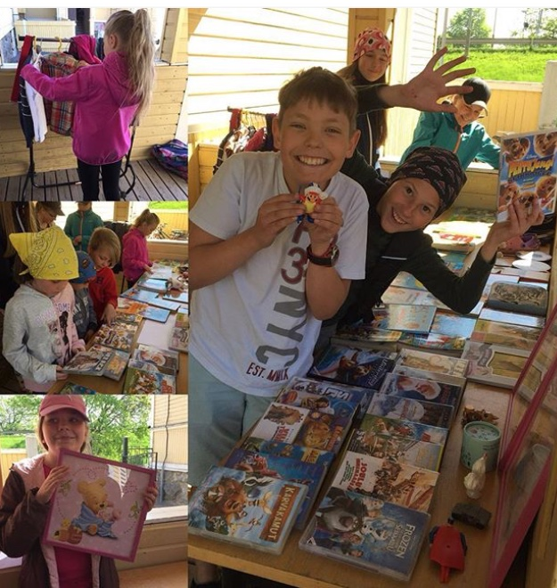

When we started our new theme- ecology- in our school, we started to think what kind of green things we already have in our school. The pupils had good ideas, things that the teachers hadn’t even thought. We do have lunch at school where we use plates, forks and knives, we don’t need disposable containers for instance.

Our school is situated very close to the center and opposite the shopping mall. The public library and public sport halls and fields are not that far away from our school, so we it’s time to P.E. the pupils either walk or ride a bike to these destinations.

What do I need in my room?

Lets's talk something about my room vanities. I have a few vanities in my room. I have one table that I don't use. I don't use it, because I do my homework on my bed. I have to get rid of it, but I dont know where I should put It. I have a wardrobe, where my clothes are. Then I have a carpet that I dont like it at all. I Don’t think it’s a vanitie but it collects so much hairs and dust, and that’s why I dont like it.
Unna the 9th grade

So the question is: what do we really need? Are our homes full of extra furniture, clothes, toys and other things?

.

The students of the 9th grade had some thoughts of the vanities we use in our everyday life. Here are some stories.

I think that one of the vanities is a plastic bag because it does not molder. Plastic bag can remain in the sea for 20 to 30 years. 56 % of seas’ rubbish are plastic bags. I think that we want that there will be less plastic bags, we should take a good price of them in the shops. One option is that we use the plastic bags many times or we use them as litter bags or we use reusable bags, canvas bag or a shopping basket.
Anna, the 9th grade

