Easter Nests Recipe
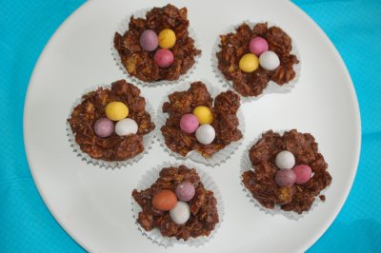

To make 10 Easter Nests you will need:
- 225g (8oz) milk chocolate
- 50g (2oz) butter
- 2 tablespoons of golden syrup
- 100g (4oz) cornflakes
- Packet of candy-coated mini eggs
- Paper baking cases
- A baking tray
- A large saucepan

Instructions

1.Place ten of the paper baking cases into the hollows of the baking tray.
2.Break the chocolate into pieces and place these into a large saucepan.
3.Add the butter into the pan. Dip a tablespoon into hot water to warm it up before using it to add the golden syrup into the pan.
4.Heat the pan stirring the mixture all the time until the chocolate and the butter have melted.
5. Turn off the heat. Add the cornflakes to the mixture gently stirring them until they are covered with the chocolate. Be careful not to crush the cornflakes too much.
6. Put the cornflake mixture into each of the paper baking cases. Make a small hollow in the centre of each nest with the back of a teaspoon.
7. Place a few eggs in each nest and then place the tray into the fridge to allow the nests to set. Remove after about an hour.
8. Either keep on or remove paper baking cases and arrange on a plate when you are ready to serve them. They are best stored in an airtight container in the fridge but need to be eaten within three days.
Happy Easter ……
with the birds’ nests!!!!

