3. KESKUSTELU

MIND MAP

My own apartment

Talk freely about the topic in the middle. The key words and questions around it are there to make the conversation easier.

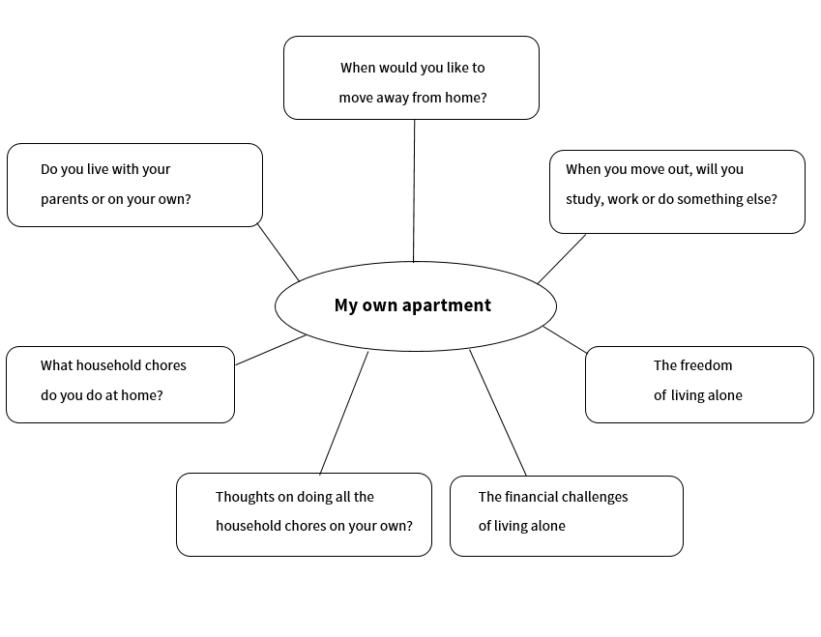

The challenges that youngsters face in their lives

Talk freely about the topic in the middle. The key words around it are there to make the conversation easier.

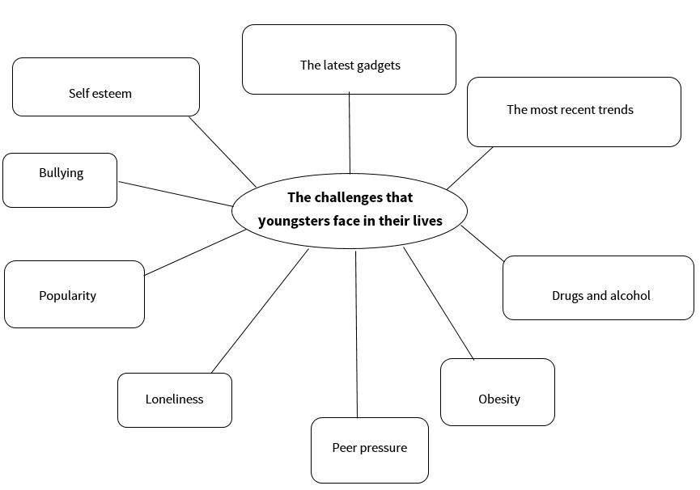

Technology

Talk freely about the topic in the middle. The key words and questions around it are there to make the conversation easier.
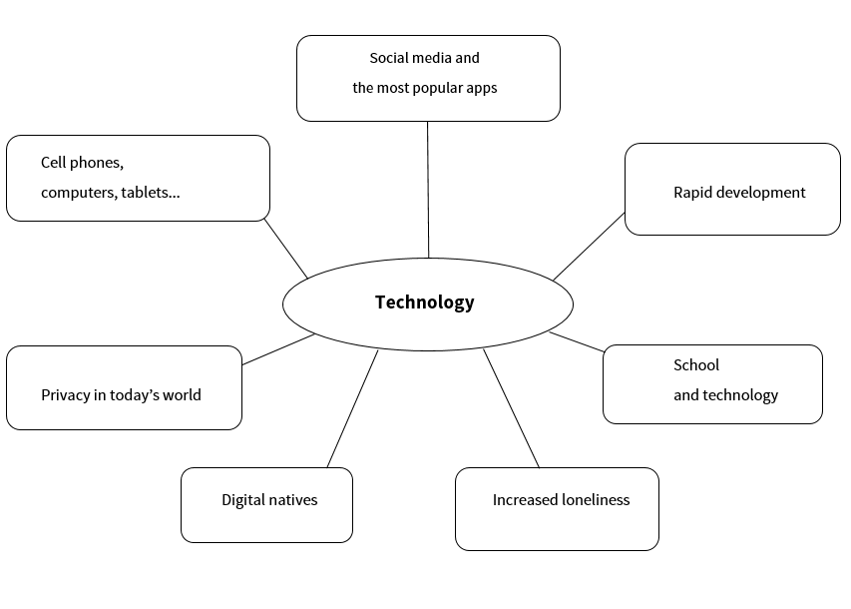

Muokattava mind map -tehtäväpohja opettajalle

Voit muokata tätä tehtäväpohjaa tehdäksesi oman mind mapin.

Your own topic

A/B-KESKUSTELU

Job interview

Below you will find some guidelines for a dialogue for students A and B. Feel free to add something extra if you like. One of you should act out the role of A and one of you should act out the role of B.

A: You are interviewing an applicant for a job in your company (decide together which company and position).

B: You are applying for a job in a company (decide together which company and position).

A: Ask the applicant to introduce him/herself.

B: Tell something about yourself when asked to.

A: Present an easy question related to the applicant’s personality.

B: Answer the question.

A: Present a more difficult question about the applicant’s qualities as an employee.

B: Answer the question.

A: Ask if the applicant has anything that he/she would like to ask.

B: Ask something.

A: Finish the interview as you like.

B: Finish the interview as you like.

Buying a car

Below you will find some guidelines for a dialogue for students A and B. Feel free to add something extra if you like. One of you should act out the role of A and one of you should act out the role of B.

A: You are a used car salesperson showing the car and trying to sell it to a customer.

B: You are a customer who is potentially interested in a car. You see the car for the first time.

A: Try to make the customer feel welcome.

B: Be polite but not overly excited.

A: Show the car to the customer, give some details and try to make the vehicle seem like a perfect deal for this customer.

B: Give some positive comments and ask questions about it.

A: Try to answer as thoroughly and professionally as possible.

B: You find something that you don’t like about the car. Remain polite but present your views firmly.

A: Try to reply so that you don’t lose the customer.

B: You have decided to buy / not to buy the car. Tell the salesperson about it and then finish the conversation.

A: Reply to the customer’s decision and finish the conversation.

Volunteer work

Below you will find some guidelines for a dialogue for students A and B. Feel free to add something extra if you like. One of you should act out the role of A and one of you should act out the role of B.

A: You are interested in volunteer work but your friend isn’t. You are telling him/her about your experiences as a volunteer worker.

B: Your friend is into volunteer work but it’s not really your cup of tea. Ask him/her a couple of questions to learn more about it.

A: Respond to your friend’s questions.

B: Be polite but make it clear that you aren’t enthusiastic about it.

A: Try to justify your point of view about the importance of volunteer work.

B: Tell you friend about all the other possibilities of spending your well-earned leisure time.

A: Tell your friend about the values related to why this is such an important matter for you.

B: Respond to your friend’s comment as you like.

A: Give your final comment on the matter and end the conversation.

B: Give your final comment on the matter and end the conversation.

