[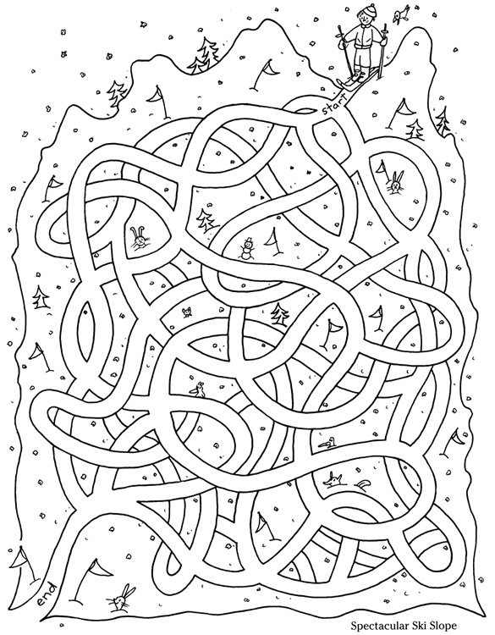](https://www.google.fi/url?sa=i&rct=j&q=&esrc=s&source=images&cd=&cad=rja&uact=8&ved=0ahUKEwjntpik3fnKAhWiIpoKHcyBD-EQjRwIBw&url=https://www.pinterest.com/pin/525584218985039526/&psig=AFQjCNH64hyejVawid7Fm6Z-FtomxzALtg&ust=1455624106803991) [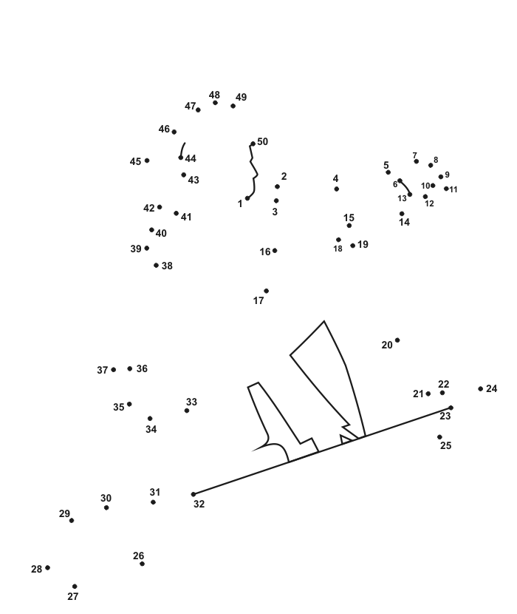](https://www.google.fi/url?sa=i&rct=j&q=&esrc=s&source=images&cd=&cad=rja&uact=8&ved=0ahUKEwi09sjZo6TLAhUmb5oKHdW_ADQQjRwIBw&url=https://www.pinterest.com/EEnid25/education-dots-to-dots-connect-the-points/&bvm=bv.115339255,d.ZWU&psig=AFQjCNFpG9l-7OlW_tNqR41SYlaW5zFYBA&ust=1457086291801154)

