[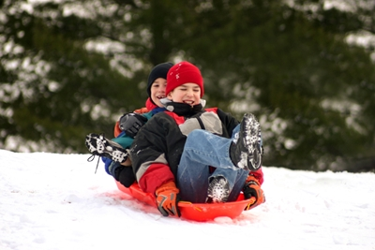](http://www.google.fi/url?sa=i&rct=j&q=&esrc=s&source=images&cd=&cad=rja&uact=8&ved=0ahUKEwjzp4330_nKAhUDYZoKHce2DYQQjRwIBw&url=http://www.dermoplast.com/en/First_Aid_Tips/Safety_for_Winter_Activities_and_Sports.aspx&bvm=bv.114195076,d.bGs&psig=AFQjCNE2rDhJ3zfLpdIFTlv2KexhNkxHxw&ust=1455621145639520)

[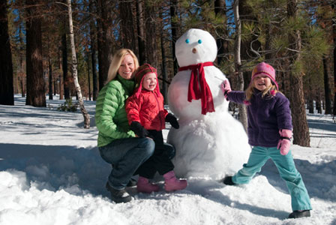](http://www.google.fi/url?sa=i&rct=j&q=&esrc=s&source=images&cd=&cad=rja&uact=8&ved=0ahUKEwjbi_CP1PnKAhUiQJoKHRaWAqoQjRwIBw&url=http://www.sheknows.com/parenting/articles/813166/10-outdoor-winter-activities-for-kids&bvm=bv.114195076,d.bGs&psig=AFQjCNE2rDhJ3zfLpdIFTlv2KexhNkxHxw&ust=1455621145639520)

[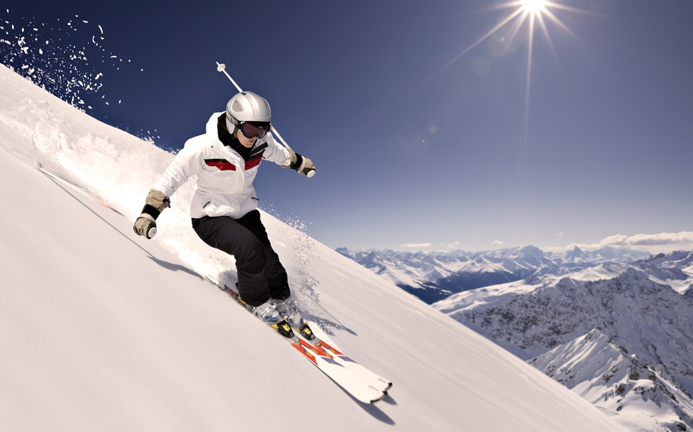](http://www.google.fi/url?sa=i&rct=j&q=&esrc=s&source=images&cd=&cad=rja&uact=8&ved=0ahUKEwjk7dbv1fnKAhVKIpoKHfxfC4MQjRwIBw&url=http://www.thinglink.com/scene/614171964189179906&bvm=bv.114195076,d.bGs&psig=AFQjCNGEXzFiEJUtcwOfkJDTQUofFJ3bTg&ust=1455621939848978)

[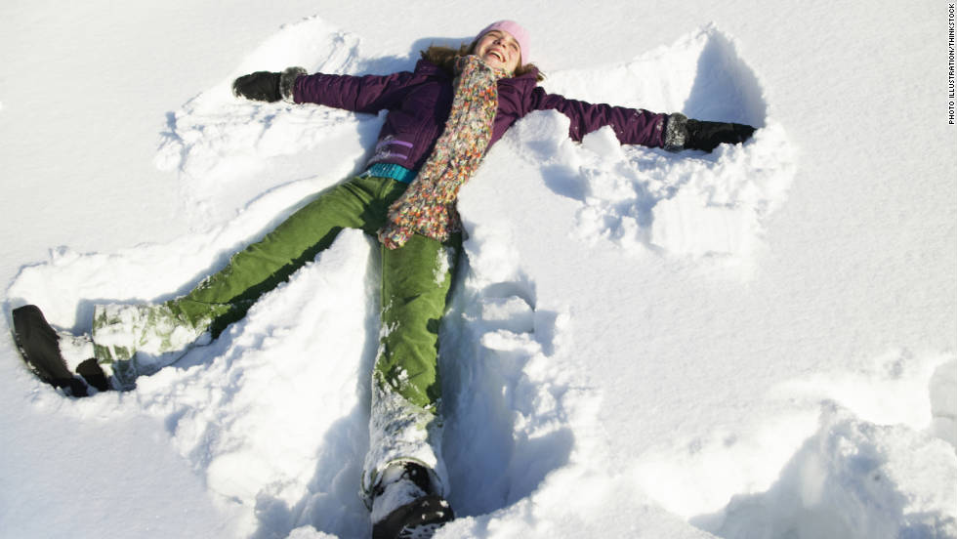](http://www.google.fi/url?sa=i&rct=j&q=&esrc=s&source=images&cd=&cad=rja&uact=8&ved=0ahUKEwiapbjj0_nKAhUjIpoKHWmyA_wQjRwIBw&url=http://www.cnn.com/2011/12/09/health/winter-activities-calorie-burning/&bvm=bv.114195076,d.bGs&psig=AFQjCNE2rDhJ3zfLpdIFTlv2KexhNkxHxw&ust=1455621145639520)

[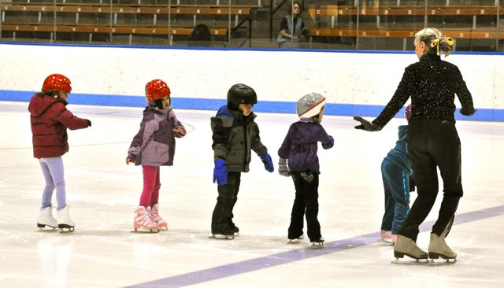](http://www.google.fi/url?sa=i&rct=j&q=&esrc=s&source=images&cd=&cad=rja&uact=8&ved=0ahUKEwi8jaPF1vnKAhXkIJoKHUvIBrwQjRwIBw&url=http://www.littleporticestadiumproject.com/why-a-stadium&bvm=bv.114195076,d.bGs&psig=AFQjCNH8cP4M_cK-oJb67ipJFvkcay2znQ&ust=1455622489763691)

[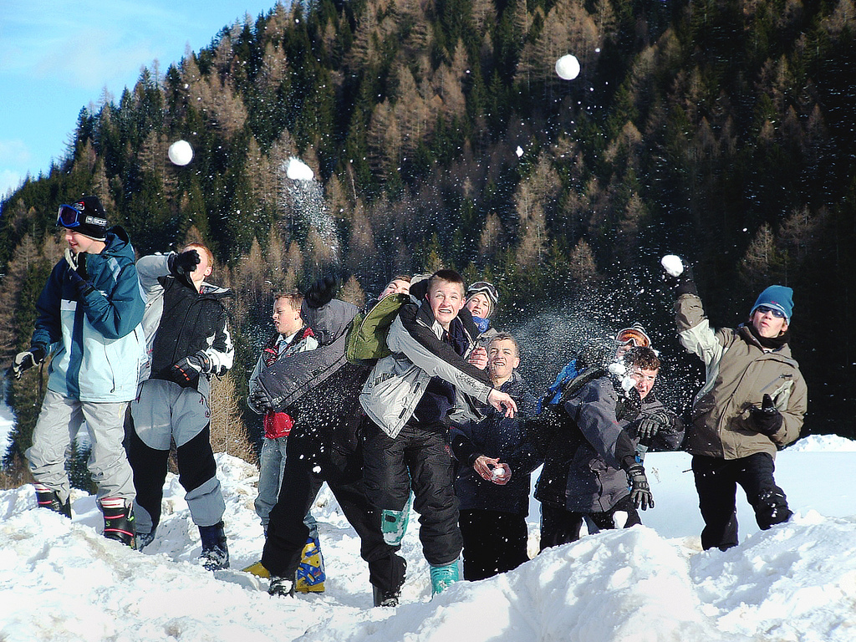](https://www.google.fi/url?sa=i&rct=j&q=&esrc=s&source=images&cd=&cad=rja&uact=8&ved=0ahUKEwit9Prj1vnKAhXEd5oKHdAzAAwQjRwIBw&url=https://www.flickr.com/photos/29239016@N02/5244443476&bvm=bv.114195076,d.bGs&psig=AFQjCNHii1zpQ9to2scuvQ_24kCQGwaBaQ&ust=1455622563142630)

[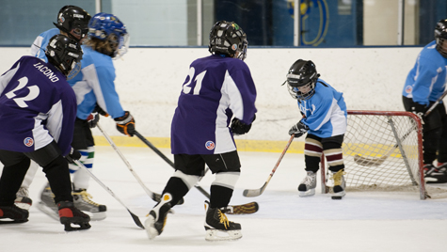](http://www.google.fi/url?sa=i&rct=j&q=&esrc=s&source=images&cd=&cad=rja&uact=8&ved=0ahUKEwjQm86S1_nKAhVFLZoKHYGLA8AQjRwIBw&url=http://www.udel.edu/icearena/hockey2/cross-icehockey.html&bvm=bv.114195076,d.bGs&psig=AFQjCNGSzdk32KTvGQ9ncClD6By4nUdsNQ&ust=1455622664821203)

[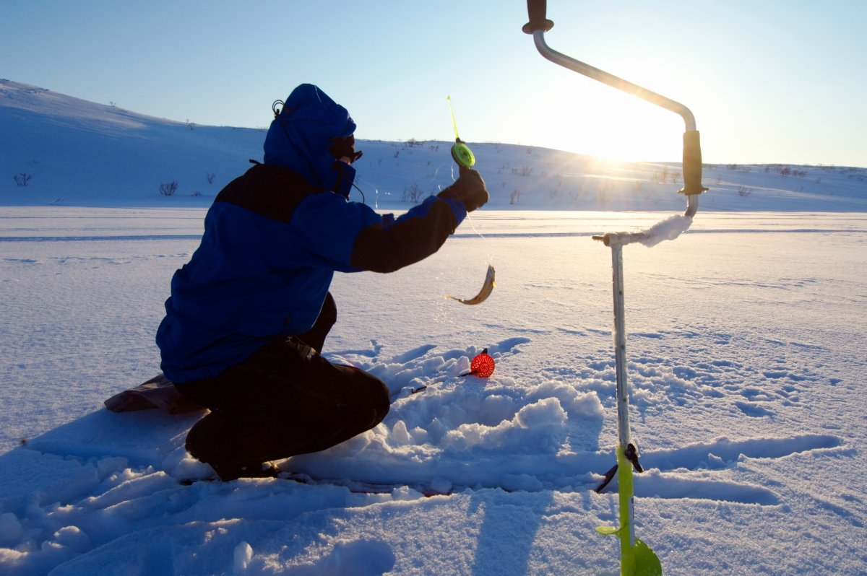](http://www.google.fi/url?sa=i&rct=j&q=&esrc=s&source=images&cd=&cad=rja&uact=8&ved=0ahUKEwjGqNWn3_nKAhVkYJoKHVvkADIQjRwIBw&url=http://www.visit-lyngenfjord.com/en/ice-fishing-norway&bvm=bv.114195076,d.bGs&psig=AFQjCNGYjSvX2E4mC-E1mnMloaJ0jiR7Uw&ust=1455624748311315)

[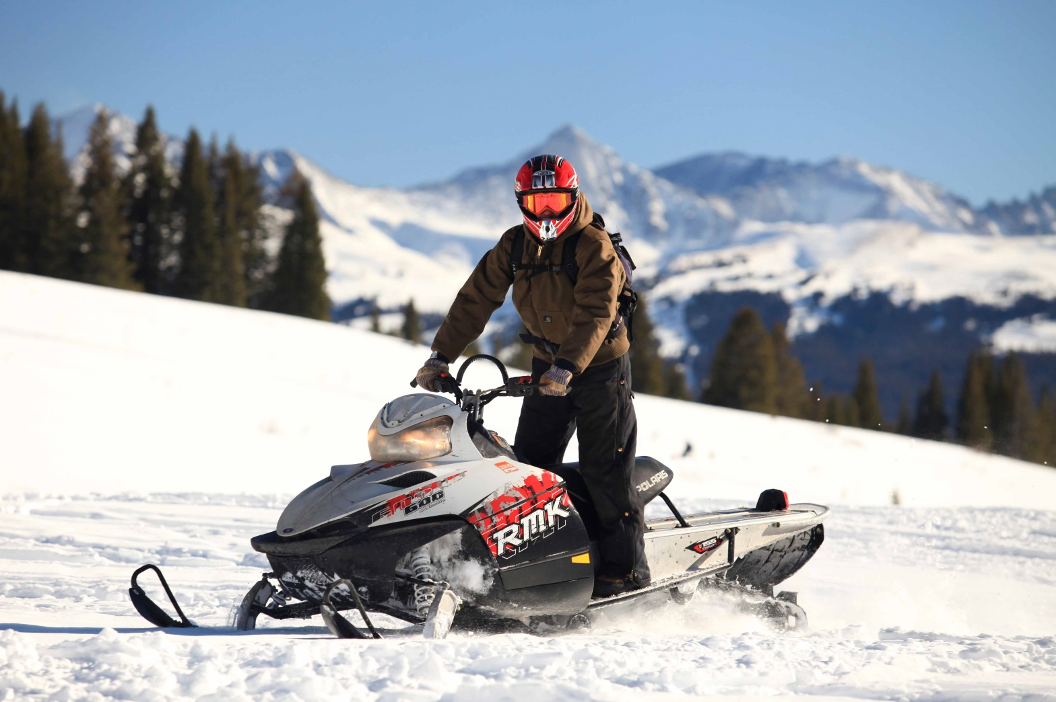](http://www.google.fi/url?sa=i&rct=j&q=&esrc=s&source=images&cd=&cad=rja&uact=8&ved=0ahUKEwiu27Cp4PnKAhWIYJoKHTGAAqwQjRwIBw&url=http://www.breckenridgesnowmobiling.com/breckenridge-snowmobile-tours-wlliams-fork.htm&psig=AFQjCNH6YqbMzDdtOhFKqvSwAimiHkg2yQ&ust=1455624965740560)

[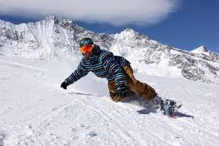](http://www.google.fi/url?sa=i&rct=j&q=&esrc=s&source=images&cd=&cad=rja&uact=8&ved=0ahUKEwjH-b3mhfrKAhXoC5oKHdsKCugQjRwIBw&url=http://users.rowan.edu/~marchi85/Snowboarding.html&psig=AFQjCNHhb_Ur6MH_0TPeYhApC18uEVHl9Q&ust=1455635166983915)

[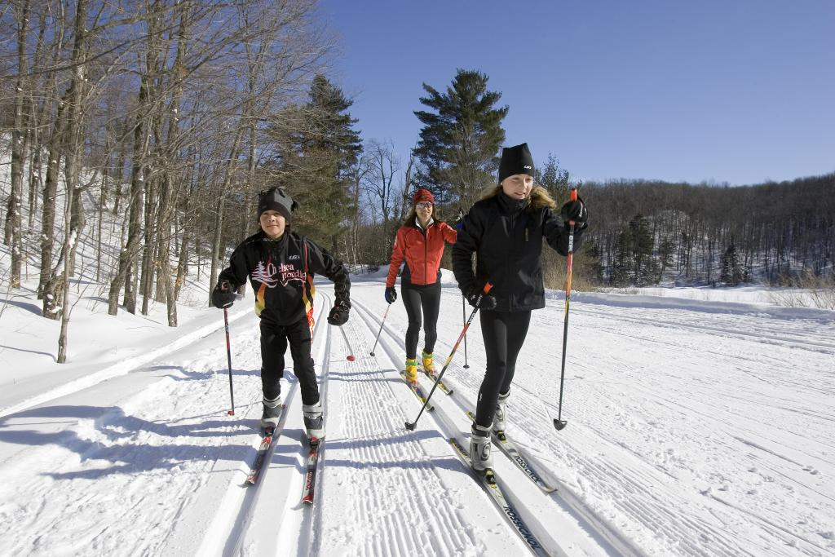](http://www.google.fi/url?sa=i&rct=j&q=&esrc=s&source=images&cd=&cad=rja&uact=8&ved=0ahUKEwjx9OaZ1vnKAhVBAZoKHQM9BwIQjRwIBw&url=http://www.ncc-ccn.gc.ca/places-to-visit/gatineau-park/things-to-do/cross-country-skiing-gatineau-park&bvm=bv.114195076,d.bGs&psig=AFQjCNHGW7NqqCCGyq0JjRVJiUseR8tPLQ&ust=1455622407898252)