[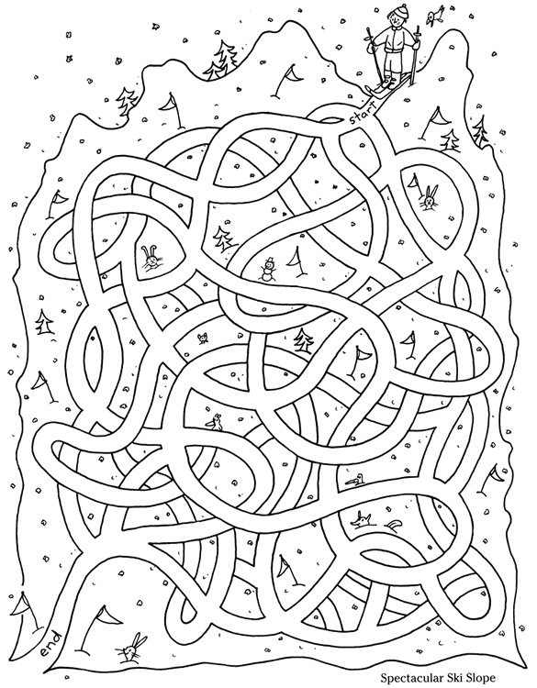](https://www.google.fi/url?sa=i&rct=j&q=&esrc=s&source=images&cd=&cad=rja&uact=8&ved=0ahUKEwjntpik3fnKAhWiIpoKHcyBD-EQjRwIBw&url=https://www.pinterest.com/pin/525584218985039526/&psig=AFQjCNH64hyejVawid7Fm6Z-FtomxzALtg&ust=1455624106803991)[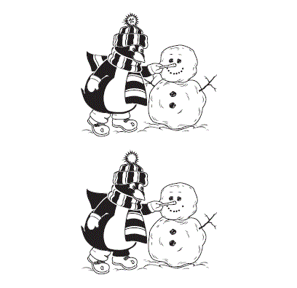](http://www.google.fi/url?sa=i&rct=j&q=&esrc=s&source=images&cd=&cad=rja&uact=8&ved=0ahUKEwidvIvv0Z_LAhXnAJoKHWdlCCsQjRwIBw&url=http://www.kiwimagonline.com/2011/08/spot-the-difference-penguin-snowman/&bvm=bv.115339255,d.ZWU&psig=AFQjCNGcVUohm67q_aOuAt59KJddL0Dt0Q&ust=1456926752158804)

