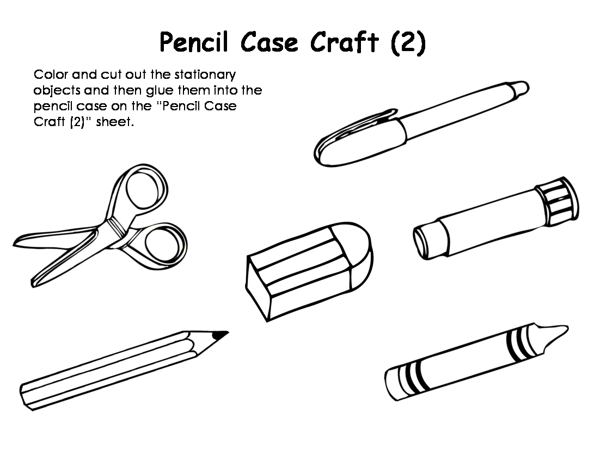

1. **COLOUR**
2. **CUT**
3. **GLUE ON THE PENCIL CASE**

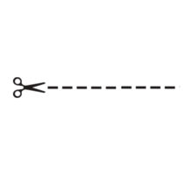

(NAME: ) __________________ ’S PENCIL CASE

