[](http://www.google.fi/url?sa=i&rct=j&q=&esrc=s&source=images&cd=&cad=rja&uact=8&ved=0CAcQjRxqFQoTCN6avfTa8cgCFQOLcgodYQAFWw&url=http://www.slideshare.net/MJSIMOES/esl-classroom-objects-video&psig=AFQjCNH9UT2cBkMrE0hJXlog1UU56wF1vA&ust=1446552669905438)[](http://www.google.fi/url?sa=i&rct=j&q=&esrc=s&source=images&cd=&cad=rja&uact=8&ved=0CAcQjRxqFQoTCI_w-Ibb8cgCFYTycgodEkEPCQ&url=http://www.slideshare.net/Teachersteam/objects-flashcards&psig=AFQjCNH9UT2cBkMrE0hJXlog1UU56wF1vA&ust=1446552669905438)[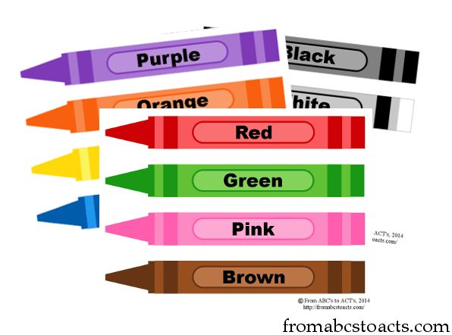](https://www.google.fi/url?sa=i&rct=j&q=&esrc=s&source=images&cd=&cad=rja&uact=8&ved=0CAcQjRxqFQoTCI3noq_b8cgCFeprcgodG5EAFw&url=https://www.pinterest.com/pin/541909767638836306/&bvm=bv.106379543,d.bGQ&psig=AFQjCNGYTDhhJyC7ReTSw9Wf7U46Z9fWpw&ust=1446552820719065)[](http://www.google.fi/url?sa=i&rct=j&q=&esrc=s&source=images&cd=&cad=rja&uact=8&ved=0CAcQjRxqFQoTCJfG08fb8cgCFWOPcgodDI0IVg&url=http://www.quia.com/jg/2030918list.html&bvm=bv.106379543,d.bGQ&psig=AFQjCNET7XUCzVBSRclz_S1HSU2DDEAt0A&ust=1446552872903812)[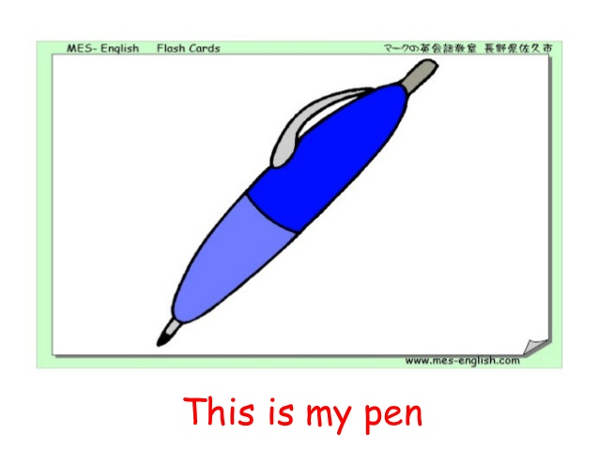](http://www.google.fi/url?sa=i&rct=j&q=&esrc=s&source=images&cd=&cad=rja&uact=8&ved=0CAcQjRxqFQoTCI3Ms57c8cgCFUX-cgodLdMPag&url=http://www.slideshare.net/Teachersteam/objects-flashcards&bvm=bv.106379543,d.bGQ&psig=AFQjCNF1LMvAunQqrIvjzStQJ9N0gcA3uw&ust=1446553060925452)

[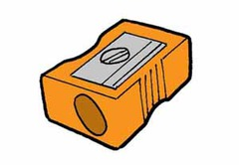](https://www.google.fi/url?sa=i&rct=j&q=&esrc=s&source=images&cd=&cad=rja&uact=8&ved=0CAcQjRxqFQoTCOzgn8jc8cgCFeSDcgodI3oMow&url=https://quizlet.com/67506850/more-7e-unit-4-in-my-bag-flash-cards/&bvm=bv.106379543,d.bGQ&psig=AFQjCNHGK_uXHUZ7vYJqDg3wsOHjX0sH-w&ust=1446553123401044)[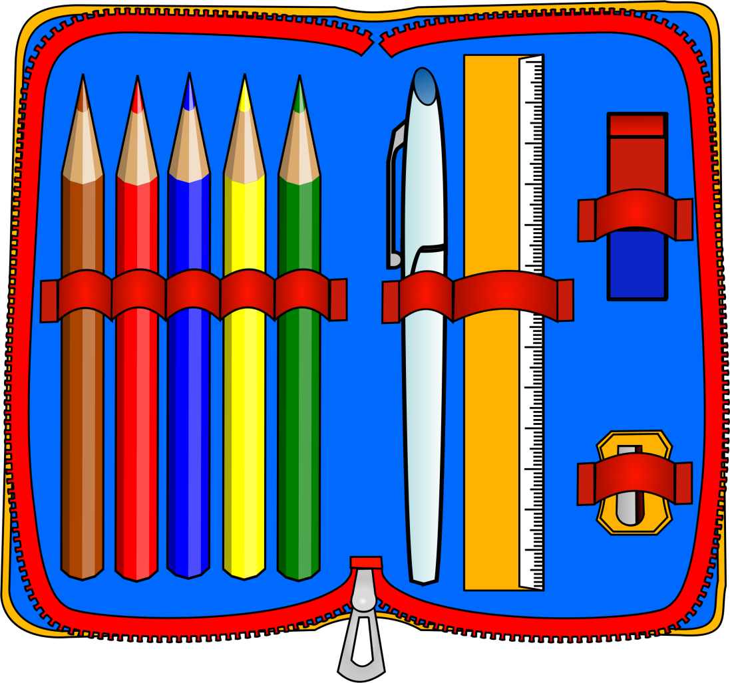](http://www.google.fi/url?sa=i&rct=j&q=&esrc=s&source=images&cd=&cad=rja&uact=8&ved=0CAcQjRxqFQoTCNHc4IHc8cgCFcUlcgodE3oKUw&url=http://blog.lili.farm/pages/p/pencil-case-clipart/&bvm=bv.106379543,d.bGQ&psig=AFQjCNGtBpqOhyPbqYuxq2T2-6fzFCIV2w&ust=1446552924039356)