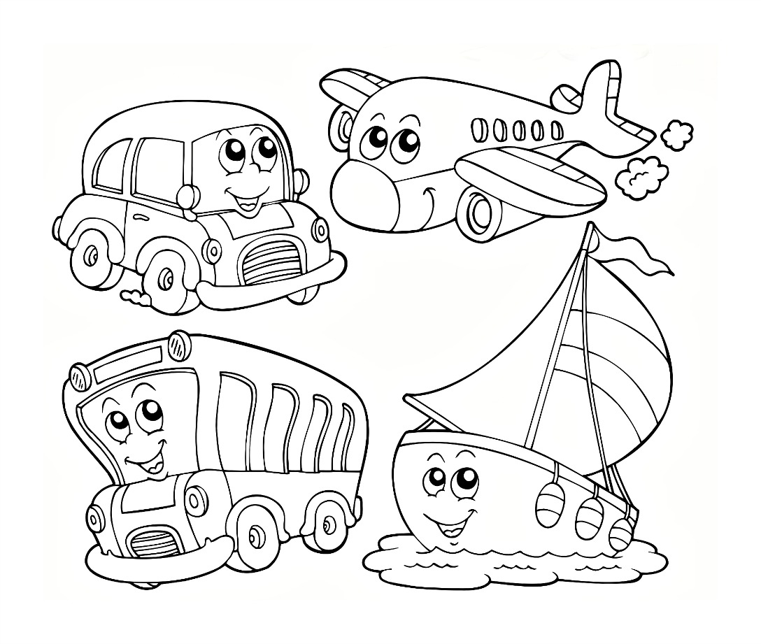

NAME:





AIRPLANE dot to dot