[](http://www.google.fi/url?sa=i&rct=j&q=&esrc=s&frm=1&source=images&cd=&cad=rja&uact=8&ved=0ahUKEwi7nse_x4HLAhVHpw4KHfkzDVcQjRwIBw&url=http://www.123rf.com/photo_25894970_funny-container-ship-comic.html&bvm=bv.114733917,d.ZWU&psig=AFQjCNEYz2TI6TAVNnbkLL8Id_az1HPZbw&ust=1455893306471654)[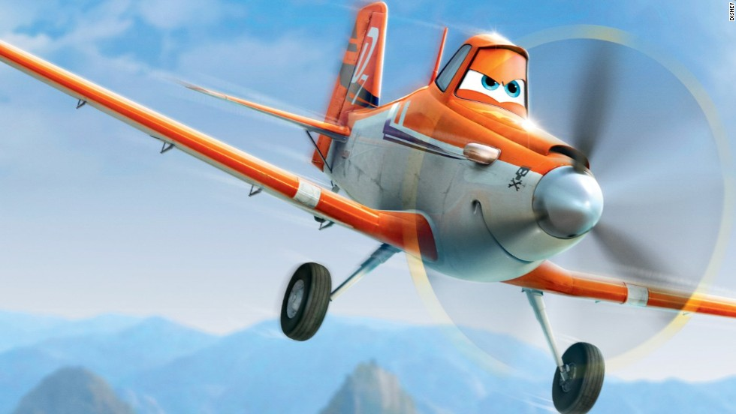](http://www.google.fi/url?sa=i&rct=j&q=&esrc=s&frm=1&source=images&cd=&cad=rja&uact=8&ved=0ahUKEwiGo9PsxoHLAhUBXg8KHXkfDCUQjRwIBw&url=http://www.cnn.com/2013/08/02/travel/disney-planes-film-bautista/&bvm=bv.114733917,d.ZWU&psig=AFQjCNEDWJaFlV_JoeIi7upoKNbzre52Rg&ust=1455893129732550)[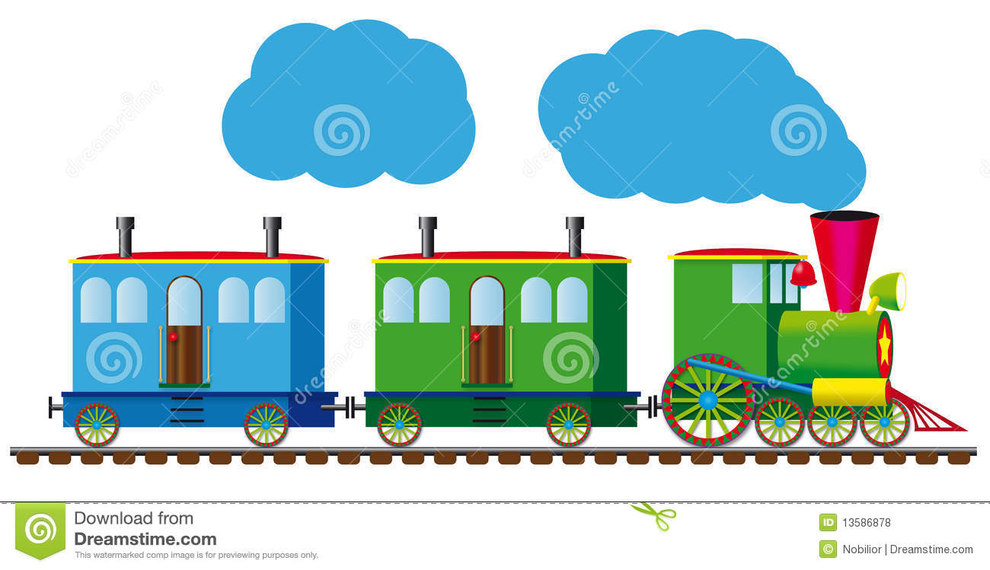](http://www.google.fi/url?sa=i&rct=j&q=&esrc=s&frm=1&source=images&cd=&cad=rja&uact=8&ved=0ahUKEwipw5yax4HLAhVCIQ8KHcWCAvIQjRwIBw&url=http://www.dreamstime.com/royalty-free-stock-photos-funny-train-image13586878&bvm=bv.114733917,d.ZWU&psig=AFQjCNGkduExojKR3DJdxqMkVrxh3Rfftg&ust=1455893202184648)[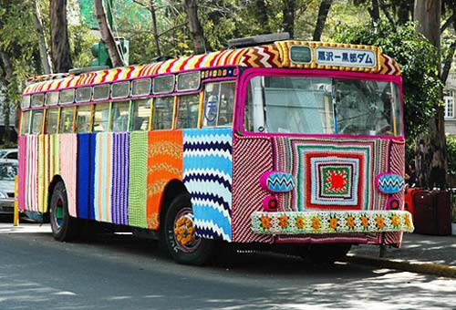](http://www.google.fi/url?sa=i&rct=j&q=&esrc=s&frm=1&source=images&cd=&cad=rja&uact=8&ved=0ahUKEwilxaOdxoHLAhVDew8KHUaiARMQjRwIBw&url=http://www.foundshit.com/tag/bus/&bvm=bv.114733917,d.ZWU&psig=AFQjCNGdFlSOMpf1TMaDbM7Cmpm8T9XqFA&ust=1455892909001933)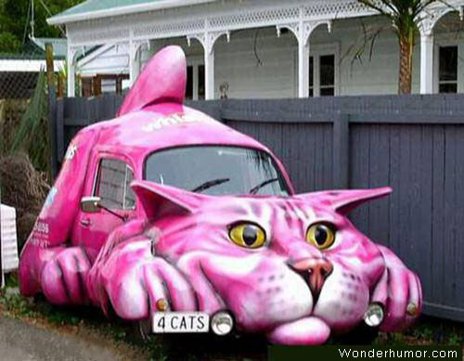[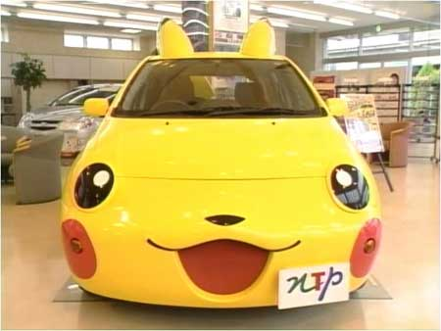](http://www.google.fi/url?sa=i&rct=j&q=&esrc=s&frm=1&source=images&cd=&cad=rja&uact=8&ved=0ahUKEwiqhvvWxYHLAhVFKw8KHaCXCqgQjRwIBw&url=http://www.funandcars.com/funny/fun-and-cars&psig=AFQjCNHPg8zKUoDQwrb8ozTbEtkyGoeFQA&ust=1455892719894563)[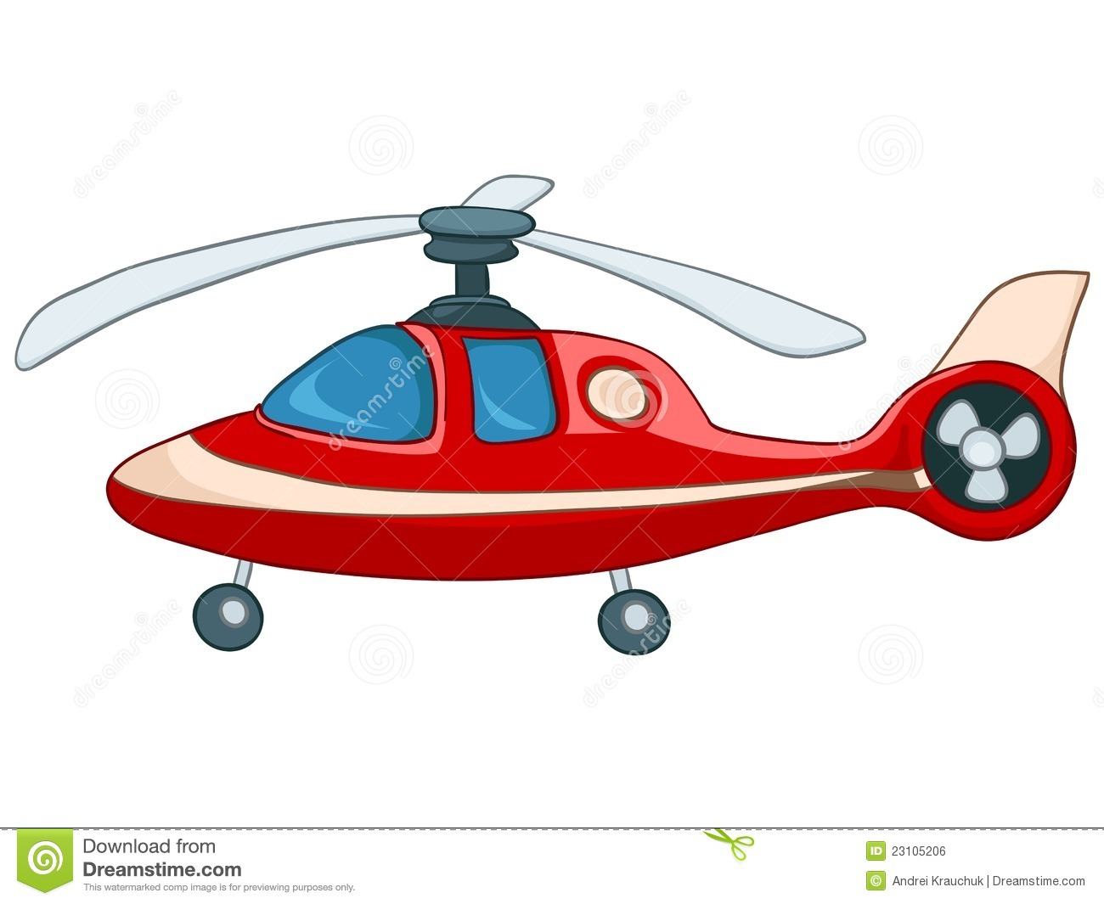](http://www.google.fi/url?sa=i&rct=j&q=&esrc=s&source=images&cd=&cad=rja&uact=8&ved=0ahUKEwjfjdekhILLAhXF_w4KHRd0DYYQjRwIBw&url=http://www.dreamstime.com/illustration/cartoon-helicopter.html&bvm=bv.114733917,d.ZWU&psig=AFQjCNE4QSz52Y2TqEPBMZSBDI1ztOV2Eg&ust=1455909651217931)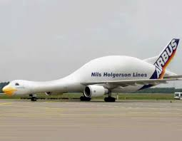

[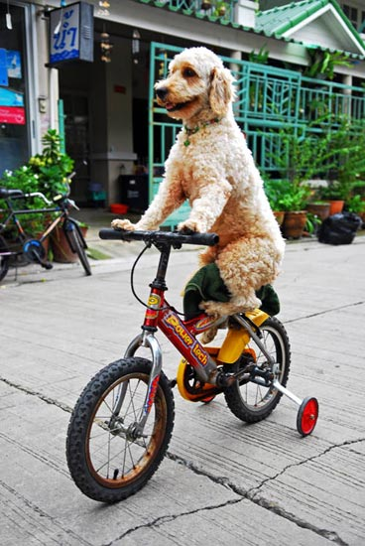](http://www.google.fi/url?sa=i&rct=j&q=&esrc=s&source=images&cd=&cad=rja&uact=8&ved=0ahUKEwjK3rrdhILLAhWFjQ8KHcCAB8cQjRwIBw&url=http://www.amusingtime.com/funny-dog-on-bicycle/&bvm=bv.114733917,d.ZWU&psig=AFQjCNGJnpNOTHUyA9nKNjk_CXhtxHMaWA&ust=1455909704496121)