[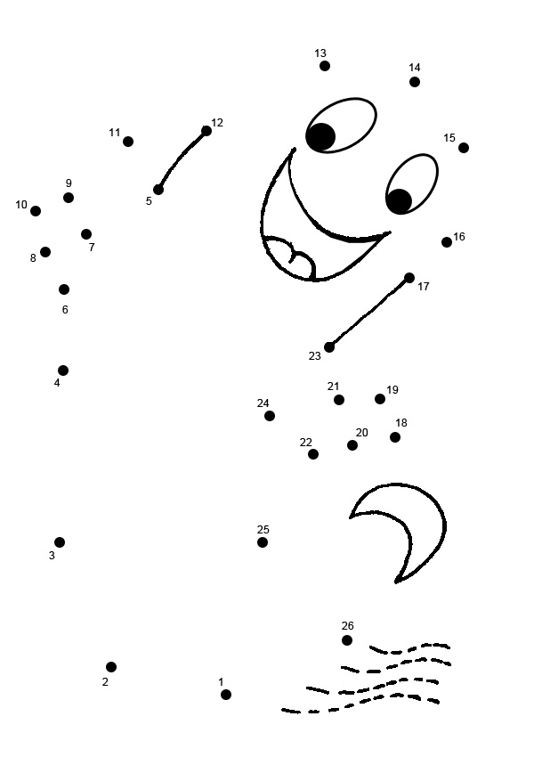](http://www.google.fi/url?sa=i&rct=j&q=&esrc=s&source=images&cd=&cad=rja&uact=8&ved=0CAcQjRxqFQoTCIGOydzq3cgCFQR_LAod504PPg&url=http://www.kidspot.com.au/slideshow/Kids-games-medium-dot-to-dot%2B71%2BHalloween-ghost-Dot-To-Dot%2B1028%2Bpreview.htm&bvm=bv.105841590,d.bGg&psig=AFQjCNFr0pBKZ_LD1quxzLZVo3zr_y5UWg&ust=1445869719202633)



[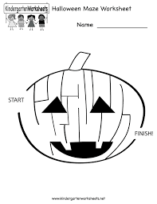](http://www.google.fi/url?sa=i&rct=j&q=&esrc=s&source=images&cd=&cad=rja&uact=8&ved=0CAcQjRxqFQoTCLbvhsi43cgCFULVcgod5o8K9A&url=http://www.kindergartenworksheets.net/halloween-worksheets/halloween-maze-worksheet.html&psig=AFQjCNFhShTA_p-Om8lL2tNuabjKXyAjeA&ust=1445855451422867)

[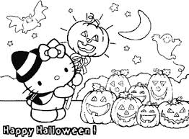](http://www.google.fi/imgres?imgurl=http://www.valentinesdaycardsprintables.com/wp-content/uploads/2015/10/Halloween-Coloring-Pages-For-Kids-Printables-Free.png&imgrefurl=http://porex.tk/2015/10/halloween-coloring-pages/&h=295&w=400&tbnid=7n8Z9lWPmaQ6oM:&docid=yGX-ihTJ3vP91M&itg=1&ei=CrIsVvqvA6OCygPx6qPYCQ&tbm=isch&ved=0CBoQMygXMBc4yAFqFQoTCPrcp_233cgCFSOBcgodcfUImw)

[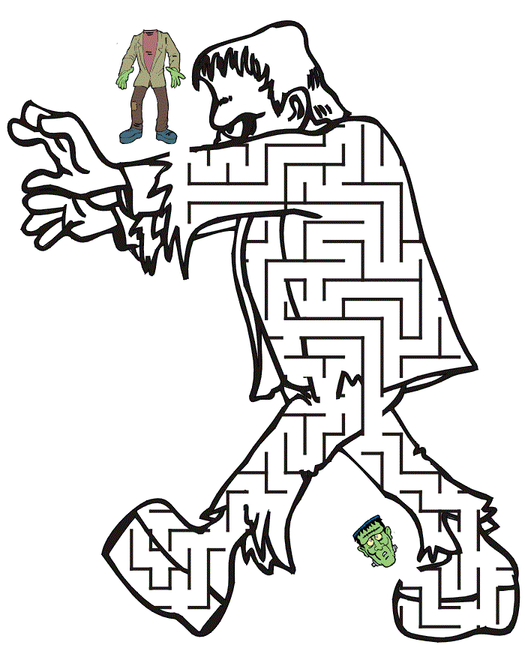](http://www.google.fi/url?sa=i&rct=j&q=&esrc=s&source=images&cd=&cad=rja&uact=8&ved=0CAcQjRxqFQoTCKfl_a3s3cgCFYGtLAodNNIMpQ&url=http://domitian.org/halloween-mazes/&bvm=bv.105841590,d.bGg&psig=AFQjCNGH4srGbrjnScj3JmNDah_DDcNB7g&ust=1445869871857129)



[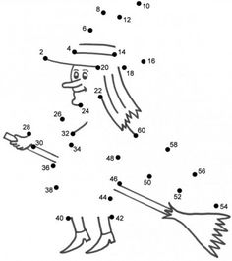](https://www.google.fi/url?sa=i&rct=j&q=&esrc=s&source=images&cd=&cad=rja&uact=8&ved=0CAcQjRxqFQoTCKjUwoHt3cgCFcLVLAodd0gMNg&url=https://www.pinterest.com/lorihinzsinn/5-halloween-coloring-pages/&bvm=bv.105841590,d.bGg&psig=AFQjCNGzupRphOOK0QNYo7An0f6gO2AhDA&ust=1445870258597365)

NAME:



NAME:



NAME:



NAME:



[](http://www.google.fi/imgres?imgurl=http://www.valentinesdaycardsprintables.com/wp-content/uploads/2015/10/Halloween-Coloring-Pages-For-Kids-Printables-Free.png&imgrefurl=http://porex.tk/2015/10/halloween-coloring-pages/&h=295&w=400&tbnid=7n8Z9lWPmaQ6oM:&docid=yGX-ihTJ3vP91M&itg=1&ei=CrIsVvqvA6OCygPx6qPYCQ&tbm=isch&ved=0CBoQMygXMBc4yAFqFQoTCPrcp_233cgCFSOBcgodcfUImw)

[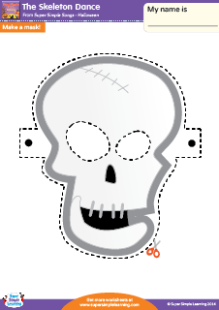](http://www.google.fi/url?sa=i&rct=j&q=&esrc=s&source=images&cd=&cad=rja&uact=8&ved=0CAcQjRxqFQoTCN2Duce23cgCFQX0cgodbAUM5g&url=http://supersimplelearning.com/resource-center/browse/song/s-v/skeleton-dance/&psig=AFQjCNFhShTA_p-Om8lL2tNuabjKXyAjeA&ust=1445855451422867)

HAPPY HALLOWEEN!