[](http://www.google.fi/url?sa=i&rct=j&q=&esrc=s&source=images&cd=&cad=rja&uact=8&ved=0CAcQjRxqFQoTCK2ouYO13cgCFerzcgodOj8HYA&url=http://www.hawthornestreet.com/2009/10/plg-halloween-trick-or-treat-route.html&bvm=bv.105841590,d.bGQ&psig=AFQjCNE0pQ4Llhc5nDlb1Fs8AWgjg9ed6A&ust=1445855333165470)

[](http://www.google.fi/url?sa=i&rct=j&q=&esrc=s&source=images&cd=&cad=rja&uact=8&ved=0CAcQjRxqFQoTCJnasuu03cgCFea-cgodr2kMAA&url=http://www.drawingstep.com/drawing-pumpkin-faces.html&bvm=bv.105841590,d.bGQ&psig=AFQjCNHosZ7eiaEkydzKRUGg11jfAiH2CQ&ust=1445855269686103)[](http://www.google.fi/url?sa=i&rct=j&q=&esrc=s&source=images&cd=&cad=rja&uact=8&ved=0CAcQjRxqFQoTCP6f5sq03cgCFUTPcgodSCQN0g&url=http://www.clipartpanda.com/clipart_images/happy-ghost-clip-art-vector-31315329&bvm=bv.105841590,d.bGQ&psig=AFQjCNH_U232eieWIwzAZ-qYTm5Srhg6Sw&ust=1445855202701225)

[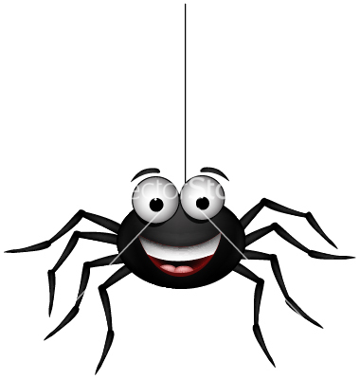](https://www.google.fi/url?sa=i&rct=j&q=&esrc=s&source=images&cd=&cad=rja&uact=8&ved=0CAcQjRxqFQoTCMemzK-03cgCFWQQcgodZcoHNA&url=https://www.vectorstock.com/royalty-free-vector/happy-spider-vector-1107456&bvm=bv.105841590,d.bGQ&psig=AFQjCNF0a8h4A3mdala8eDhK7rsuq6fPnw&ust=1445855163720463)[](http://www.google.fi/url?sa=i&rct=j&q=&esrc=s&source=images&cd=&cad=rja&uact=8&ved=0CAcQjRxqFQoTCMG42Ja03cgCFeGDcgodytwAxg&url=http://www.dreamstime.com/royalty-free-stock-photo-halloween-witch-image20656475&bvm=bv.105841590,d.bGQ&psig=AFQjCNHHUiakGFuPUWqvdi_u7o9GSEyfxQ&ust=1445855081680037)

[](http://www.google.fi/url?sa=i&rct=j&q=&esrc=s&source=images&cd=&cad=rja&uact=8&ved=0CAcQjRxqFQoTCMqi8u2z3cgCFQOmcgod-LMOTQ&url=http://www.dreamstime.com/royalty-free-stock-photos-thumbs-up-zombie-happy-giving-two-image36126398&bvm=bv.105841590,d.bGQ&psig=AFQjCNG_kZ97fHEAMUzdYalxlGTMYiBQOQ&ust=1445854991961837)