[](http://www.google.fi/url?sa=i&rct=j&q=&esrc=s&source=images&cd=&cad=rja&uact=8&ved=0ahUKEwjkv9uu_PvKAhXBKw8KHY44CaMQjRwIBw&url=http://www.someawesome.com/2015/10/inside-out-review-minimal-spoilers/&bvm=bv.114195076,d.ZWU&psig=AFQjCNHVmMHhXd3HcqX9BoA1IBWse0KcGQ&ust=1455701166005654)

[](https://www.google.fi/url?sa=i&rct=j&q=&esrc=s&source=images&cd=&cad=rja&uact=8&ved=0ahUKEwj_tuWo-_vKAhWDDw8KHWtqC5UQjRwIBw&url=https://www.pinterest.com/explore/feelings-chart/&bvm=bv.114195076,d.ZWU&psig=AFQjCNHChH-0W9bN5b0m6p9Baza3fIC3NA&ust=1455700667776881)

[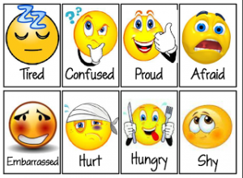](http://www.google.fi/url?sa=i&rct=j&q=&esrc=s&source=images&cd=&cad=rja&uact=8&ved=0ahUKEwitwPnf-vvKAhVICw8KHXgaDpAQjRwIBw&url=http://thestressdoctorisin.com/putting-words-feelings/&bvm=bv.114195076,d.ZWU&psig=AFQjCNHChH-0W9bN5b0m6p9Baza3fIC3NA&ust=1455700667776881)[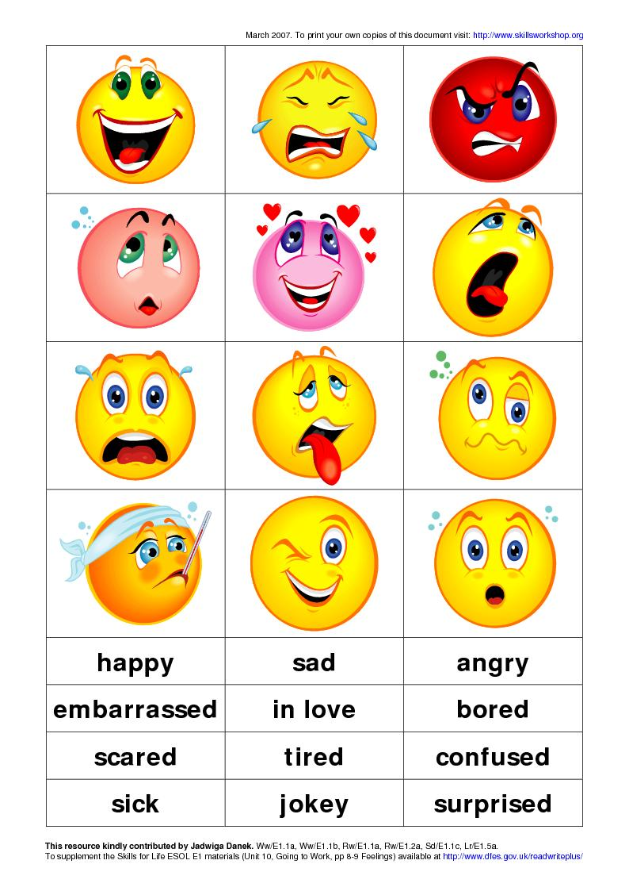](http://www.google.fi/url?sa=i&rct=j&q=&esrc=s&source=images&cd=&cad=rja&uact=8&ved=0ahUKEwiglbC__fvKAhWGKA8KHSDpDPMQjRwIBw&url=http://englishspot01.blogspot.com/2010/05/feelings-face-cards.html&bvm=bv.114195076,d.ZWU&psig=AFQjCNHChH-0W9bN5b0m6p9Baza3fIC3NA&ust=1455700667776881)

[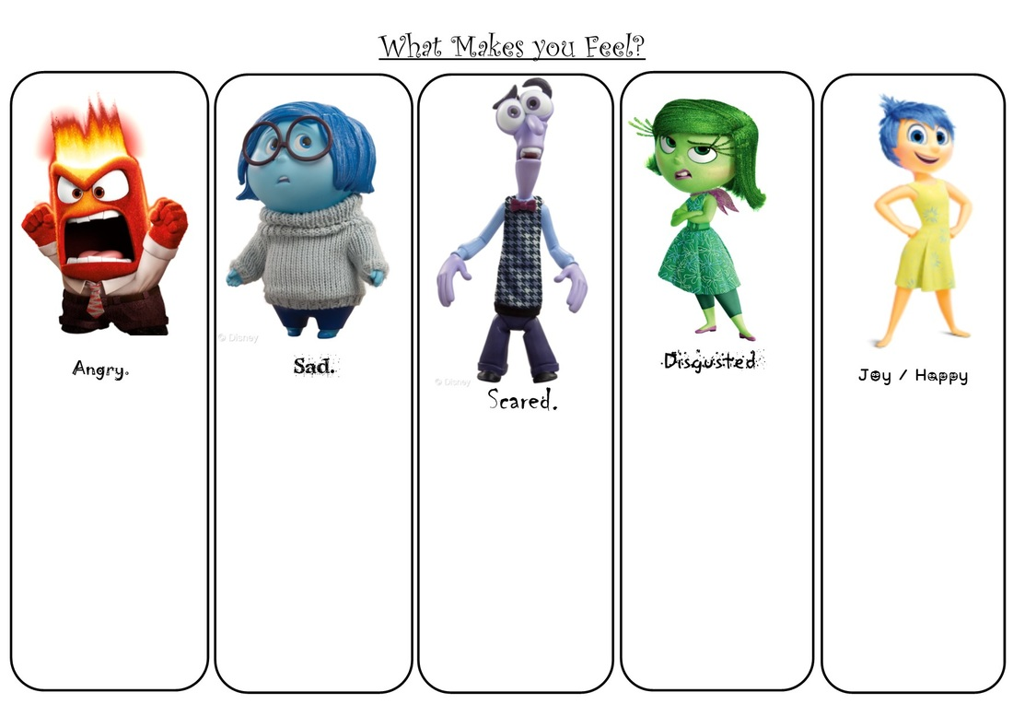](http://www.google.fi/url?sa=i&rct=j&q=&esrc=s&source=images&cd=&cad=rja&uact=8&ved=0ahUKEwivqpbj-_vKAhWChA8KHZEZAp8QjRwIBw&url=http://www.mathematicshed.com/miscellaneous.html&bvm=bv.114195076,d.ZWU&psig=AFQjCNHVmMHhXd3HcqX9BoA1IBWse0KcGQ&ust=1455701166005654)