[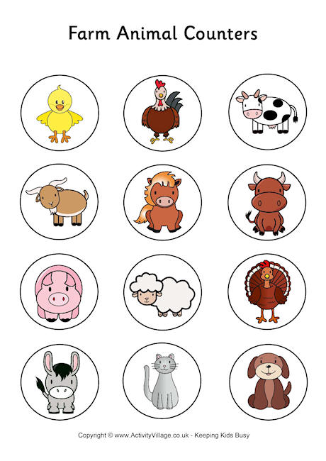](http://www.google.fi/url?sa=i&rct=j&q=&esrc=s&source=images&cd=&cad=rja&uact=8&ved=0CAcQjRxqFQoTCLTknvSUj8gCFebscgodH_cDBA&url=http://www.activityvillage.co.uk/farm-animal-counters&psig=AFQjCNG1t0lyxPruiPG5JfOEMVgfFGIzPA&ust=1443166064399368)

