[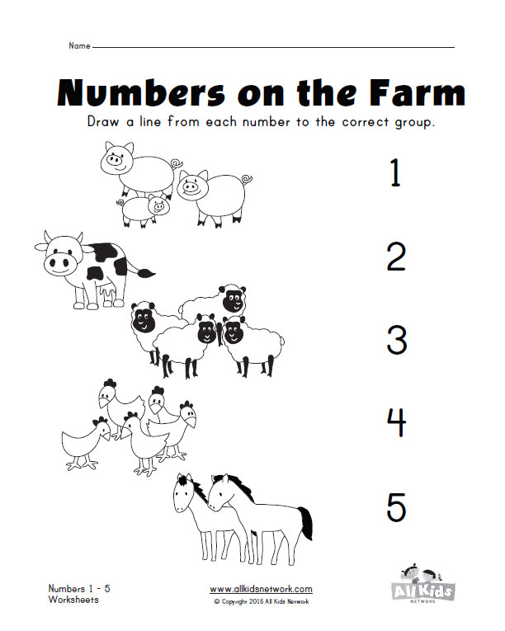](http://www.google.fi/url?sa=i&rct=j&q=&esrc=s&source=images&cd=&cad=rja&uact=8&ved=0CAcQjRxqFQoTCIfBiYKHisgCFYO_cgod6UIEQg&url=http://www.kidslearningstation.com/numbers/numbers-1-10/&bvm=bv.103073922,d.bGQ&psig=AFQjCNF2NDN5m9OQjM8zchOz4a5R14TjnQ&ust=1442990845371643)

[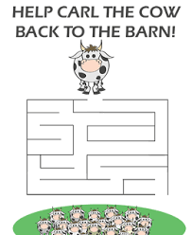](http://www.google.fi/url?sa=i&rct=j&q=&esrc=s&source=images&cd=&cad=rja&uact=8&ved=&url=http://laminating.blackanddecker.com/kids/carl-the-cow-maze.html&bvm=bv.113034660,d.bGg&psig=AFQjCNGYxnULkUI9_H_nXKqKP7EtZXPNrQ&ust=1454419221750886)



[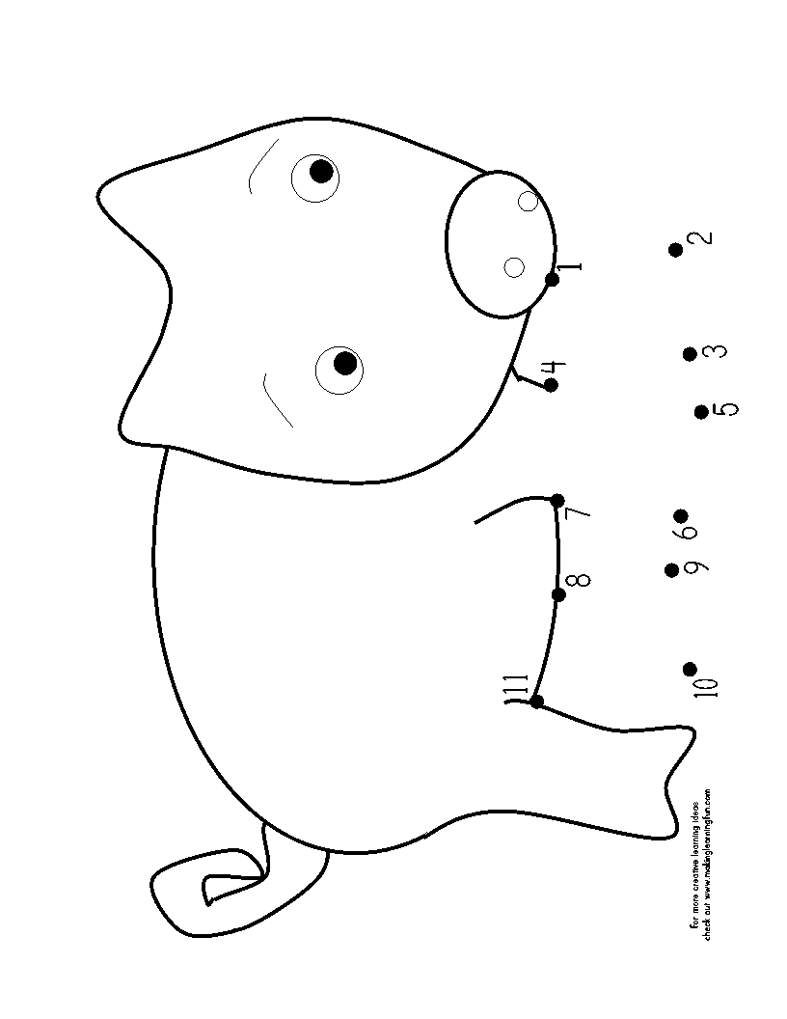](http://www.google.fi/url?sa=i&rct=j&q=&esrc=s&source=images&cd=&cad=rja&uact=8&ved=0ahUKEwiRvaH30tbKAhVIDywKHd-FAUcQjRwIBw&url=http://freecoloringpages.co.uk/?q%3Dstampy%20cat%20dot%20to%20dot&psig=AFQjCNF6fsw1wqdhLfq81AIohKX54XZ3BQ&ust=1454418875811227)

[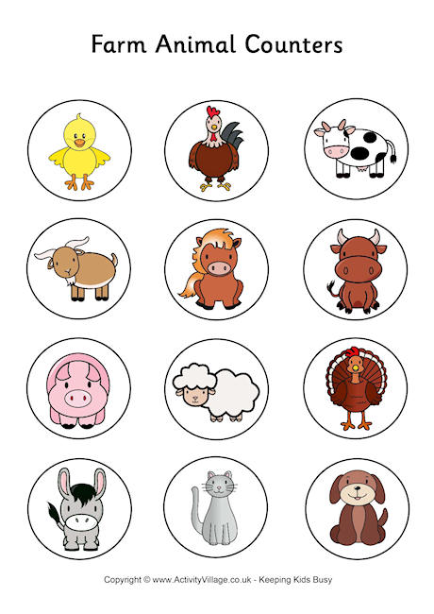](http://www.google.fi/url?sa=i&rct=j&q=&esrc=s&source=images&cd=&cad=rja&uact=8&ved=0CAcQjRxqFQoTCLTknvSUj8gCFebscgodH_cDBA&url=http://www.activityvillage.co.uk/farm-animal-counters&psig=AFQjCNG1t0lyxPruiPG5JfOEMVgfFGIzPA&ust=1443166064399368)

[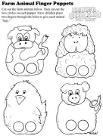](http://www.google.fi/url?sa=i&rct=j&q=&esrc=s&source=images&cd=&cad=rja&uact=8&ved=0CAcQjRxqFQoTCIHpovKSj8gCFavAcgodzq4Jvw&url=http://www.dcrhome.org/fun_pages.php&psig=AFQjCNG1t0lyxPruiPG5JfOEMVgfFGIzPA&ust=1443166064399368)

[](http://www.google.fi/url?sa=i&rct=j&q=&esrc=s&source=images&cd=&cad=rja&uact=8&ved=0CAcQjRxqFQoTCIfBiYKHisgCFYO_cgod6UIEQg&url=http://www.kidslearningstation.com/numbers/numbers-1-10/&bvm=bv.103073922,d.bGQ&psig=AFQjCNF2NDN5m9OQjM8zchOz4a5R14TjnQ&ust=1442990845371643)

[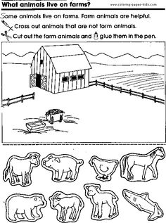](https://www.google.fi/url?sa=i&rct=j&q=&esrc=s&source=images&cd=&cad=rja&uact=8&ved=0CAcQjRxqFQoTCI-Qwc6GisgCFWP8cgodRzgEQg&url=https://www.pinterest.com/explore/farm-coloring-pages/&bvm=bv.103073922,d.bGQ&psig=AFQjCNF2NDN5m9OQjM8zchOz4a5R14TjnQ&ust=1442990845371643)[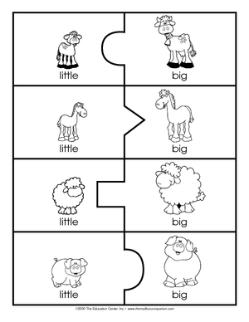](http://www.google.fi/url?sa=i&rct=j&q=&esrc=s&source=images&cd=&cad=rja&uact=8&ved=0CAcQjRxqFQoTCISJ1bqFisgCFcjycgodn2ICQg&url=http://search.theeducationcenter.com/educationproduct/baby-animals&psig=AFQjCNExTxRyfiSudFcknBDL_IL0uhRDFw&ust=1442990566161597)

[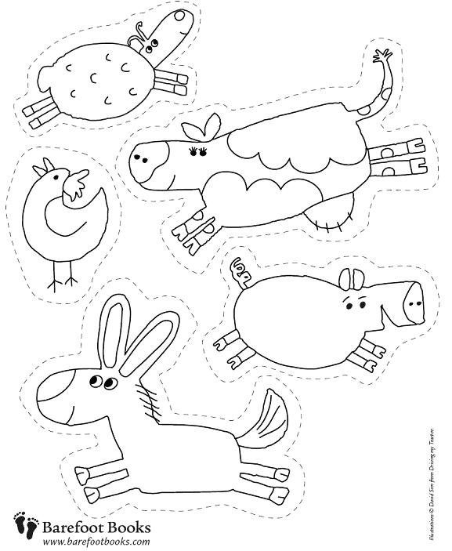](http://www.google.fi/url?sa=i&rct=j&q=&esrc=s&source=images&cd=&cad=rja&uact=8&ved=0CAcQjRxqFQoTCKX7upiFisgCFebzcgodgaULQQ&url=http://colorwithfun.com/category/farm/page/6/&psig=AFQjCNExTxRyfiSudFcknBDL_IL0uhRDFw&ust=1442990566161597)