[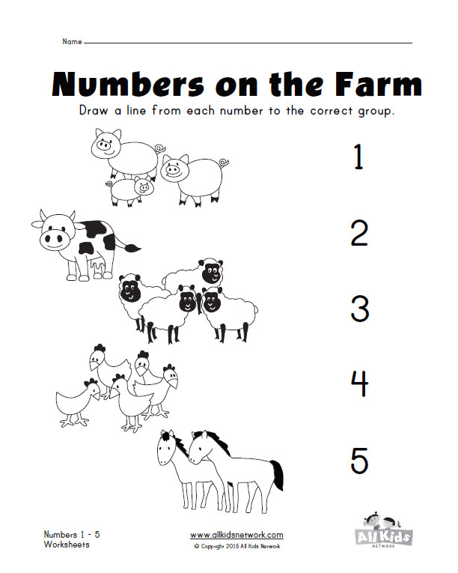](http://www.google.fi/url?sa=i&rct=j&q=&esrc=s&source=images&cd=&cad=rja&uact=8&ved=0CAcQjRxqFQoTCIfBiYKHisgCFYO_cgod6UIEQg&url=http://www.kidslearningstation.com/numbers/numbers-1-10/&bvm=bv.103073922,d.bGQ&psig=AFQjCNF2NDN5m9OQjM8zchOz4a5R14TjnQ&ust=1442990845371643)