[](http://www.google.fi/url?sa=i&rct=j&q=&esrc=s&source=images&cd=&cad=rja&uact=8&ved=0CAcQjRxqFQoTCPv19_nsqsgCFWXxcgodgb0F3g&url=http://www.eashidden.appspot.com/printablecolouringpages.co.uk/?s%3Dspidespiderman%2Blogo&bvm=bv.104317490,d.bGQ&psig=AFQjCNFBAGw2yXLjZHRs9ZXsbTlsGDQWCQ&ust=1444117965303219)

**___________ LIKES DOGS**

[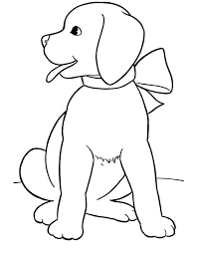](http://www.google.fi/url?sa=i&rct=j&q=&esrc=s&source=images&cd=&cad=rja&uact=8&ved=0CAcQjRxqFQoTCLL4t4-Oq8gCFcXZLAodBw8KEg&url=http://www.dreszon.com/spanish-coloring-page/&bvm=bv.104317490,d.bGg&psig=AFQjCNH8mtHs7yF5x9yW8rDiUI1V319aAw&ust=1444126850458158)

**___________ LIKES SPIDERS**

**___________ LIKES CATS**

[](http://www.google.fi/url?sa=i&rct=j&q=&esrc=s&source=images&cd=&ved=0CAcQjRxqFQoTCL-fp7mPq8gCFYQULAodK08NIw&url=http://www.dreszon.com/coloring-pages-of-football/&bvm=bv.104317490,d.bGg&psig=AFQjCNFZ9N0FQ1gdTVUCROwbc5mkKGj-6A&ust=1444127226395118)

**___________ LIKES LIZARDS**

[](https://www.google.fi/url?sa=i&rct=j&q=&esrc=s&source=images&cd=&cad=rja&uact=8&ved=0CAcQjRxqFQoTCLLXvL2Tq8gCFcsTLAod0tYDHw&url=https://masonillustration.wordpress.com/swirly-things/&psig=AFQjCNHKrb5_NsIbssbE18qmskAB59Z0qg&ust=1444128247999720)

[](http://www.google.fi/url?sa=i&rct=j&q=&esrc=s&source=images&cd=&ved=0CAcQjRxqFQoTCL-fp7mPq8gCFYQULAodK08NIw&url=http://www.dreszon.com/coloring-pages-of-football/&bvm=bv.104317490,d.bGg&psig=AFQjCNFZ9N0FQ1gdTVUCROwbc5mkKGj-6A&ust=1444127226395118)

**___________ LIKES CATS**

**___________ LIKES HORSES**

[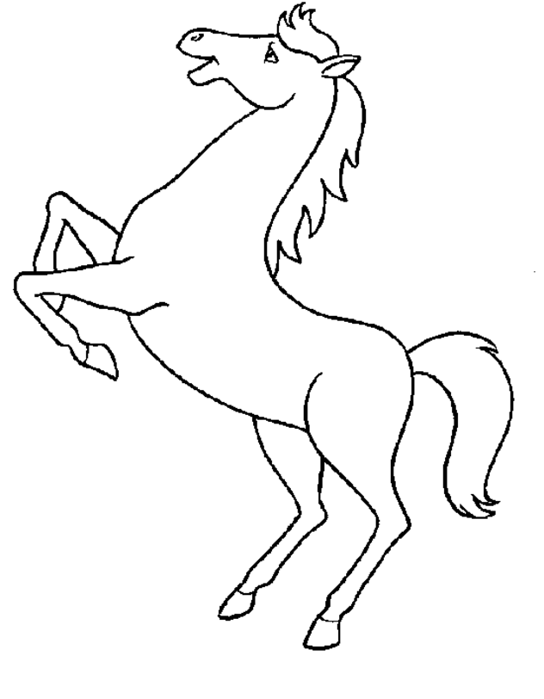](https://www.acoloringpages.net/2014/03/16/precious-moments-coloring-pages-printables/)

**___________ LIKES HORSES**

[](https://www.acoloringpages.net/2014/03/16/precious-moments-coloring-pages-printables/)

[](http://www.google.fi/url?sa=i&rct=j&q=&esrc=s&source=images&cd=&ved=0CAcQjRxqFQoTCL-fp7mPq8gCFYQULAodK08NIw&url=http://www.dreszon.com/coloring-pages-of-football/&bvm=bv.104317490,d.bGg&psig=AFQjCNFZ9N0FQ1gdTVUCROwbc5mkKGj-6A&ust=1444127226395118)

**___________ LIKES HORSES**

[](https://www.acoloringpages.net/2014/03/16/precious-moments-coloring-pages-printables/)

**___________ LIKES CATS**

**___________ LIKES DOGS**

[](http://www.google.fi/url?sa=i&rct=j&q=&esrc=s&source=images&cd=&cad=rja&uact=8&ved=0CAcQjRxqFQoTCLL4t4-Oq8gCFcXZLAodBw8KEg&url=http://www.dreszon.com/spanish-coloring-page/&bvm=bv.104317490,d.bGg&psig=AFQjCNH8mtHs7yF5x9yW8rDiUI1V319aAw&ust=1444126850458158)