[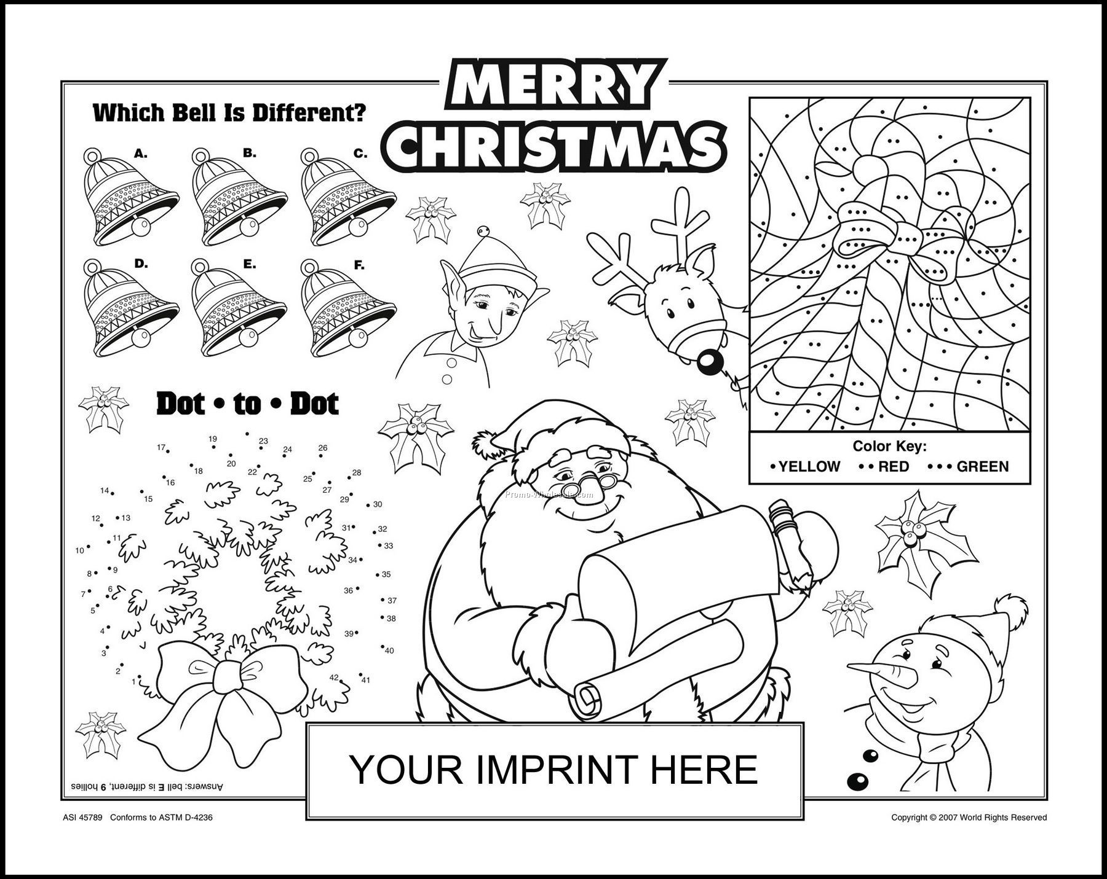](http://www.google.fi/url?sa=i&rct=j&q=&esrc=s&source=images&cd=&cad=rja&uact=8&ved=0ahUKEwi3oJP46MHJAhXq_HIKHbxNBCIQjRwIBw&url=http://www.eslprintables.com/forum/topic.asp?id%3D24792&bvm=bv.108538919,d.bGQ&psig=AFQjCNEKQzsdW0xT4-g1wkmUZY2uJf7ZLQ&ust=1449305239843741)

Sally

MERRY CHRISTMAS FROM