[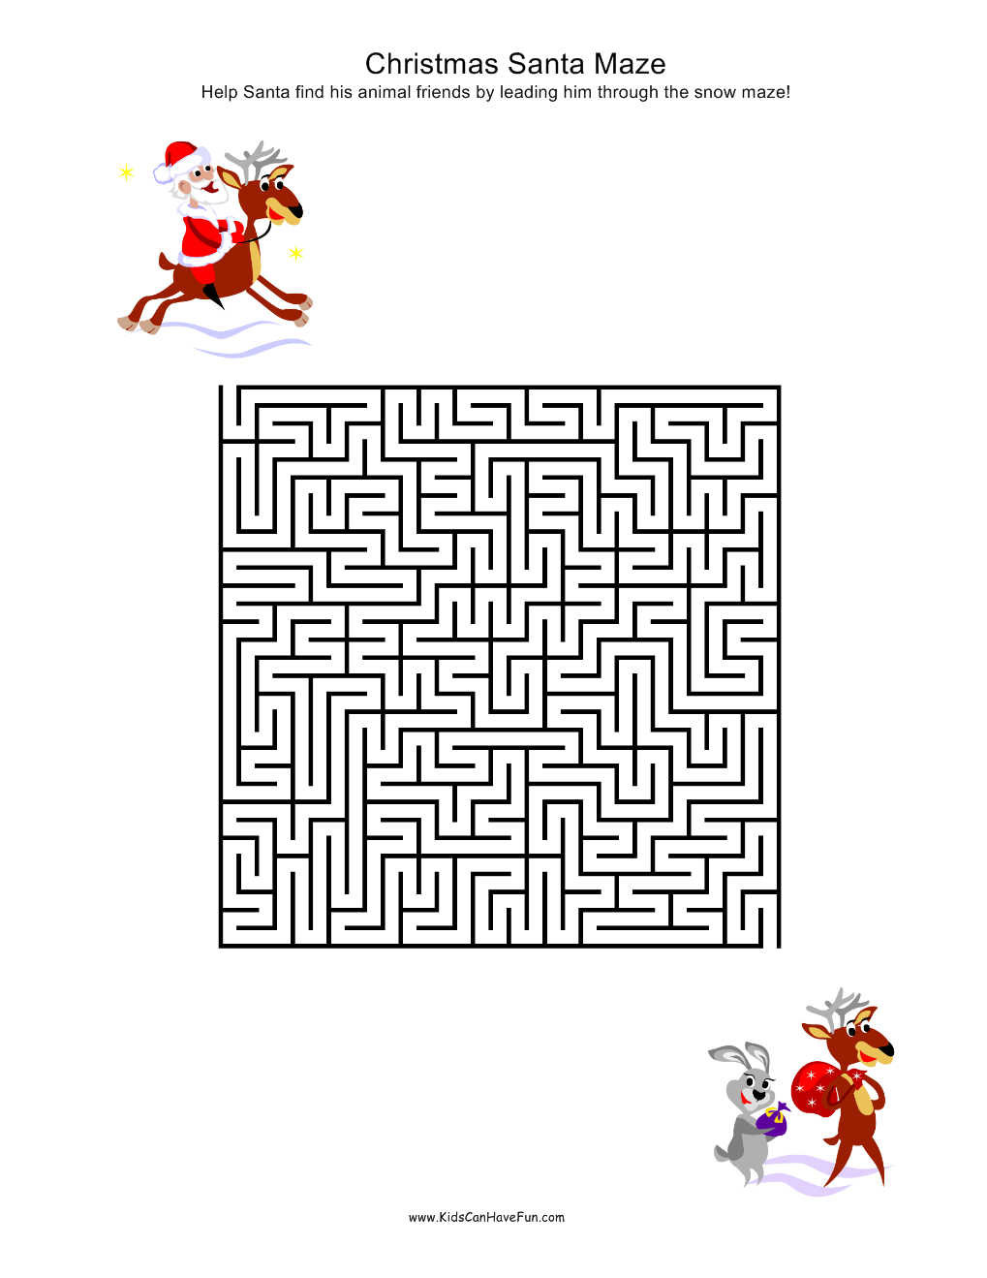](http://www.kidscanhavefun.com/blog/christmas-mazes/870/christmas-santa-maze/)

[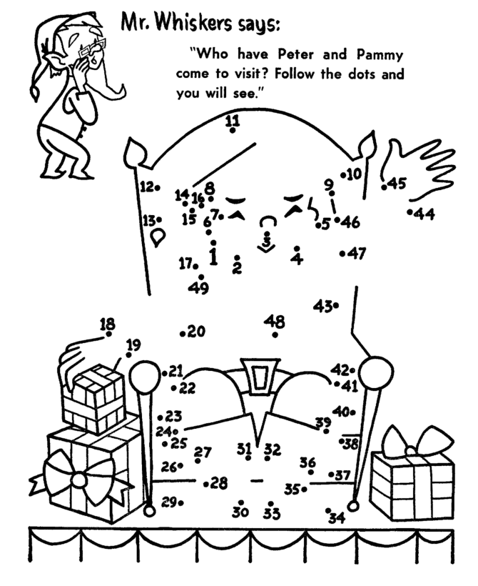](https://www.google.fi/url?sa=i&rct=j&q=&esrc=s&source=images&cd=&cad=rja&uact=8&ved=0ahUKEwiV_umWq8nJAhWEqnIKHd-6CDIQjRwIBw&url=https://www.pinterest.com/pin/375909900116833011/&bvm=bv.108538919,d.bGQ&psig=AFQjCNGwpBYmQThZYy4eggMqXXVSOBW9jg&ust=1449563499665465)

[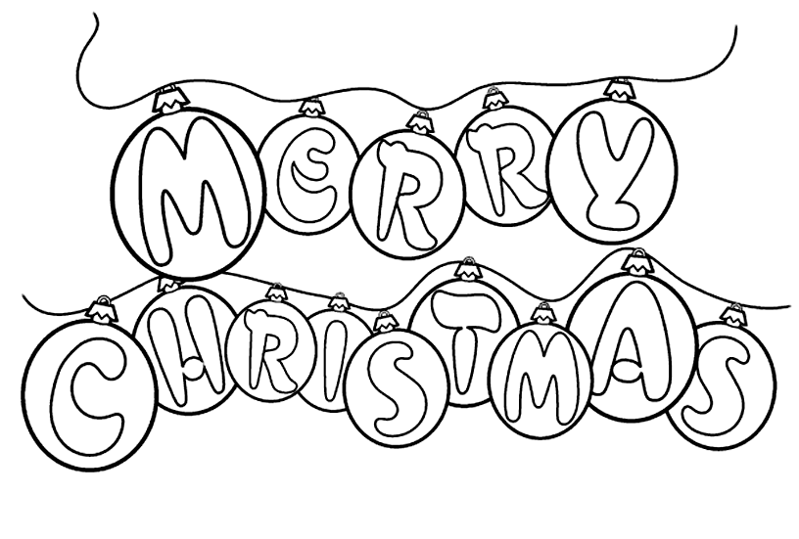](http://www.google.fi/url?sa=i&rct=j&q=&esrc=s&source=images&cd=&cad=rja&uact=8&ved=0ahUKEwj2wsuEkrvJAhUm8HIKHZOyDosQjRwIBw&url=http://www.onlycoloringpages.com/disney-merry-christmas-coloring-pages/5263.html&psig=AFQjCNFq_gt30WXSkagkfEtkqw0b7yuOLQ&ust=1449075349281696)

NAME:______________________________