[](http://www.google.fi/url?sa=i&rct=j&q=&esrc=s&source=images&cd=&cad=rja&uact=8&ved=0ahUKEwjHkcrEqcnJAhXDKnIKHS-JDCQQjRwIBw&url=http://cliparts.co/father-christmas-colouring-pictures&bvm=bv.108538919,d.bGQ&psig=AFQjCNEpR0HAVuwHQEdOXcz6THH2MnVgdg&ust=1449563032439049) [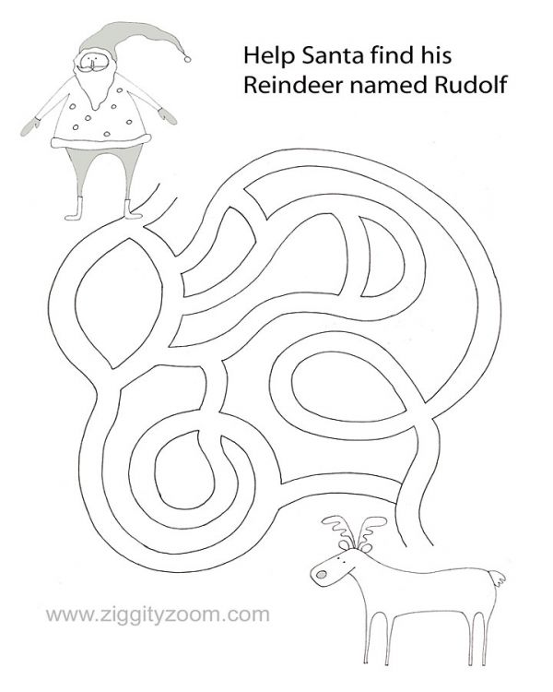](http://www.google.fi/url?sa=i&rct=j&q=&esrc=s&source=images&cd=&cad=rja&uact=8&ved=0ahUKEwjv6abrqMnJAhUm7nIKHaaLCsQQjRwIBw&url=http://www.ziggityzoom.com/activity/santa-maze-christmas-printable&psig=AFQjCNHCyKgjmrq5-BRhAK24rLrnbe1yaw&ust=1449562849378022)

NAME:

____________________

[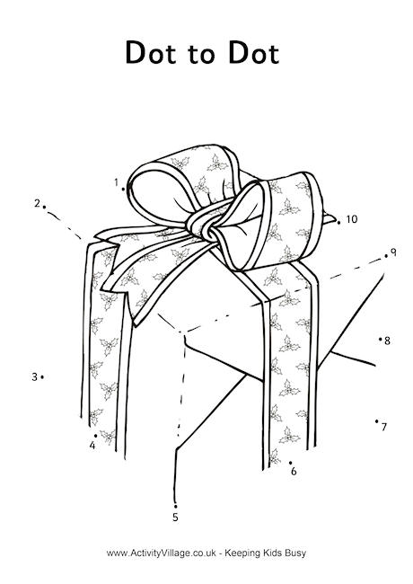](http://www.google.fi/url?sa=i&rct=j&q=&esrc=s&source=images&cd=&cad=rja&uact=8&ved=0ahUKEwjg_s_TqsnJAhUCgXIKHfnyAYwQjRwIBw&url=http://www.activityvillage.co.uk/christmas-dot-to-dots&bvm=bv.108538919,d.bGQ&psig=AFQjCNFnkgfwGv4TOfb5lRGgIKozVB9B2Q&ust=1449563399068051)

[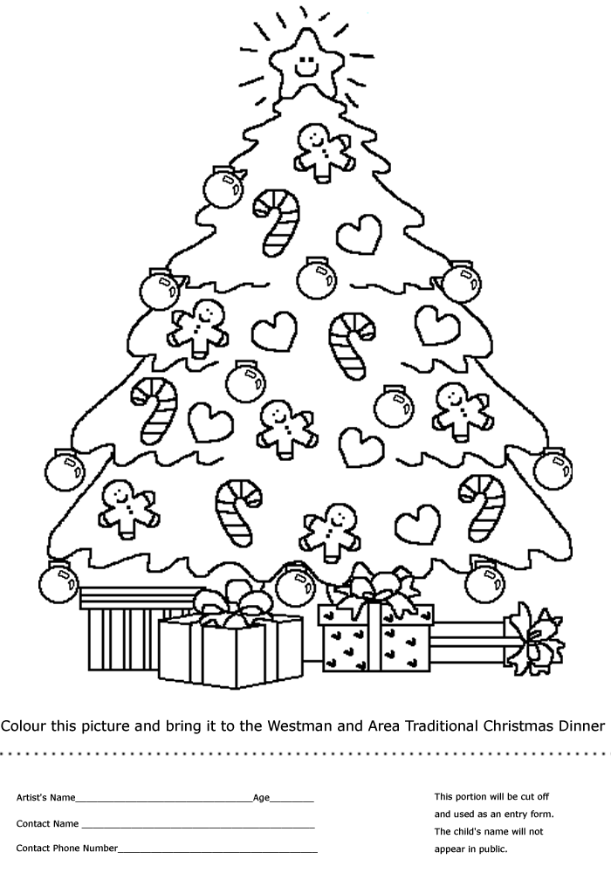](http://www.google.fi/url?sa=i&rct=j&q=&esrc=s&source=images&cd=&cad=rja&uact=8&ved=0ahUKEwj1iLe9qsnJAhVK7nIKHQGRCKIQjRwIBw&url=http://achristmaspicturesb.hol.es/christmas-pictures-to-print-and-colour/&bvm=bv.108538919,d.bGQ&psig=AFQjCNEpR0HAVuwHQEdOXcz6THH2MnVgdg&ust=1449563032439049)

[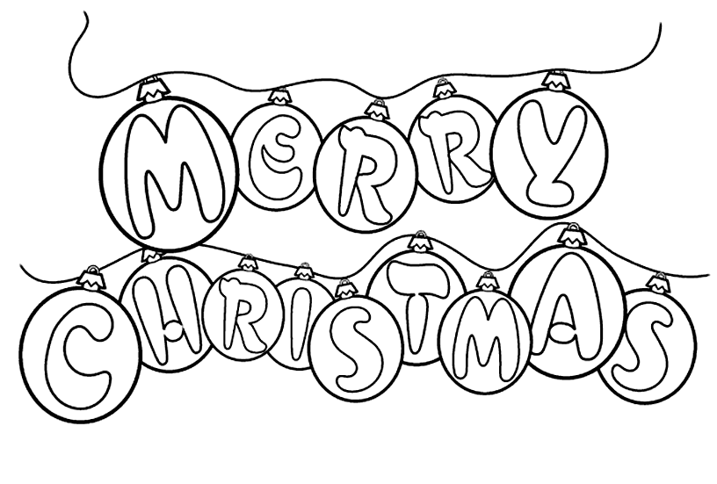](http://www.google.fi/url?sa=i&rct=j&q=&esrc=s&source=images&cd=&cad=rja&uact=8&ved=0ahUKEwj2wsuEkrvJAhUm8HIKHZOyDosQjRwIBw&url=http://www.onlycoloringpages.com/disney-merry-christmas-coloring-pages/5263.html&psig=AFQjCNFq_gt30WXSkagkfEtkqw0b7yuOLQ&ust=1449075349281696)