[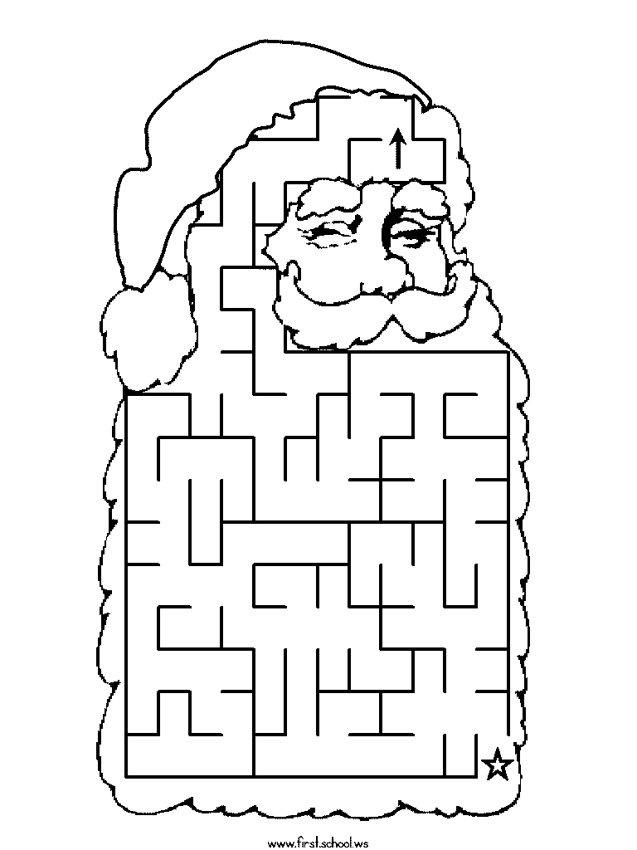](http://www.first-school.ws/t/preschool-mazes/santa-claus.html)

[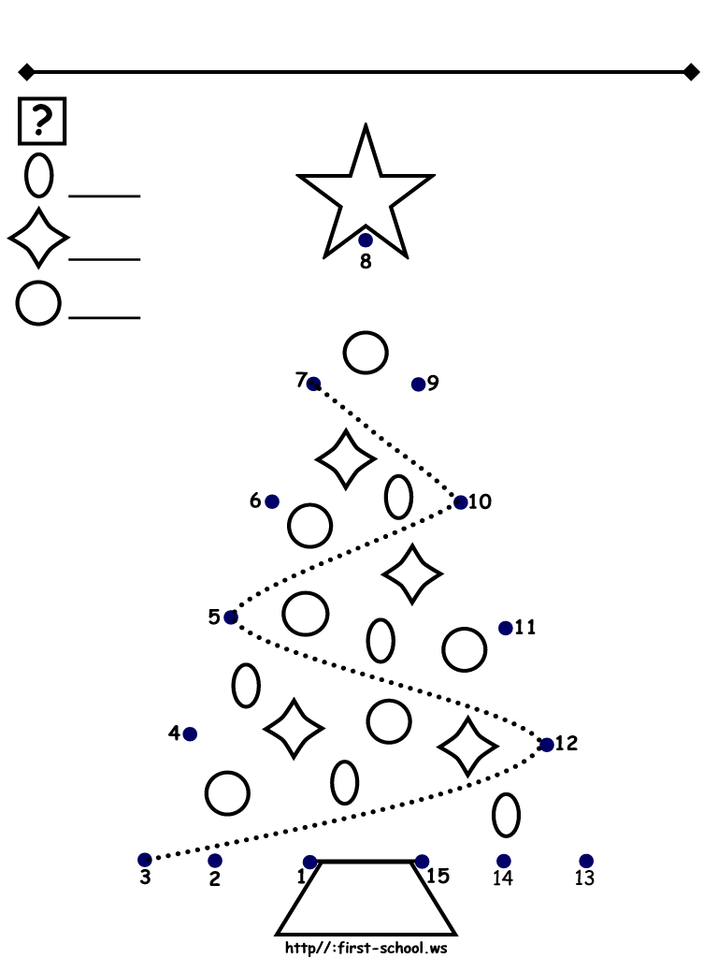](http://www.first-school.ws/t/ap/connect-the-dots/x-mas-tree-15.html)

[](http://www.google.fi/url?sa=i&rct=j&q=&esrc=s&source=images&cd=&cad=rja&uact=8&ved=0ahUKEwj2wsuEkrvJAhUm8HIKHZOyDosQjRwIBw&url=http://www.onlycoloringpages.com/disney-merry-christmas-coloring-pages/5263.html&psig=AFQjCNFq_gt30WXSkagkfEtkqw0b7yuOLQ&ust=1449075349281696)

NAME:______________________________