[](http://www.google.fi/url?sa=i&rct=j&q=&esrc=s&source=images&cd=&cad=rja&uact=8&ved=0ahUKEwirjJS9h7bJAhULJnIKHUhACQMQjRwIBw&url=http://www.dreamstime.com/royalty-free-stock-photo-snowman-clip-art-banners-borders-image3696955&bvm=bv.108194040,d.bGQ&psig=AFQjCNEDDvjxnlCeBpc3_wk5_1yVoBQL-g&ust=1448901124257486)

[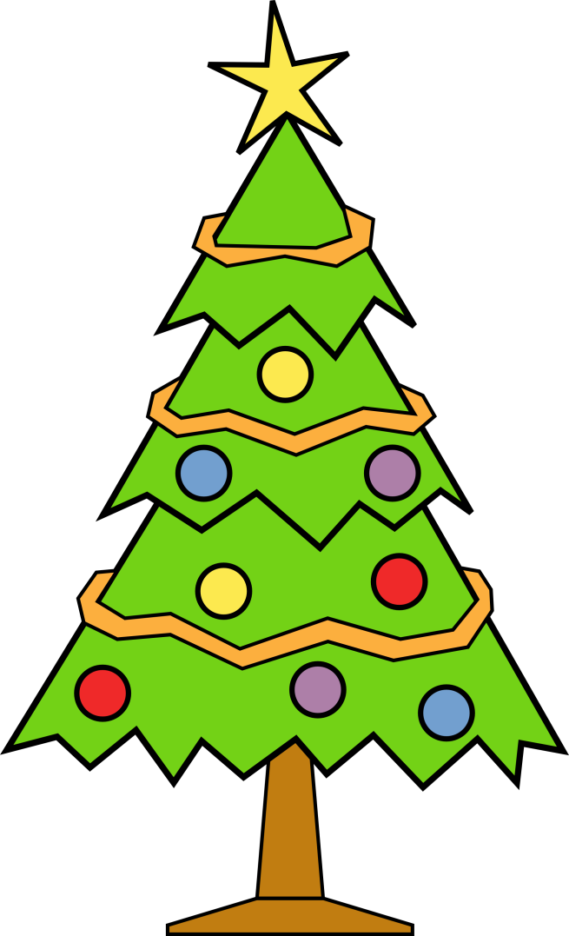](http://www.google.fi/url?sa=i&rct=j&q=&esrc=s&source=images&cd=&cad=rja&uact=8&ved=0ahUKEwjSreDvi7TJAhWKpnIKHUaTBwIQjRwIBw&url=http://cliparts.co/clip-art-christmas-tree&psig=AFQjCNHFfBqsf5KyOFFikRRVHQxXiqvJRQ&ust=1448833422023447)

[](http://www.google.fi/url?sa=i&rct=j&q=&esrc=s&source=images&cd=&cad=rja&uact=8&ved=0ahUKEwibg-L7i7TJAhWH_XIKHU6aDrsQjRwIBw&url=http://newchrismasrs.esy.es/christmas-present/&psig=AFQjCNHhEWJJKi8q2unYwYSiLSrV_VTu7w&ust=1448833615853489)

[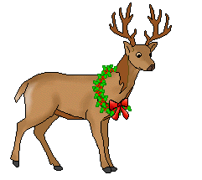](http://www.google.fi/url?sa=i&rct=j&q=&esrc=s&source=images&cd=&cad=rja&uact=8&ved=0ahUKEwiu99f5hrbJAhUiMnIKHSO8DO0QjRwIBw&url=http://www.clipartpanda.com/clipart_images/reindeer-clip-art-4974349&bvm=bv.108194040,d.bGQ&psig=AFQjCNHAwex-7Q3qQAIZoK6SD5ngfF1q7g&ust=1448900895496895)

[](http://www.google.fi/url?sa=i&rct=j&q=&esrc=s&source=images&cd=&cad=rja&uact=8&ved=0ahUKEwjDpcSOiLbJAhUhLHIKHQCvDrkQjRwIBw&url=http://letoukan.fr/tag-santa-claus-clipart.html&bvm=bv.108194040,d.bGQ&psig=AFQjCNHbp8SjRIoVBadAynq0D8wK1TdlBQ&ust=1448901292944025)

[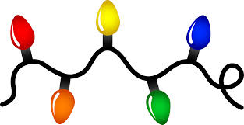](http://www.google.fi/url?sa=i&rct=j&q=&esrc=s&source=images&cd=&cad=rja&uact=8&ved=0ahUKEwjCj57KiLbJAhXl8XIKHdVfAwIQjRwIBw&url=http://www.clipartpanda.com/categories/christmas-clipart-borders-free-for-mac&bvm=bv.108194040,d.bGQ&psig=AFQjCNGxETl4cSrmv19eMFnT0pT3zmtG0g&ust=1448901381236870)

[](http://www.google.fi/url?sa=i&rct=j&q=&esrc=s&source=images&cd=&cad=rja&uact=8&ved=0ahUKEwjY9cXfj7bJAhVl8HIKHWf5DSMQjRwIBw&url=http://www.clker.com/clipart-candle-11.html&psig=AFQjCNGSjqA8SyQ89-3l-y53GdKs2g_oeg&ust=1448903346387434)