**sustainability – Europe’s youth can make a difference!**

While you have been working on cultural similarities and differences of Finland and Germany to get to know each other’s home country and mentality a bit better, we want to work on a very topical issue here in Germany.

All over Europe students have become active in making people, especially politicians, aware of the urgent problems we are facing. Only few people are still doubting that climate change and loss of diversity is not the threat of our time. We are approaching a situation that calls for action.

The well-known ‘’Fridays for Future’’ movement has spread all around the globe and we want to take our meeting as an international group as an opportunity to work on these issues.

It is no secret that the only solution to all the problems humans (and not your generation) have caused is to change our ways of living. S**ustainability** is the key concept here.

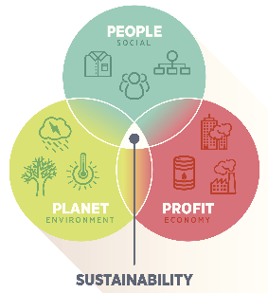

This morning we would like you to invest some time on what problems mankind face and work on how to face those challenges. For this we want to look at the big problems first and then try to work on small solutions, as everyone can only work on himself/herself to set a small change in motion.

Why not start just looking at our little lives and maybe learn from each other?

**How to go ahead?**

1. In your group discuss your opinion and knowledge about the ‘**Fridays for Future’** movement. How do you feel about it? Did you participate? What did other people (friends, parents) say about it? Was/ Is it (still) important for Finish/ German students? How did the different governments/ Ministries of Education respond to this movement?

Prepare a mind-map (A3) on your ideas and put it up on the wall when you have finished.

1. Now discuss the term **sustainability.** Check the definition (illustration) and make sure you all understand it in the same way. Take this as a starting point.
2. From the list below choose a problem field/ challenge you would like to work on. There are films to get into this topic (pen-drive). They illustrate problems or possible solutions . Try to agree on what you would like to work on.
3. Discuss your personal experience in your group. How do Finish or German people deal with this problem? Are there differences/ similarities? What are the main facts you need to have to fully understand the problem?
4. In your group agree on aspects you’d like to do some research on now to get a full view of the problem. Do some research (tablets/ Inf room in lesson 1-3). Take notes on your findings.
5. Now comes the important bit: what can you as one small person do? What can you personally change/ or keep doing in your life to reduce this problem? Try to be realistic but creative with ideas because this is how changes start.
6. Present your results in the **form of an interview** you film.
   1. Make sure this interview gives an introduction to the problem and give reasons why it needs to be tackled.
   2. Describe/ illustrate the problem further to avoid being superficial.
   3. Give solutions/ answers to the questions that go along with the question.
   4. Try to work on differences/ similarities in Finland/ Germany if there are any.
   5. Break down this solution to a very small scale: what can you as individuals do in your lives to move in the right direction?
   6. Note down all your text, for the filming you will also be given time at the end of the excursion on Thursday.
   7. Decide on **who** in your group is responsible for editing/ cutting of the film. All group members should be mentioned and seen on the screen at some point.
   8. Put your film on the pen-drive.

**Challenges that lie ahead of us:**

topic 1 How have we changed the world? loss of diversity

How can we make a difference?

topic 2 How have we changed the world? food production/agriculture

How can we make a difference?

topic 3 How have we changed the world? transport

How can we make a difference?

topic 4 How have we changed the world? travel/ tourism

How can we make a difference?

topic 5 How have we changed the world? waste/ plastic

How can we make a difference?

topic 6 How have we changed the world? life in the city

How can we make a difference?

topic 7 How have we changed the world? your topic

How can we make a difference?

Tasks:

**group 3 – the loss of biodiversity**

protest in Paris at the World Biodiversity Conference in Paris in May, 2019

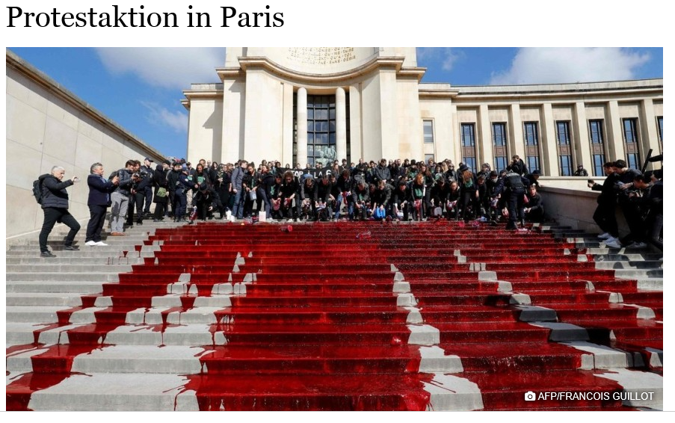

activists pour gallons of artificial blood down the conference building to express their concern about mass extinction

UN-backed report, one million species face the risk of extinction, many within decades. This loss of biodiversity is likely to have a direct and lasting impact on human life. But it's not too late to fix the problem, the report's authors say

film:

What is climate change and why does it receive so much attention these days? Human activities are heating up Earth, with far-reaching consequences, changing biodiversity levels and distributions at alarming, unprecedented rates.

links

<https://www.dw.com/en/why-biodiversity-loss-hurts-humans-as-much-as-climate-change/a-48579014>

[https://science.sciencemag.org/content/360/6390/791](https://science.sciencemag.org/content/360/6390/791 )

videos

[UN report says species decline is 'unprecedented'](https://www.dw.com/overlay/media/en/un-report-says-species-decline-is-unprecedented/48626545/48579014)

