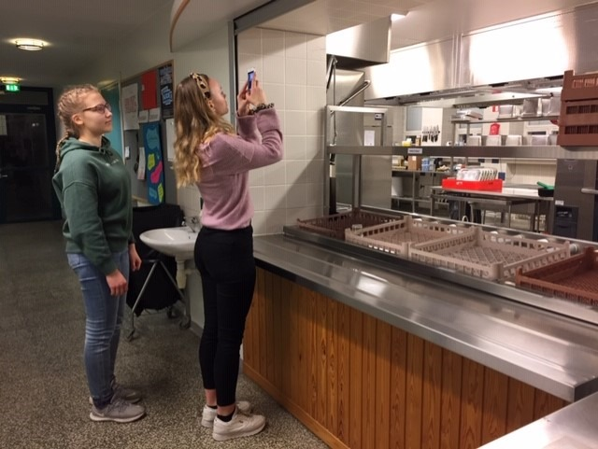
Find different ways of heat transfer in physics

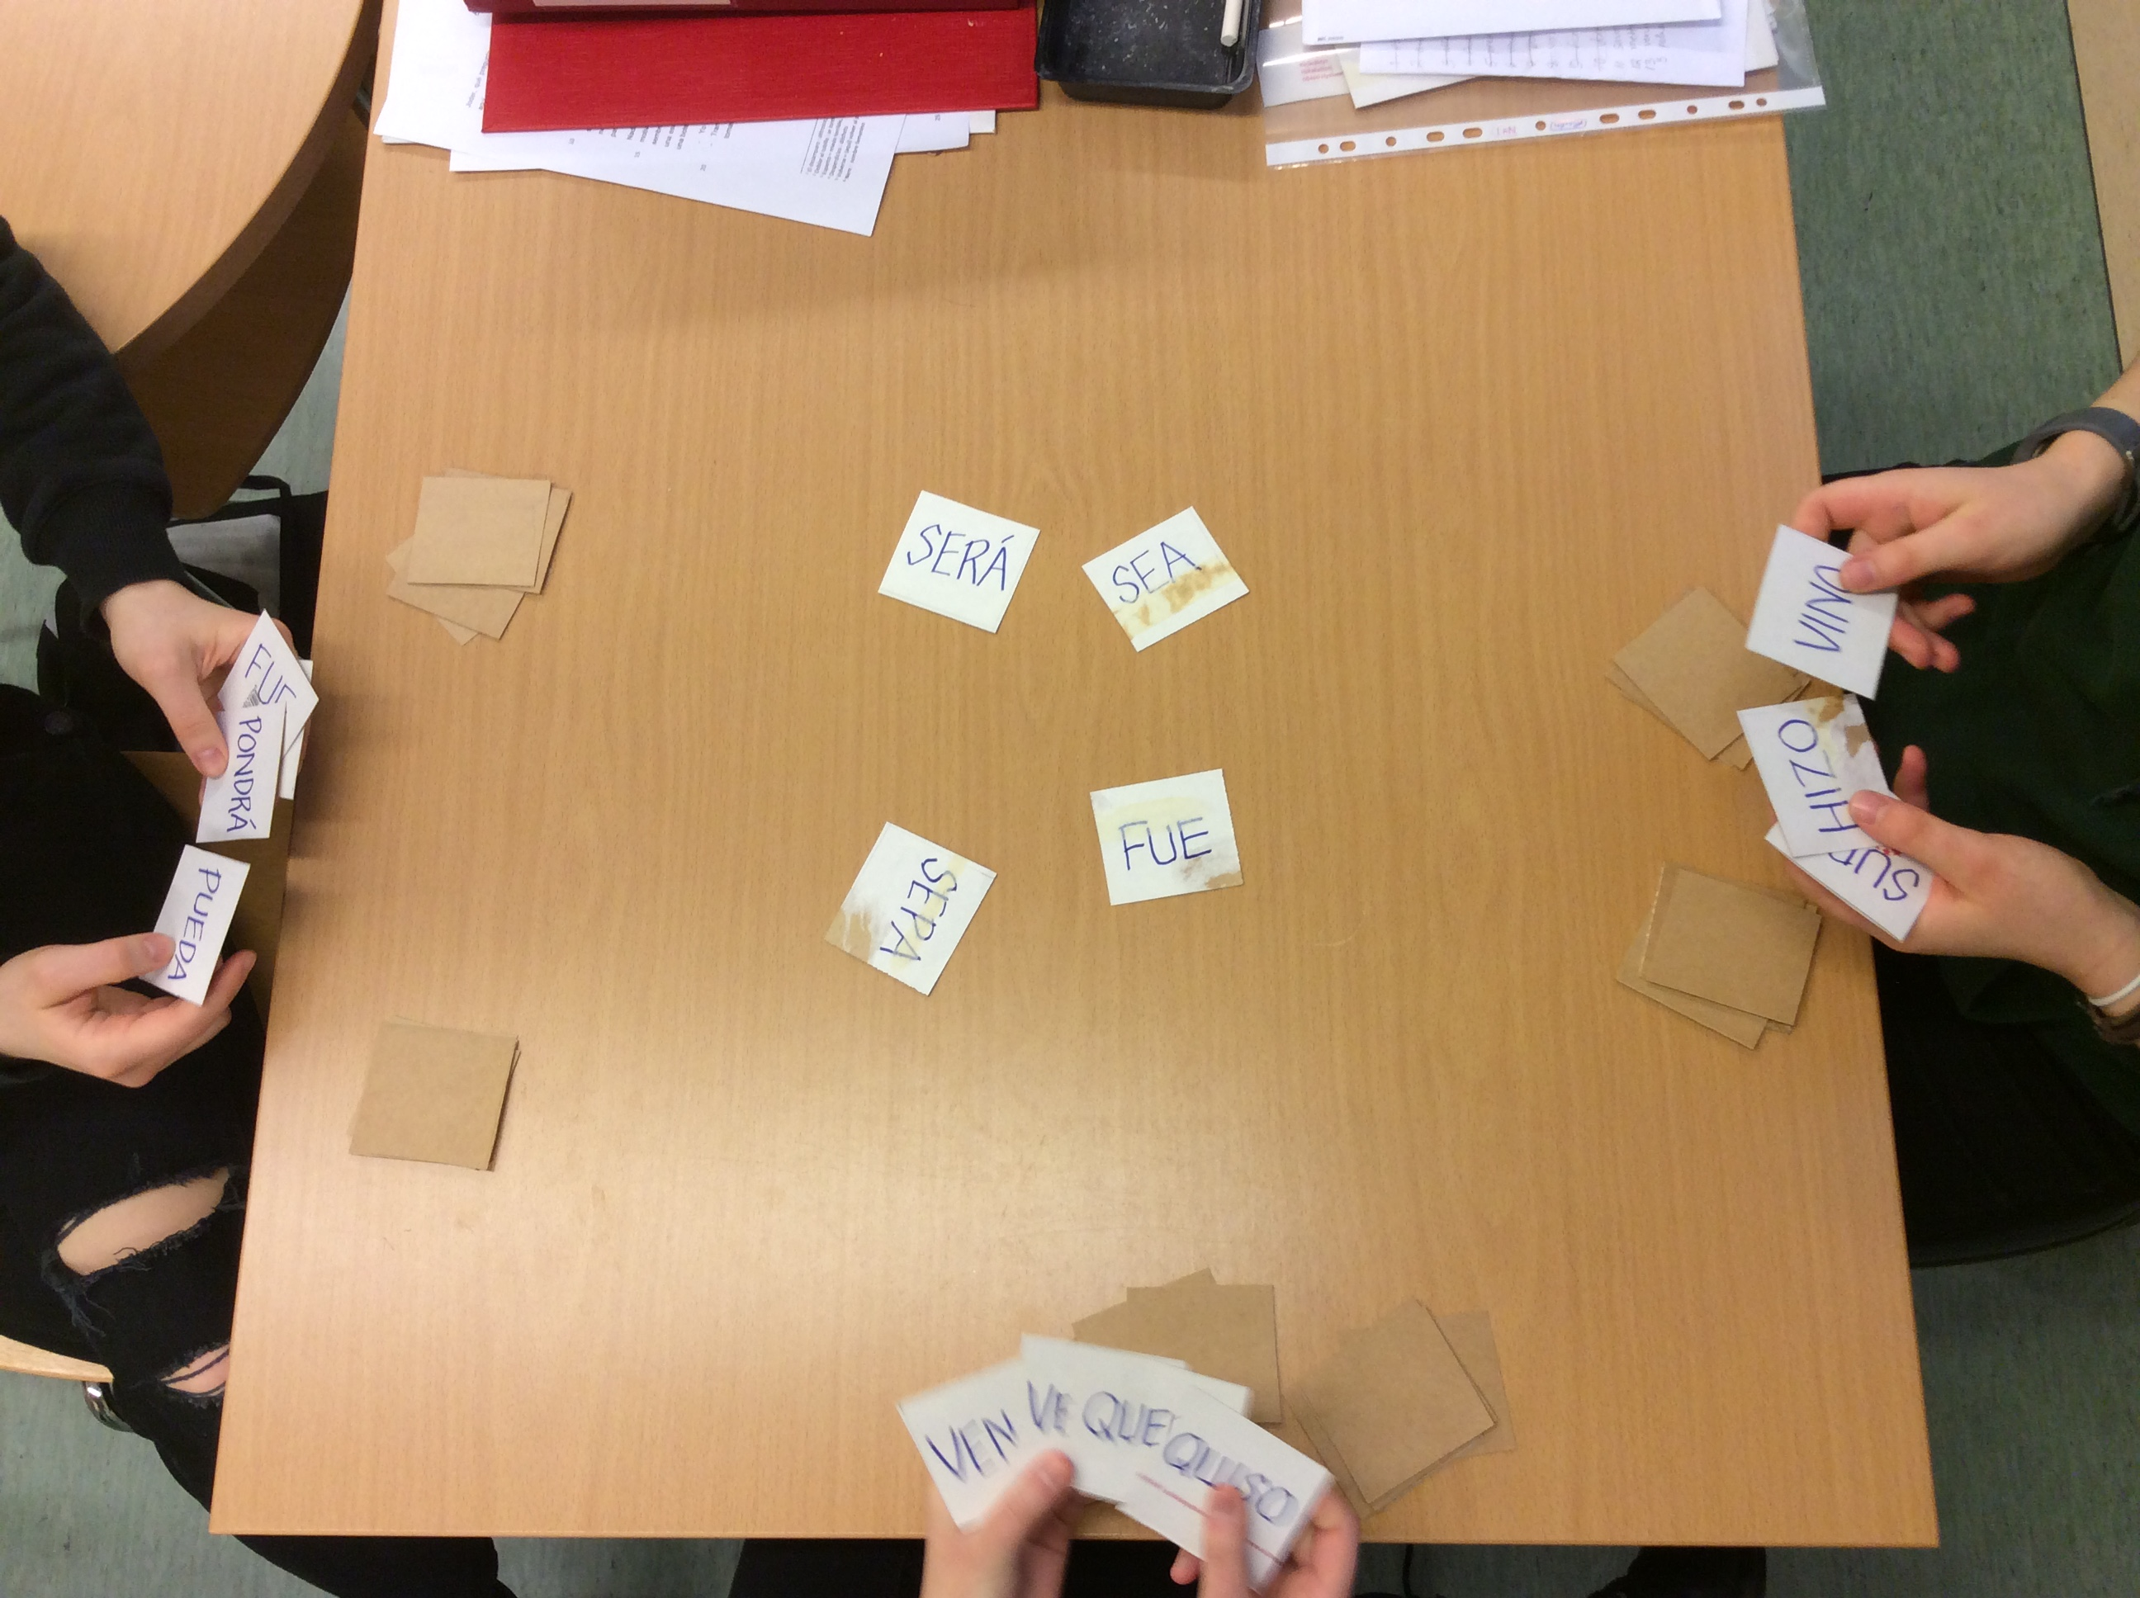
Verb rally in Spanish lesson (find four forms of the same verb and be quick)
Body parts in German lesson (book Magazin.de 2)
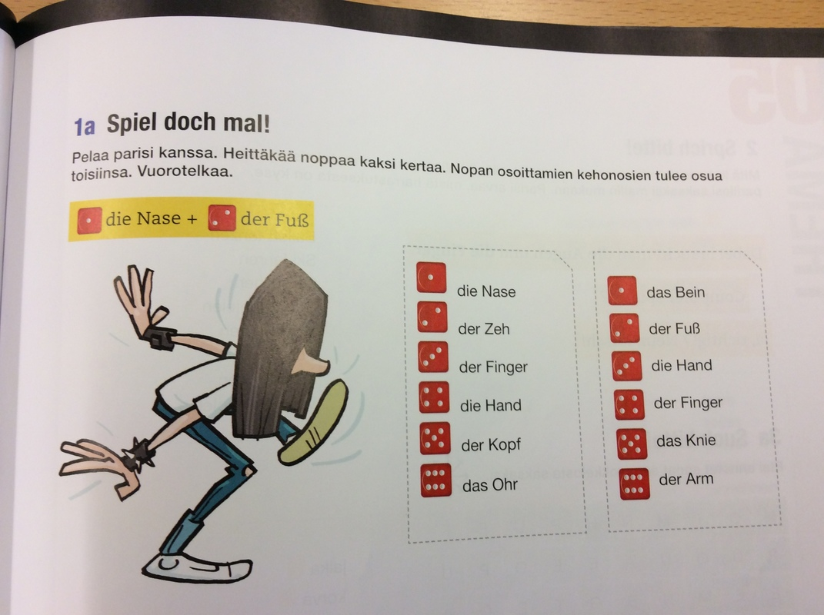
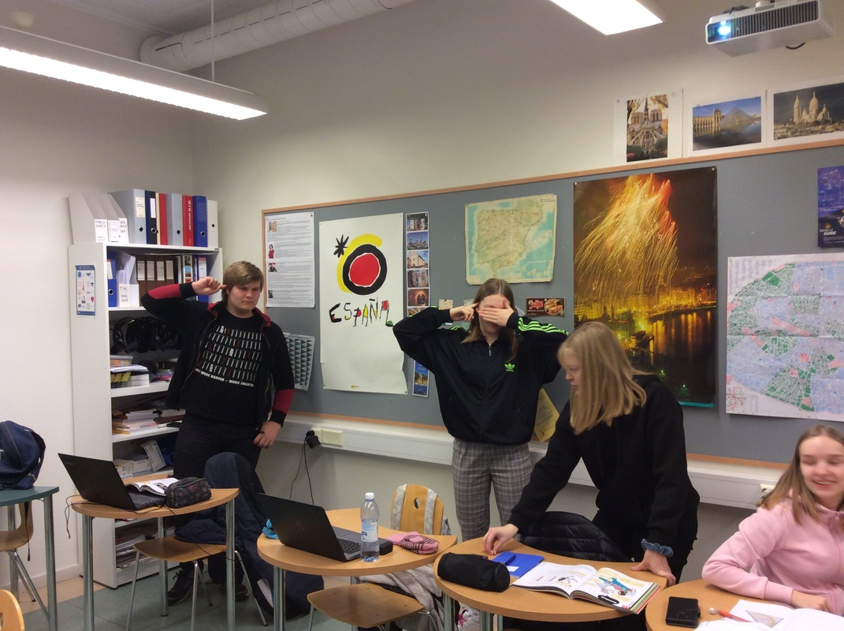
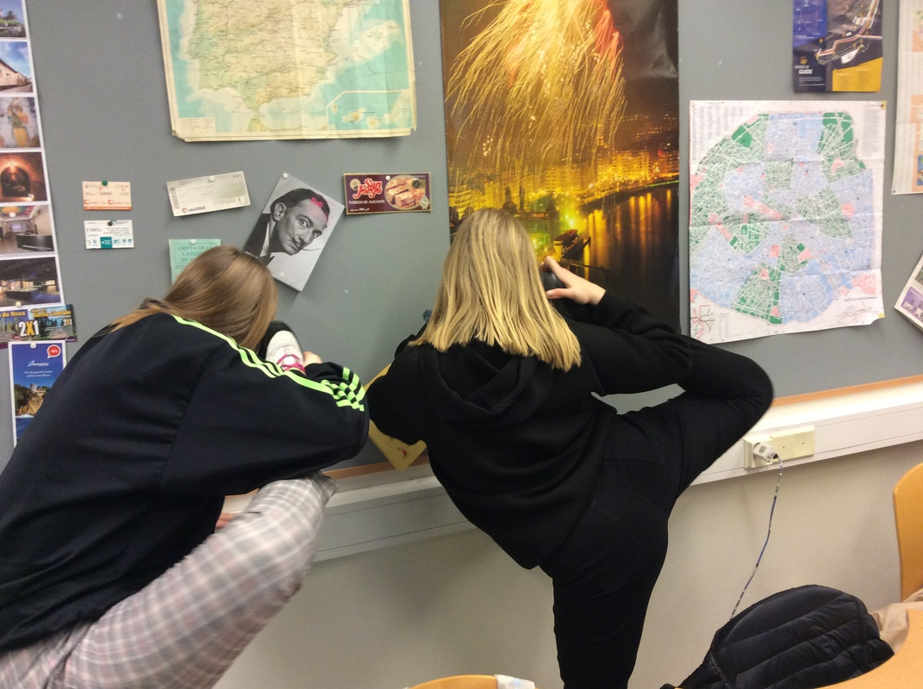

Go to the right interrogative in Swedish lesson
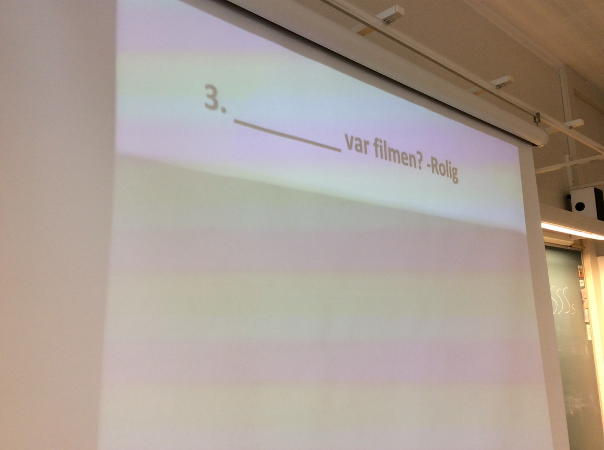
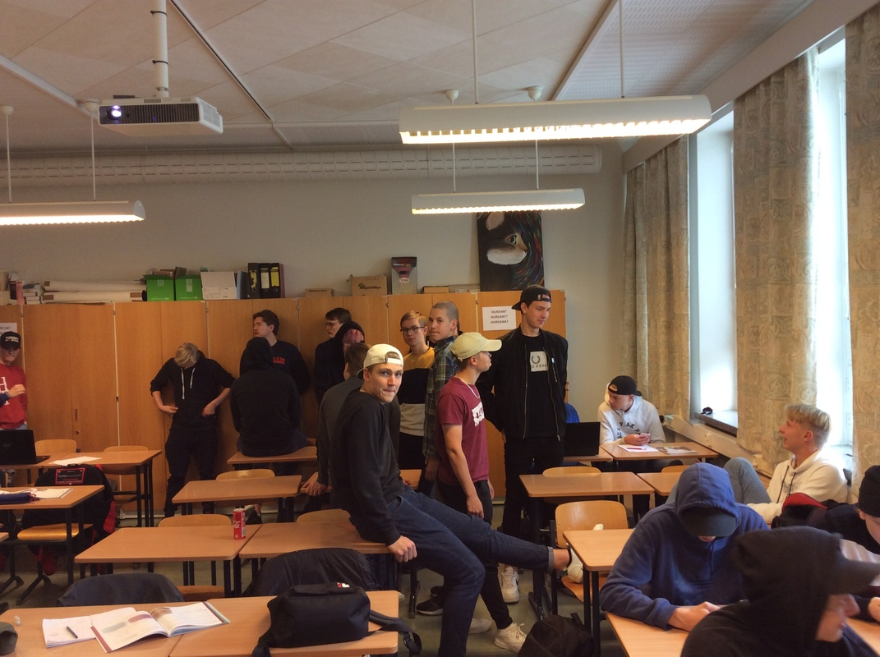
Things don´t always go the way you planed it… the interrogatives were in different places in the classroom. The students were supposed to go the right word, but the group was big and the students lazy to move.

