ForssAndújar - sustainable schools and nature parks; Forssa September 2022

Group 4: Torronsuo - importance for nature conservation, recreation and tourism

TORRONSUO
NATURAL PARK
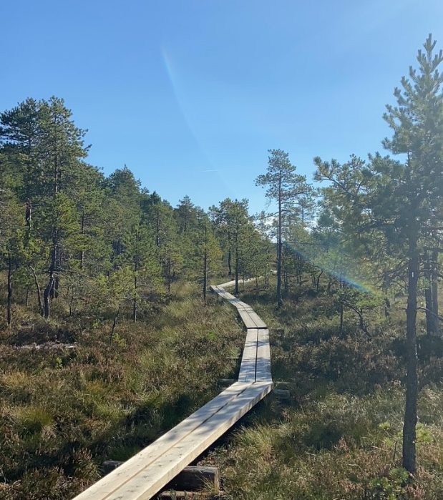

NATURE IN THE PARK

ANIMAL SPECIES PLANT SPECIES

Northen grey shrike Peat moss
Crane (kurki) Red cranberries
Spotted Crake (luhtahuitti) fir trees
Golden plover (kapustarinta) wild rosemary

Northern grey shrike (Isolepinkäinen): They are long tailed, tiny birds, with grey, black and white feathers and an upright posture. They are quite small, weighting around 70 grams. They place their nests in pine trees and they nest in the area of Torronsuo
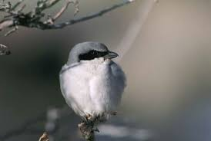

Crane: have very long necks and legs and are grey colored. They fly with their necks extended straight ahead. One characteristic feature is the bushy part of their plumage next to the tail. They are founded throughout Finland as far north as the open fields of northern Finnish Lapland
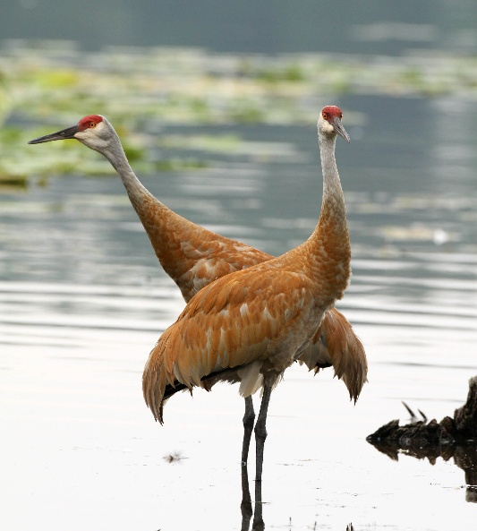

spotted crake (Luhtahuitti): This bird has greenish legs and a pale yellow patch underneath the tail, is better recognised by its distinctive call. It's a small bird, weighting 150 grams. They set their nests near moist meadows and they are rare breeders in Finland.
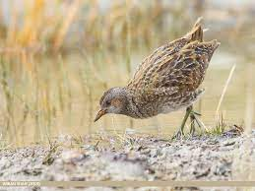
The golden Plover (kapustarinta): It is a medium sized bird that weighs about 200 grams and its feathers are black and gold in summer and during the winter the black colour feathers are replaced with white and buffy ones.
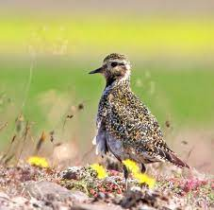

Peat moss: It is a moss that grows in the swamp. The moss likes to live in places where the ground has a lot of moisture. When the moss decomposes it turns into turf.
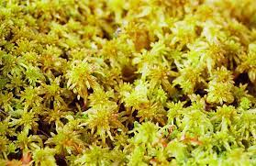

Red cranberries: They are a group of evergreen dwarf shurbs. They can be found in acidic bogs throughout the cooler regions of the Notherm Hemisphere.
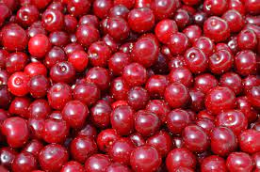

Fir trees: They are an evergreen trees with upright cones and flat needle-shaped leaves. Firs are an important source of timber and resins.
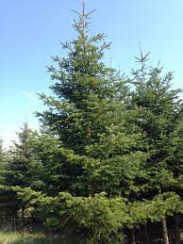

Wild rosemary: They have traditionally been used as a medicine for many aliments like colds, flatulence and as diaphoretic. Ancient finnish druids used to take them for their rituals, it seems they knew all the properties
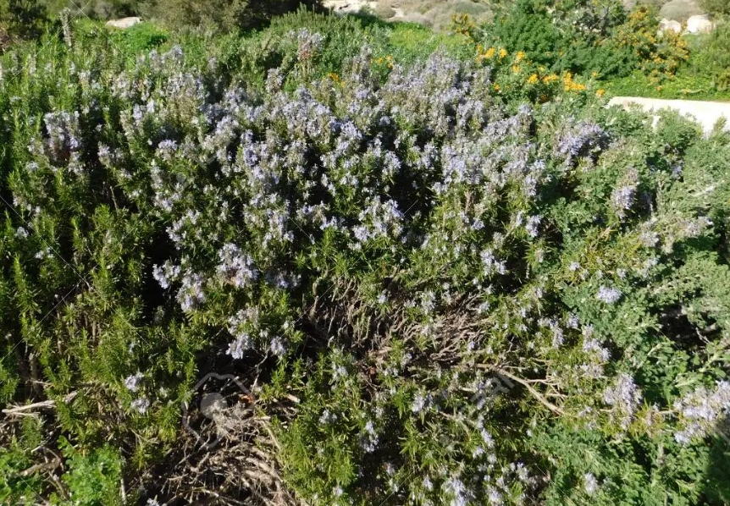

ENDANGERED SPECIES
Grizzled skipper (suokirjosiipi)
Freija's Fritillary (muurainhopeatäplä)

Nephroma laevigatum (lännenmunuaisjäkälä)

Grizzled skipper and Freija's Fritillary: The endangered butterfly species come from the northern parts of Finland. They are common in the northern parts, but they have become endangered here because swamps have been drained.
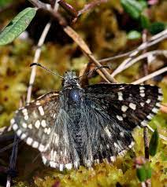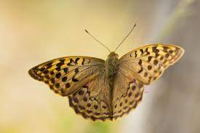
Grizzled skipper Freija's Fritillary

Nephroma laevigatum: A type of lichen species. They are grayish blue on top and the underside is light brown to black. It grows on old three trunks, on rocks or on top of moss. It's a really rare species in Finland.
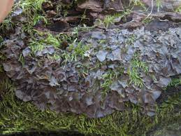

What to do in Torronsuo National park
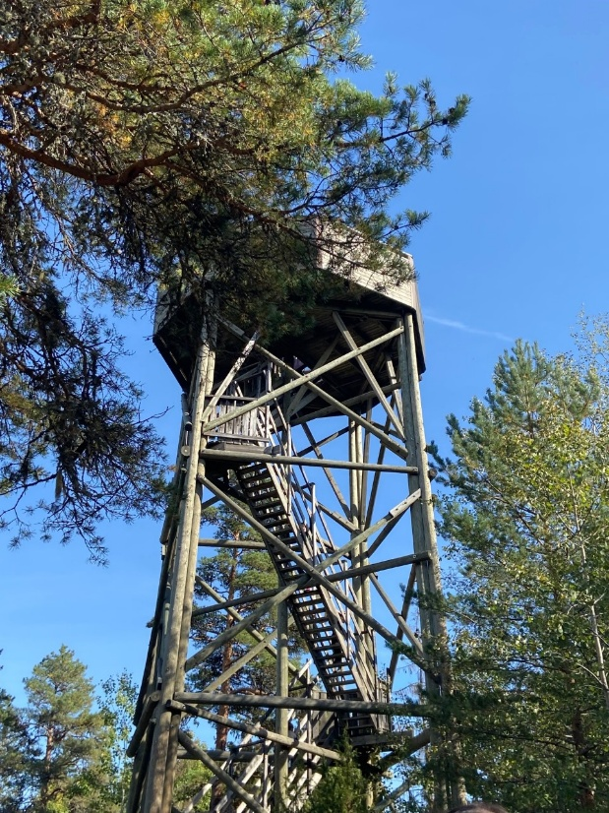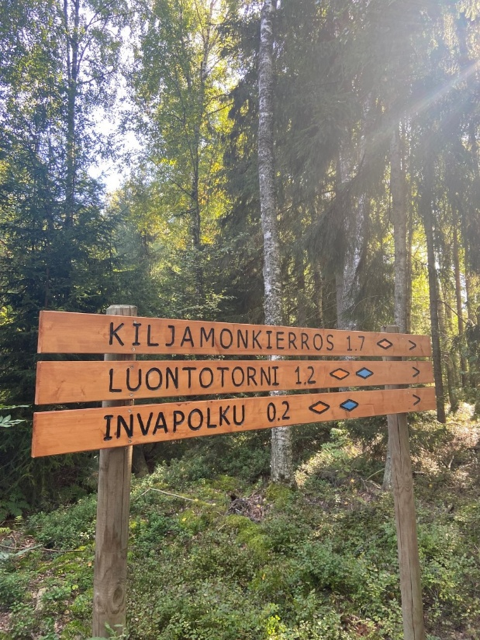
There are various things to do in Torronsuo national park throughout the year. There are different paths to walk from 1,5 km to 10 km. The paths are easy to follow so anybody can go there even if they have never been in a swamp.
In the winter you can go skiing. There are a few different paths that have ski tracks so it's easier to ski. You can also rent snowshoes. With snowshoes you can walk easily on the snow.
You can find a big variety of berries in Torronsuo. There are blueberries, cranberries, cloudberries, bog whortleberries and so on. You can pick the berries freely and eat them or take them home and make something with them.
Torronsuo is one of the places where migrating birds land for a bit to rest. You can see many different species that normally don't live in the southern parts of Finland. There is a nature tower in Torronsuo which is a good place for birdwatching.
And of course you can go to Torronsuo just to experience the swamp or to relax and enjoy the beautiful nature.

SPANISH POINT OF VIEW
Us, as Spanish, we are not able to see this kind of landscape so often. For some of us it was the first time visiting a swamp, and it was stunning to observe the mud stumble underneath our feet. Also we got to know new kind of plants such as the wild rosemary or the peat moss and we tasted the wild berries and soaked up the water from the soil. It was a brand new experience we would like to repeat.
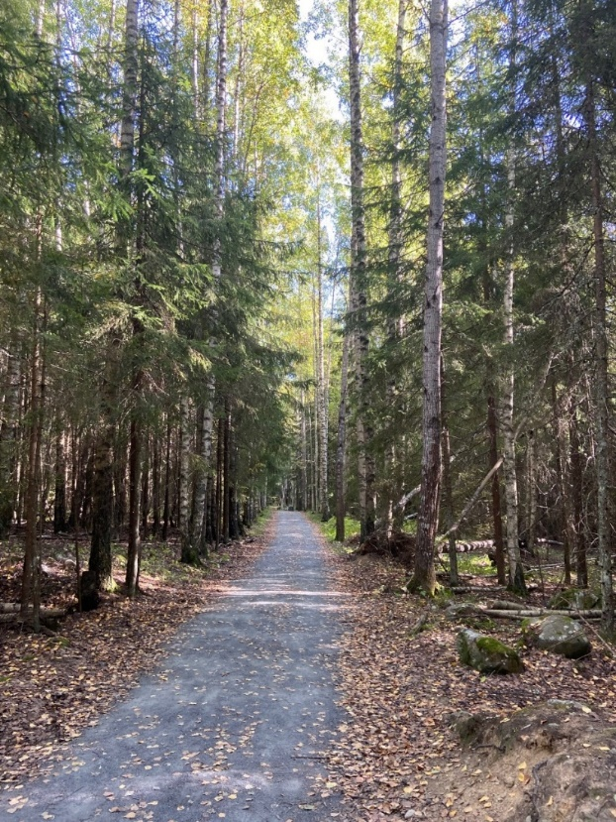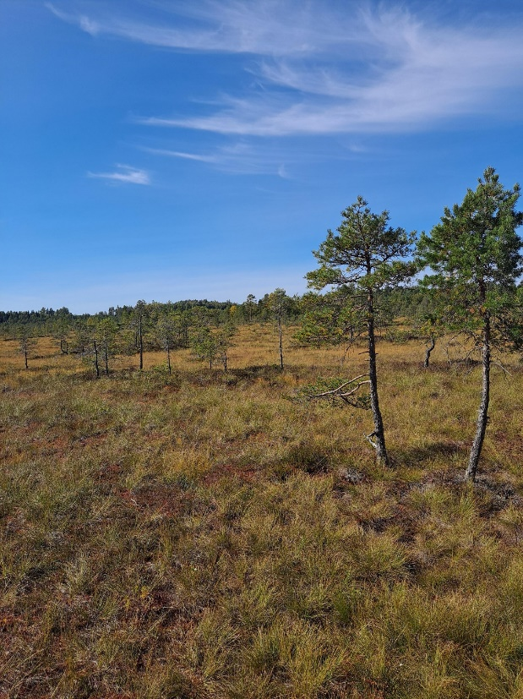

HOW TO IMPROVE TOURISM
We believe the best ways to increase tourists is to put more duckboards so people can have longer walks and more corners to explore. Also maybe put a bar so people can rest there after the walks and serve themselves a drink.
Show more publicity of the place so people know more about it and make it look more interesting as well.

Sources:
https://www.nationalparks.fi/torronsuonp/nature
https://fi.wikipedia.org/wiki/Torronsuon_kansallispuisto
https://laji.fi/taxon/MX.66240
https://luontoportti.com

