ForssAndújar - sustainable schools and nature parks; Forssa September 2022

Group 1: Questionnaire about sustainable habits at schools and homes

We made a questionary about sustainable habits in schools and homes. Our group decided to make two Google forms. One for Finnish students and one for Spanish students. The questions are for example about recycling and other sustainable habits. The questionary was sent to the students in this project and the teachers. From Finland the quiz was answered by 10 people and from Spain by 14 people. There were 21 questions.
The first question was simply: Do you care about sustainability? Gladly both groups answered 100 % "yes".
Second question asked about the opinions about getting enough knowledge about sustainability personally.
These are the Spanish results:
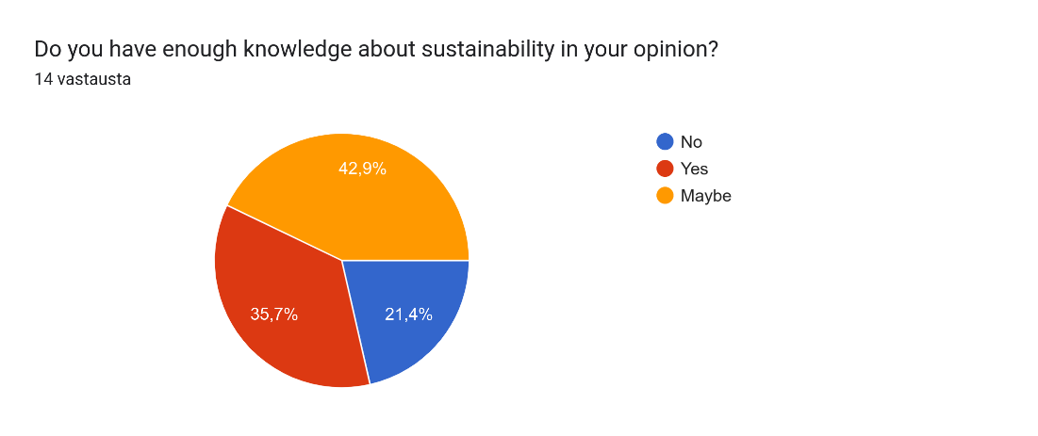

Finnish answers:
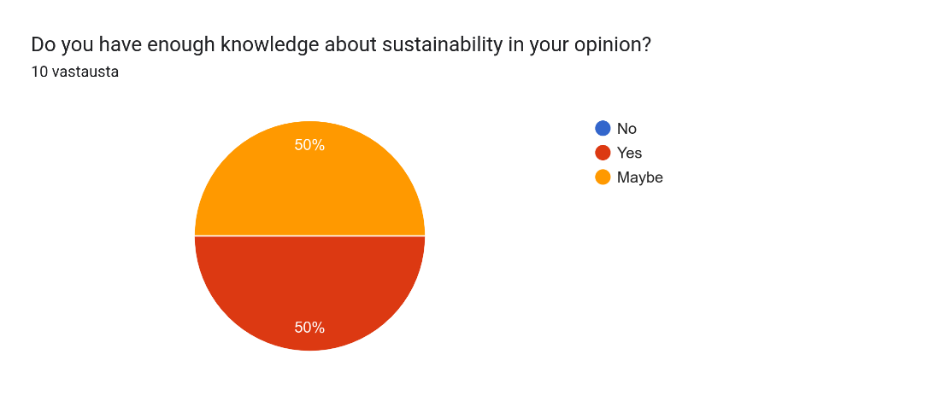

Third and fourth questions asked if the person recycled at home and school.
Spanish results:
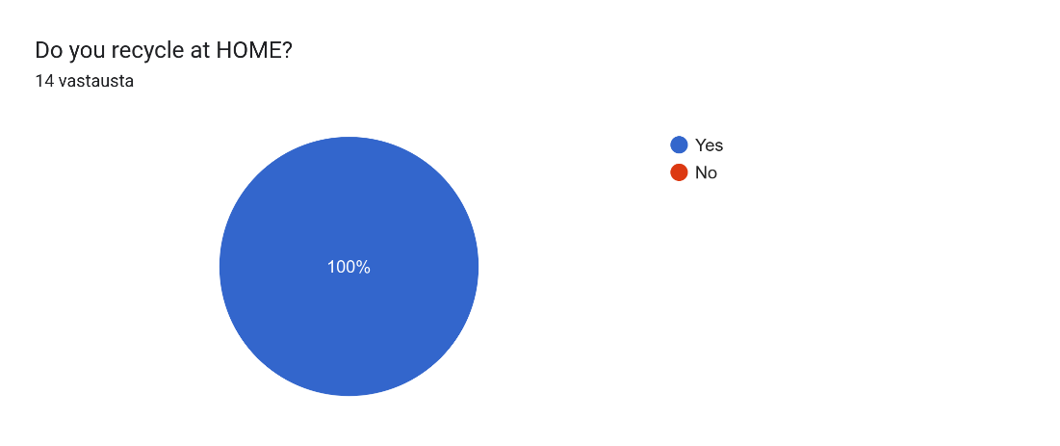
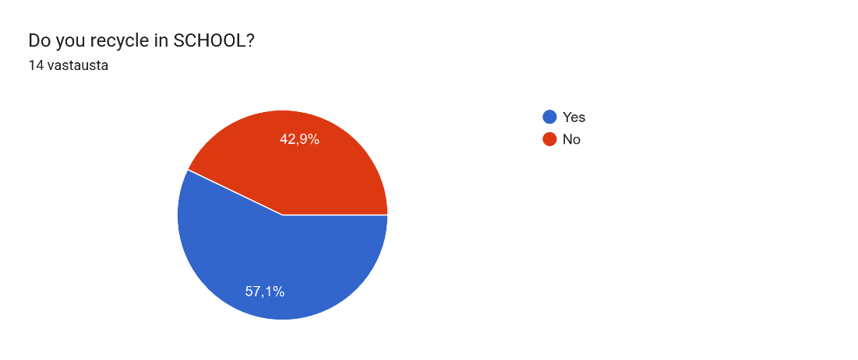

Finnish answers:
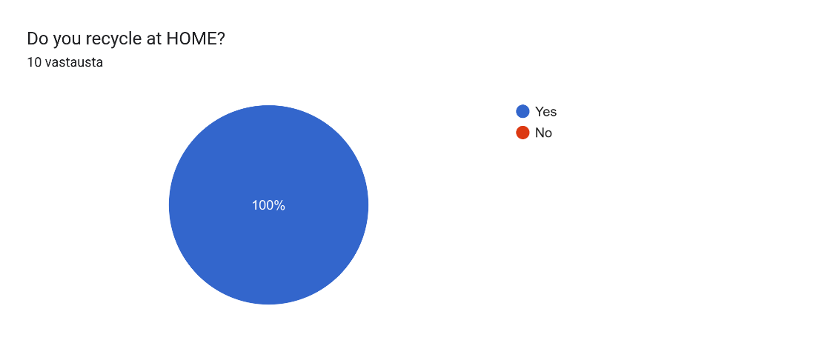
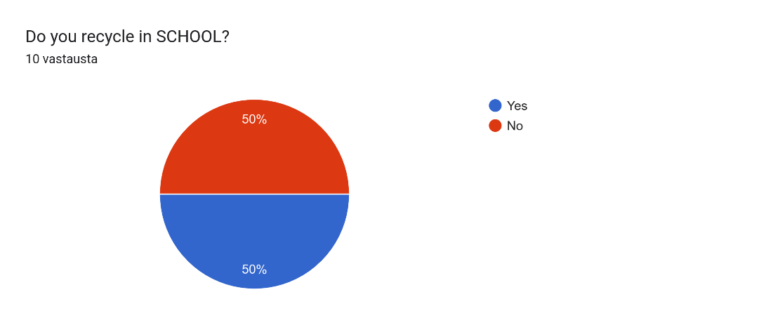

Fifth and sixth questions were designed to continue the topic on recycling trash at home and school. We asked what kind of trash we recycled and there were clear differences between the countries.
Spanish answers about home:
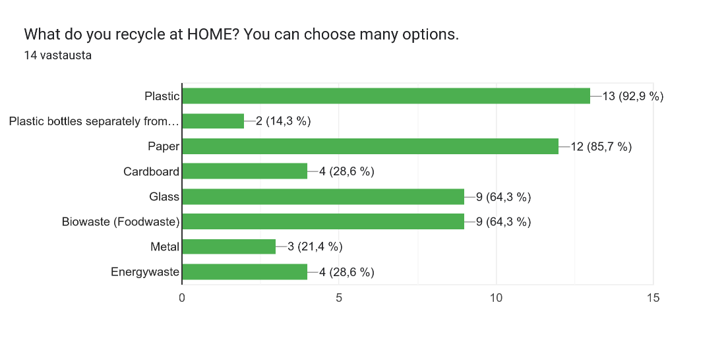
Finnish results about home:
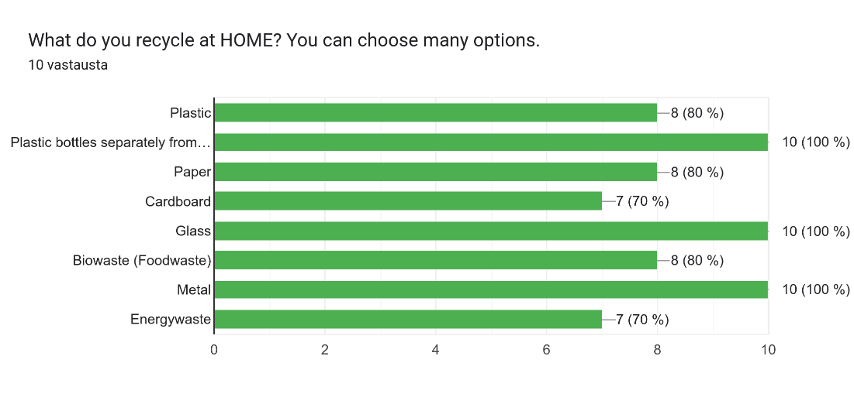

And there were same options, but about recycling in school:
Spanish:
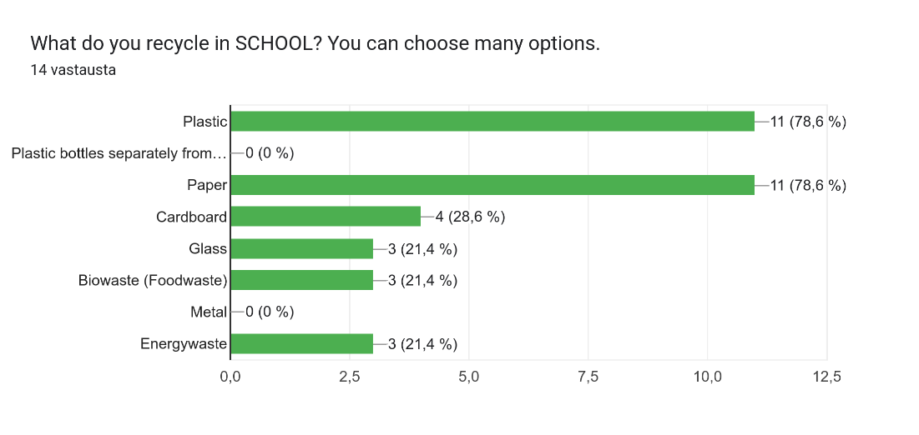
Finnish:
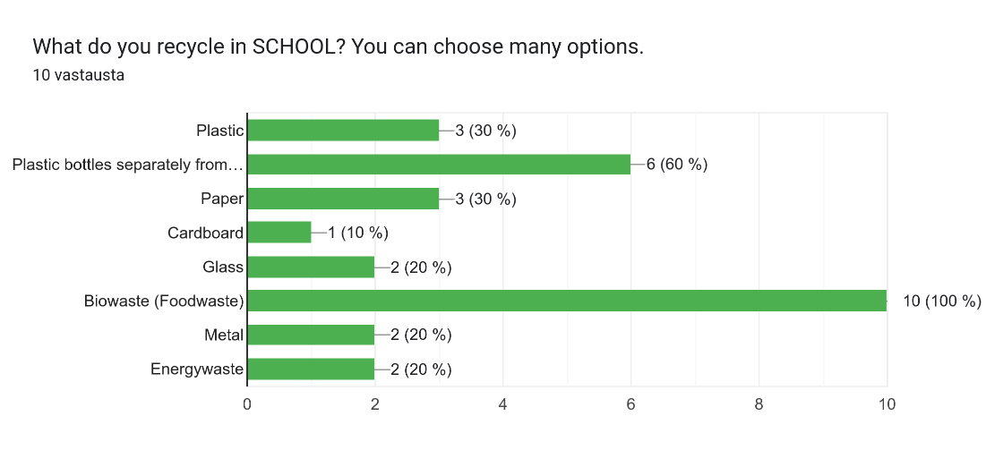

7th and 8th questions were again related. We asked about the students' homes heating and if they knew the way of warming them.
Spanish answers to both:
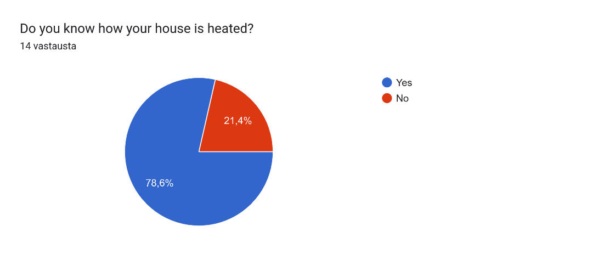
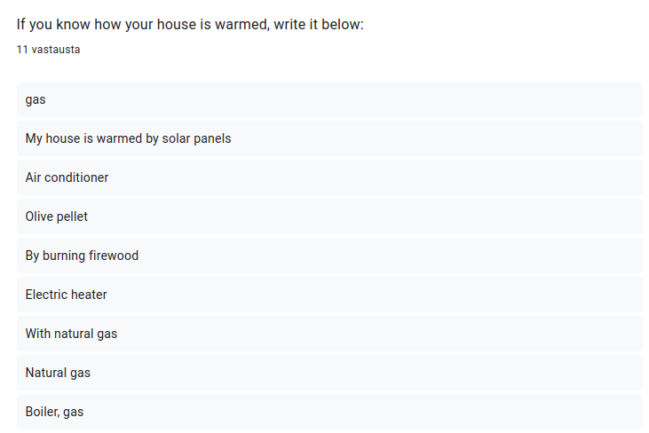

Finnish answers to both:
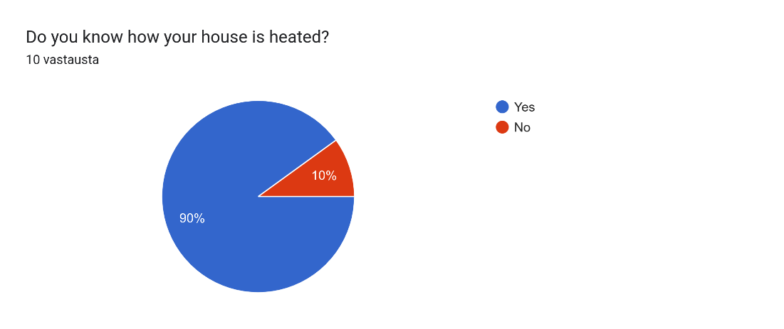
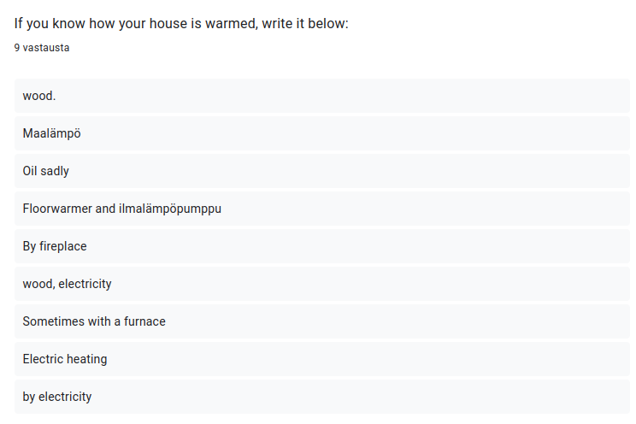

9th and 10th questions were about simple and small habits, but the differences were surprising. 9th question asked about switching the light switch off when leaving the room and 10th question asked about turning off the tap when it's not in use.
Spanish results for light:
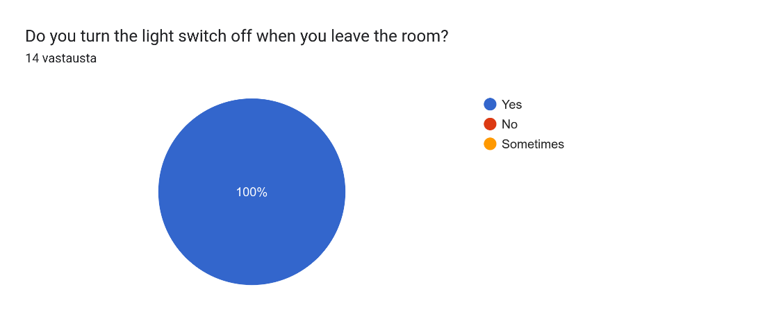
Finnish:
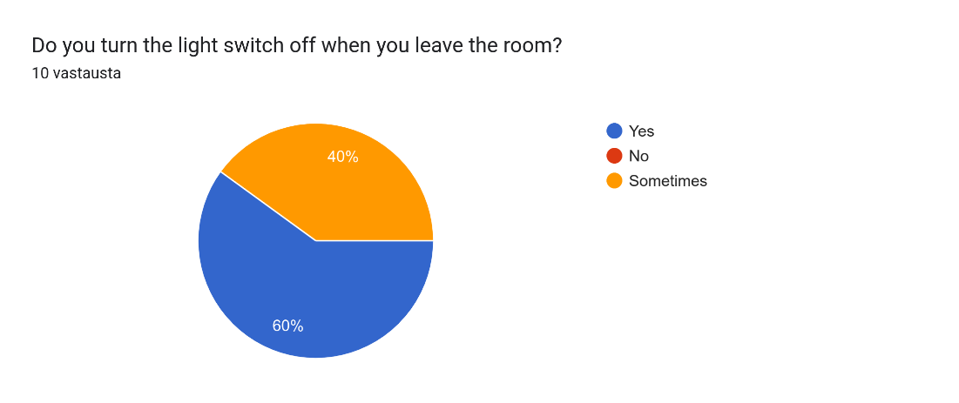

Spanish answers for water:
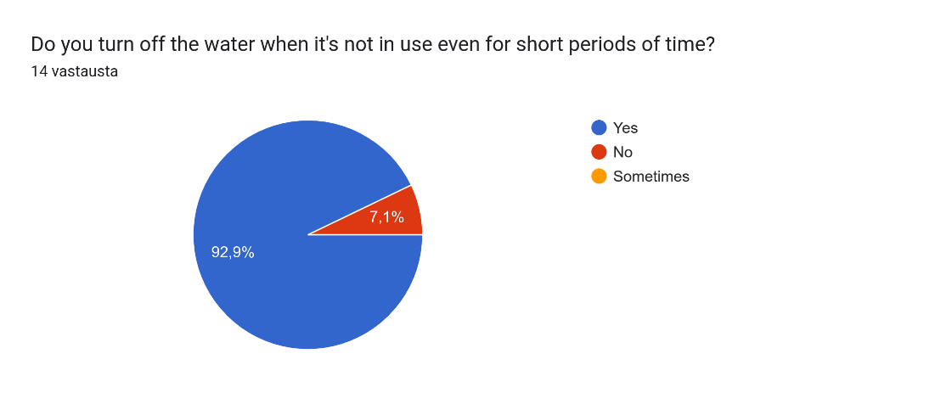
Finnish:
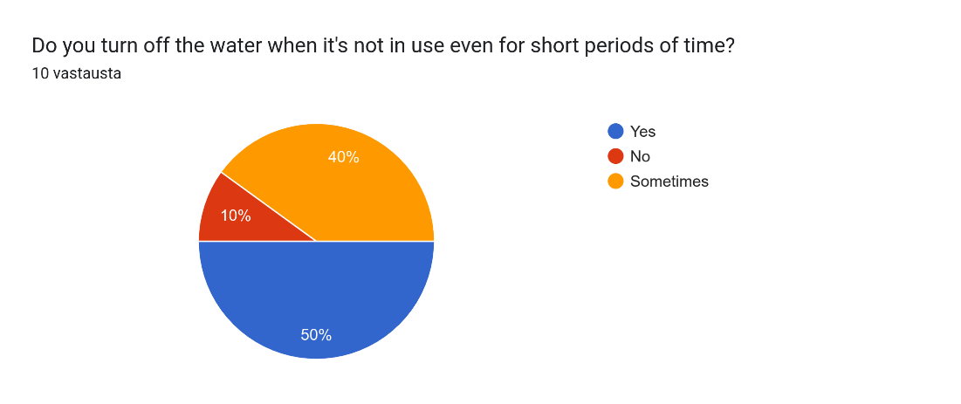

Because we're all students and use schoolbooks, we decided to ask about the books we use most often.
Spanish answers:
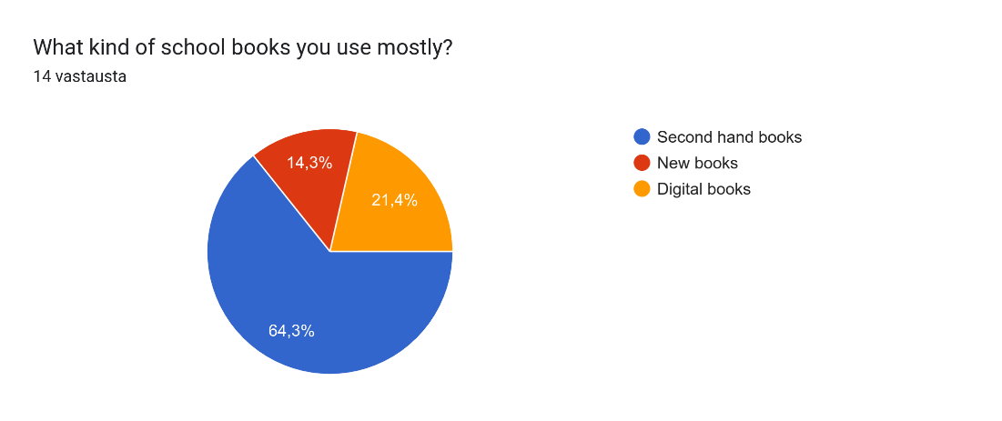
Finnish answers:
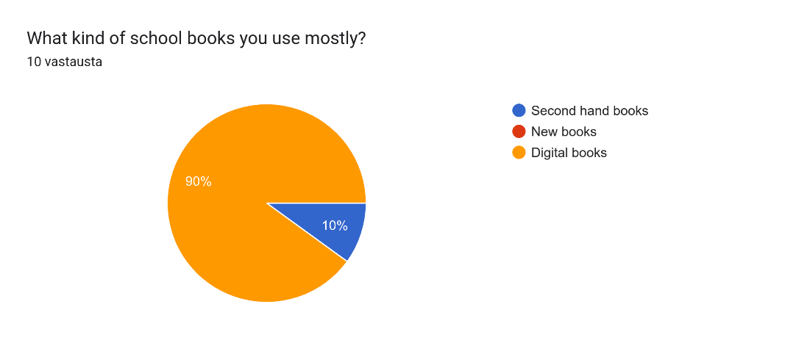
12^{th,} 13th and 14th questions were about our everyday objects, clothes. We asked if the students sell their old clothes and where they got them and what was the most often place to get clothes.
Spanish results to 12th question:
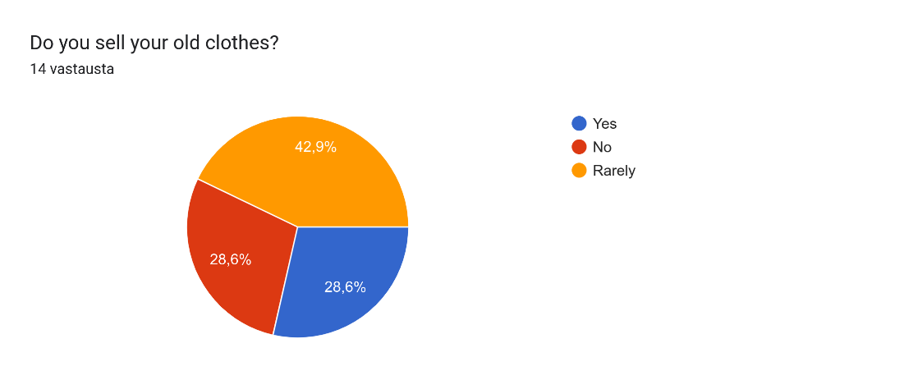
Finnish results to 12th question:
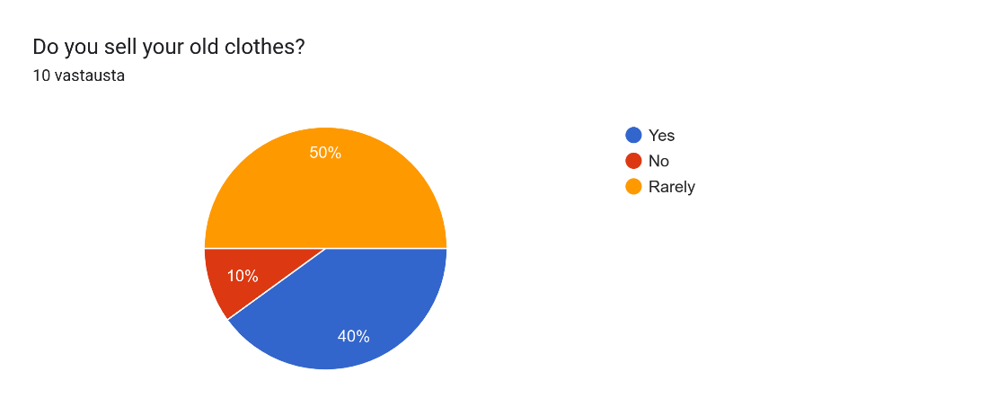
Spanish 13th:
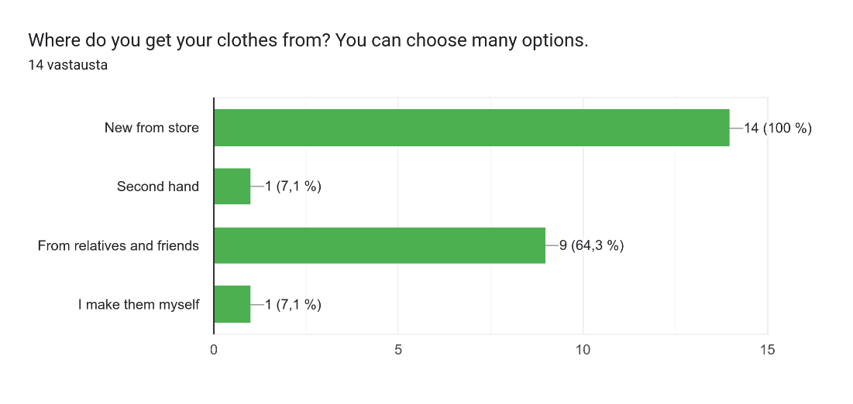
Finnish 13th:
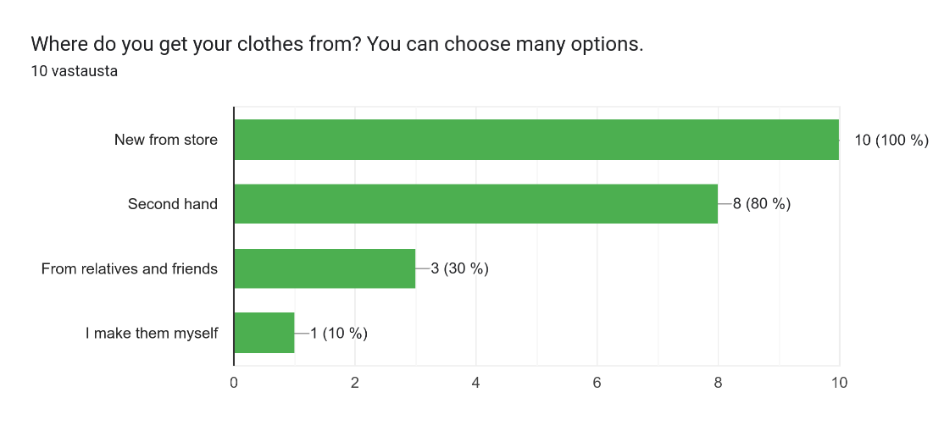
Spanish 14th:
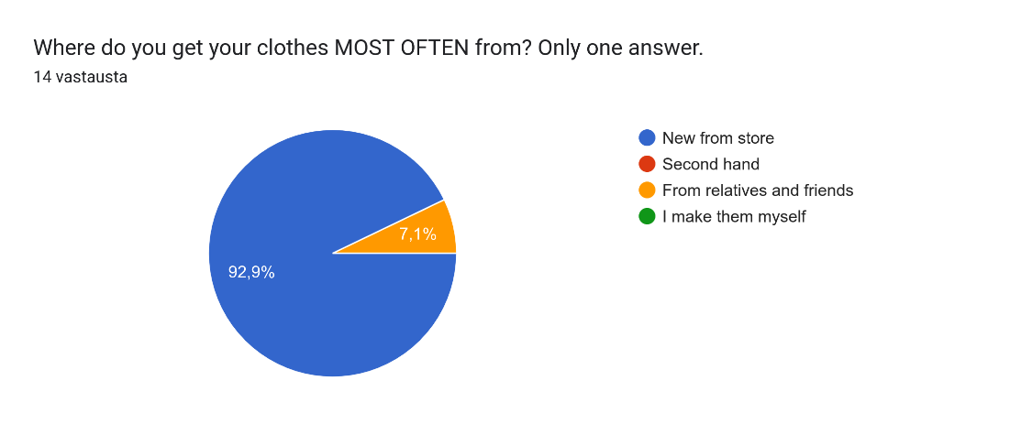
Finnish 14th:
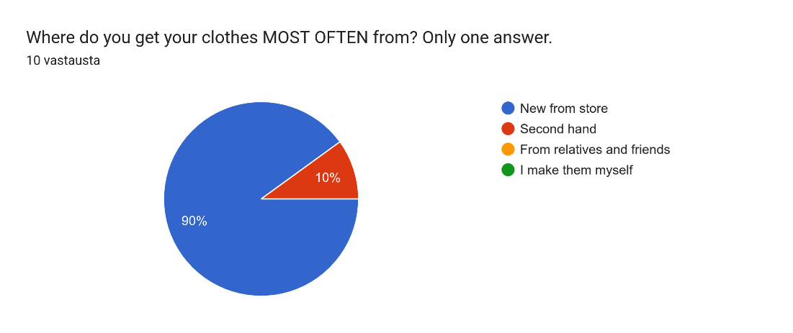

15th and 16th questions were related to each other too. First, we asked that how the students and teachers got to school, and then we asked how far their school is from their home.
Spanish answers to both:
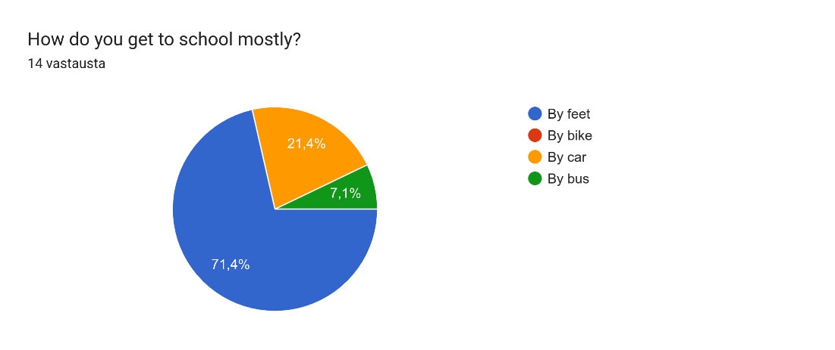
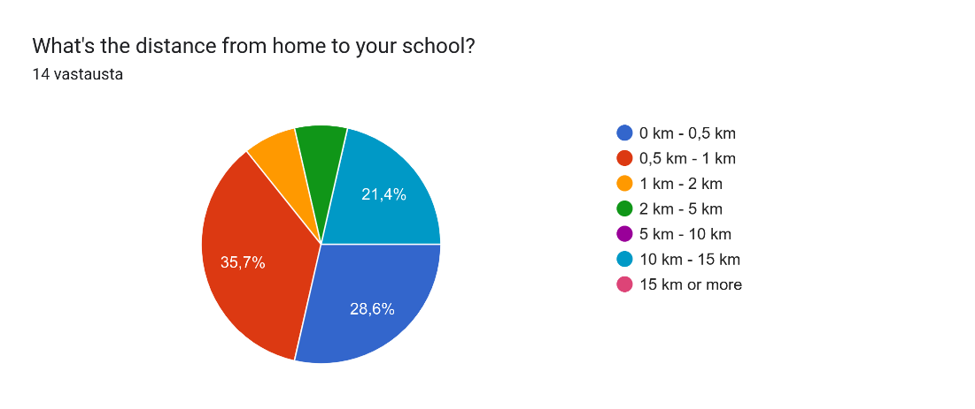
Finnish answers to both:
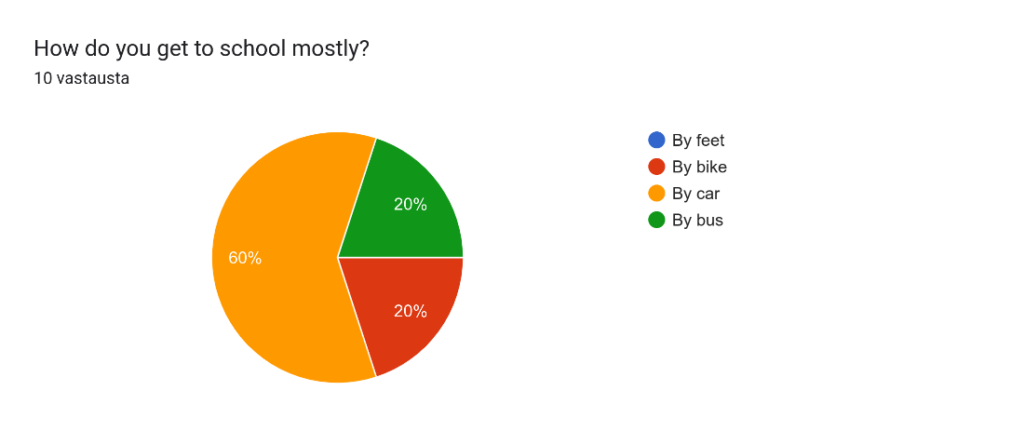
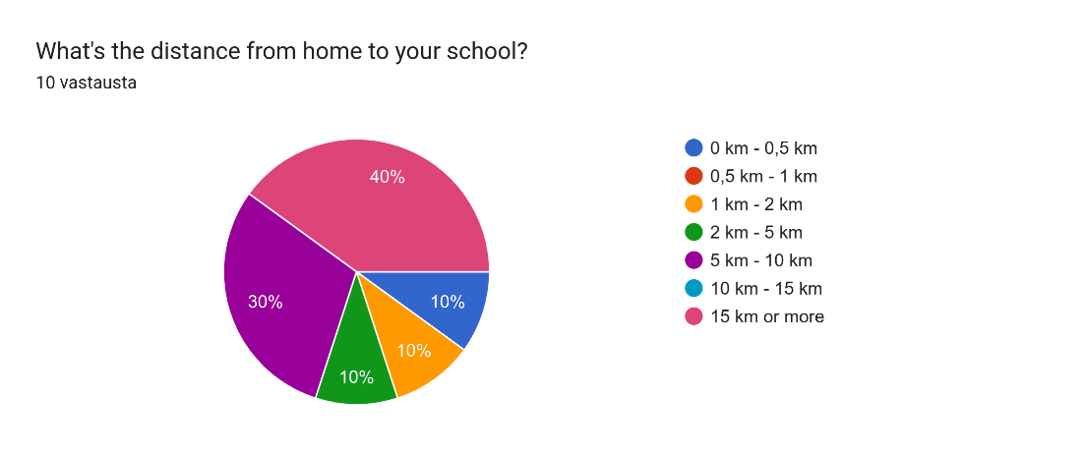

17th question was a question to see our meat-eating habits.
Spanish answers:
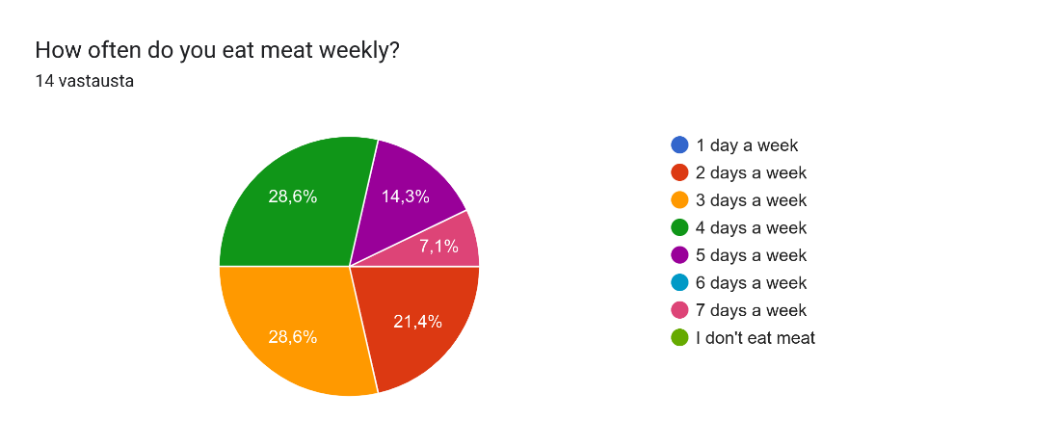
Finnish answers:
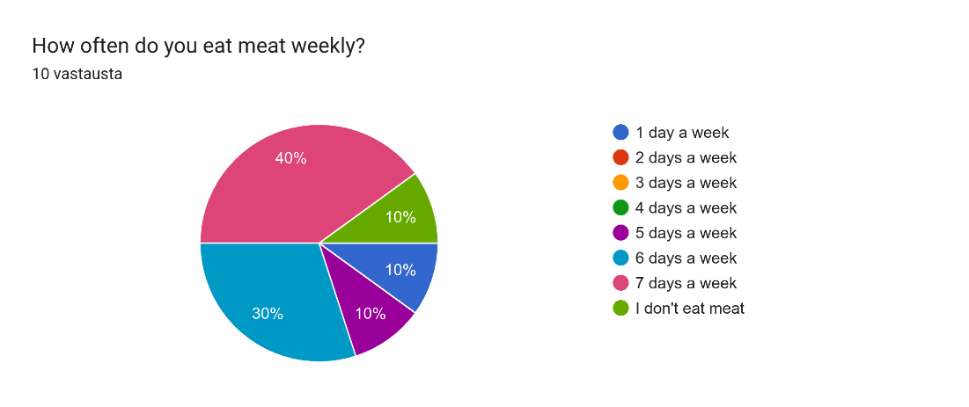

18th question was more about opinions. We asked, if the person answering thought that their country talked enough about sustainability.
Spanish:
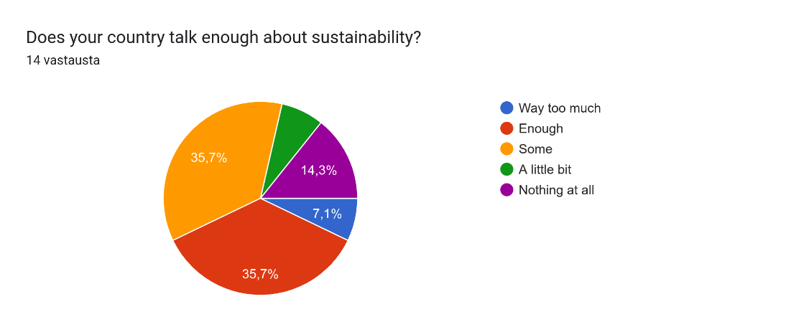
Finnish:
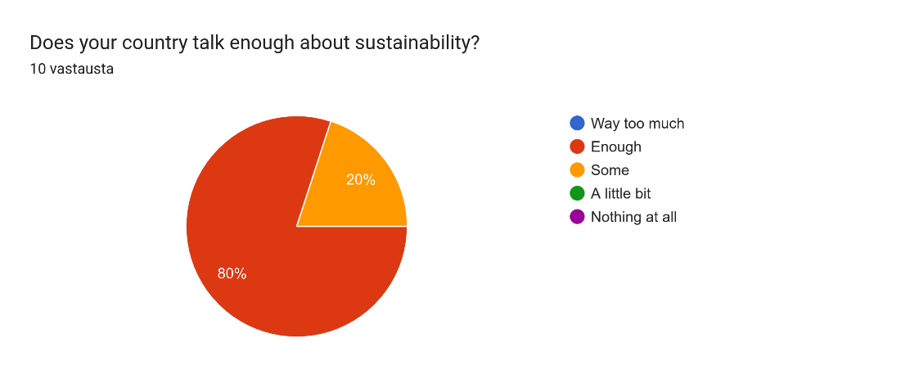
19th and 20th questions were about seeing ideas to improve sustainable habits in schools and at homes.
Spanish suggestions for home:
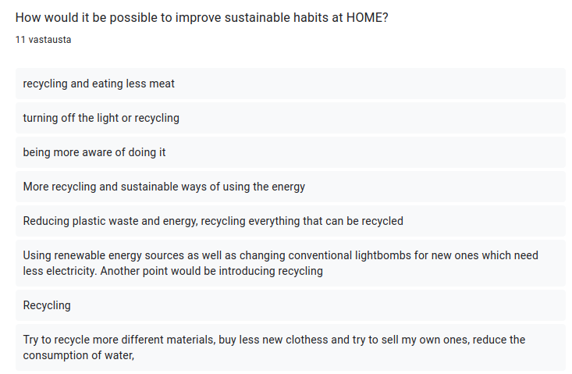
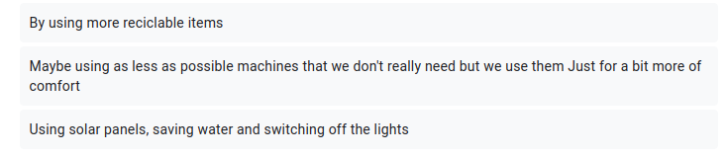
Finnish suggestions for home:
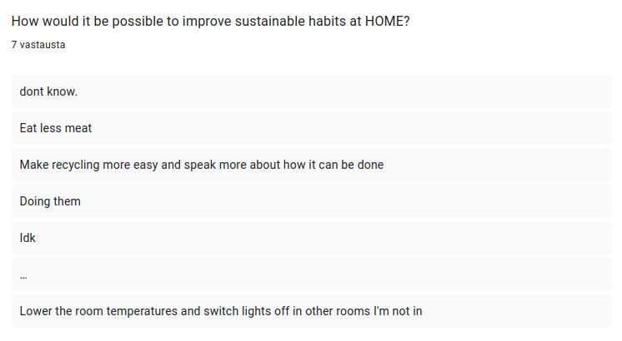
Spanish suggestions for school:
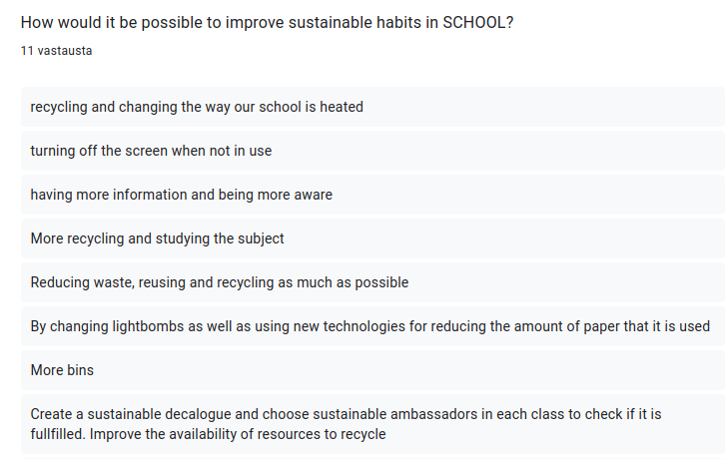
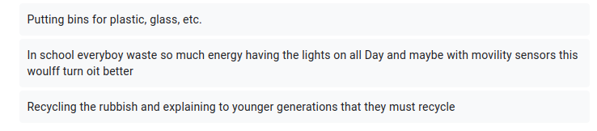
Finnish suggestions for school:
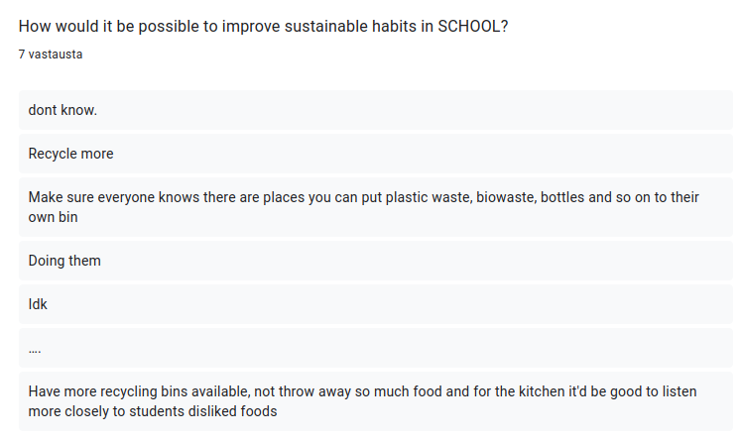

And last question was a really general question, but the results were surprising. We asked, if our quiz made the persons answering think about their sustainable habits. Nobody said no, but it might or might not be a cultural thing with the difference between answering "yes" and "tiny bit".
Spanish answers:
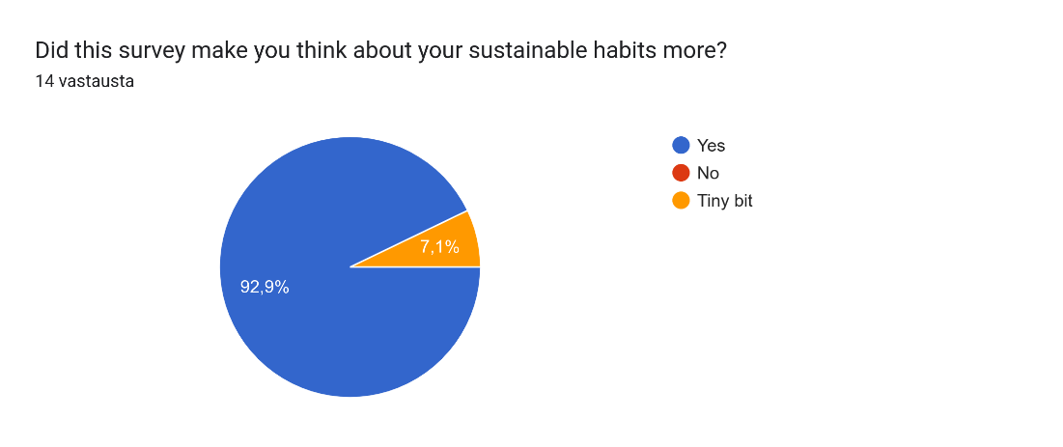
Finnish answers:
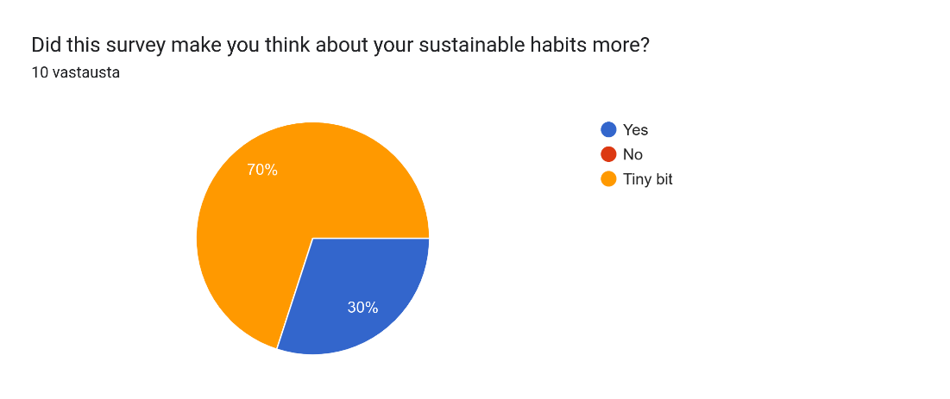

Overall feelings about the results:

Spanish people are really strict about turning the lights off and turning water off. But the reason is, that energy and water are expensive in Spain. The reason is not that much because of sustainability.
Recycling was different in our countries. Finnish people recycle a lot more at home than Spanish people. Especially the difference between recycling plastic bottles was big, because in Spain they don't get money from returning the bottles. Spanish people recycle plastic and paper more in school than Finnish people. There was also a big difference between biowaste and plastic bottles.
In the school system there's a huge difference with books. Spanish people don't really use digital books, which was on the other hand most dominant result with Finnish people.
When getting clothes, there was a huge difference between getting clothes second hand or from relatives and friends. In Finland second hand culture is more important and in Spain it's a lot more common to get clothes from relatives.
Last but not least, the question about thinking more about sustainable habits through this survey was interesting. Most Spanish people wrote that "yes", they thought more about their habits. Most Finnish people answered, "tiny bit". Spanish people, according to a few other Spanish students, probably wanted to look good in this survey:)

