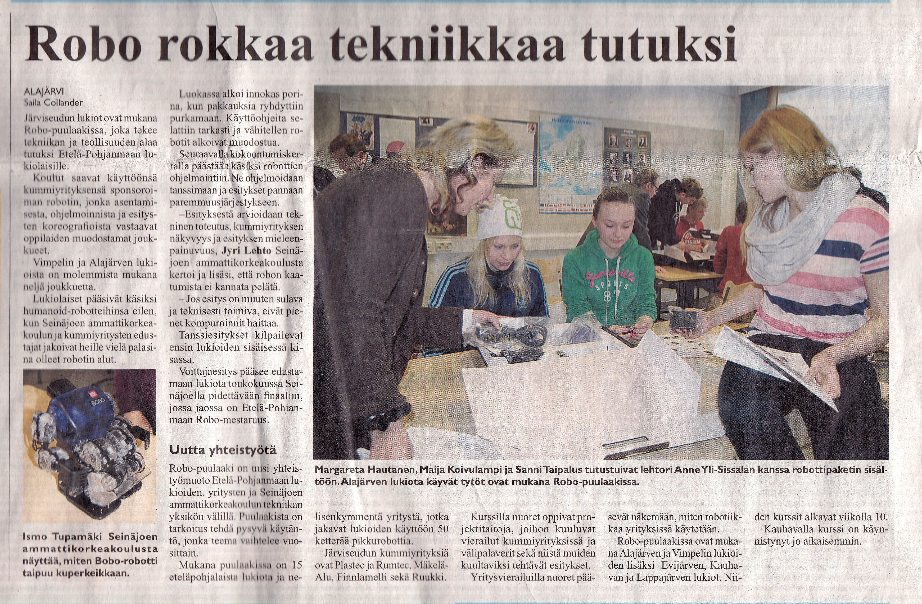
Robots Rock – Järviseudun sanomat Feb 6, 2013

